FIFTH SUNDAY AFTER EPIPHANY
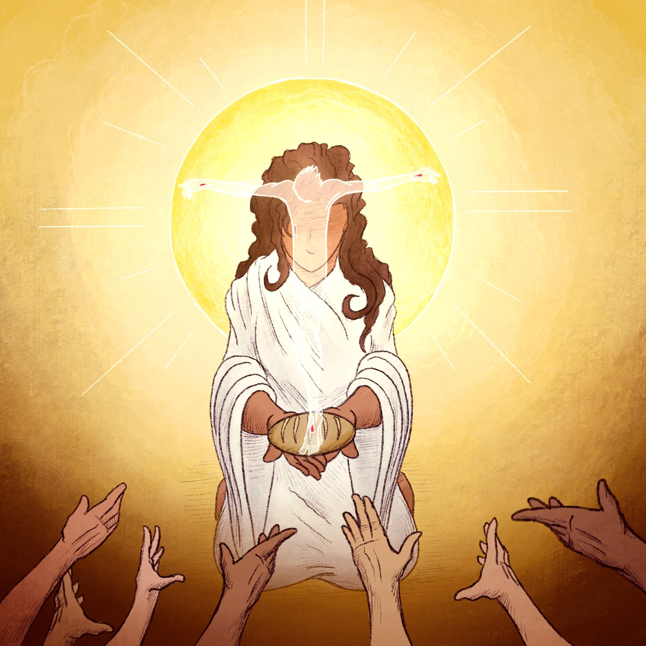
Mt. Zion Evangelical Lutheran Church

320 Mt. Zion Dr., Ripon, WI
www.mtzionripon.org
Facebook: Mt. Zion Evangelical Lutheran Church

Pastor Kurt Hagen (Vacancy Pastor)
Phone 651-764-3901
pastorhagen@gmail.com

Epiphany 5 Feb. 7, 2026
Handicapped accessible restrooms are located upstairs next to the Pastor’s Study and downstairs next to the elevator.
Attendance: Please remember to sign the friendship pads. Registration for communion will continue as usual at the table. If you have any questions or concerns, please contact Mike Meeker.


Hearing Loop: Our sanctuary is equipped with a hearing loop system. Those who have compatible hearing aids (with a T-switch) will be able to hear the sound system directly into their ear(s). The two main seating areas and the choir area are looped so that you may sit in any of the three areas. We also have four receivers available for those who do not have compatible hearing aids. If you wish to use a receiver please ask the ushers. Those who wish may bring their own headphones or ear buds.

A note for our visitors on member communion –
Out of sincere love for the truth of God’s Word and for precious human souls, we practice member communion in our synod and congregation. This teaching, as practiced by the Church for centuries, is thoroughly Scriptural. It questions the faith of no individual yet asks that there be full doctrinal agreement between those who commune. For this reason, we ask that only those who are members of a WELS or ELS congregation join us for the Lord’s Supper. If you wish to commune with us please speak with the pastor before the service.
The front row on the pulpit side is reserved for people who are unable to navigate the steps. Pastor will serve you Communion first.

Prayer Before Communion: Dearest Jesus, I thank you for the gift of your Holy Supper. As I come to your table, work true repentance in my heart. Teach me to confess my sins and to believe that I am forgiven for your sake. May your body and blood, which are in and with the bread and wine, nourish my faith and strengthen my will to live to the glory of your name. Amen.

Hymns: 794, 630, (800), 697

Order of Worship Setting One pg. 154

First Reading: Exodus 19:1-8a (EHV)
In the third month after the Israelites had left the land of Egypt, on that same day of the month, they came to the Wilderness of Sinai. ²After they set out from Rephidim and came to the Wilderness of Sinai, they camped in the wilderness. Israel camped there in front of the mountain.
³Moses went up to God, and the Lord called to him from the mountain, “This is what you are to say to the house of Jacob and to tell the people of Israel: ⁴‘You have seen what I did to the Egyptians and how I carried you on eagles’ wings and brought you to myself. ⁵Now if you will carefully listen to my voice and keep my covenant, then you will be my special treasure out of all the nations, although the entire earth is mine. ⁶You will be my kingdom of priests and my holy nation.’ These are the words that you are to speak to the Israelites.”
⁷Moses went and summoned the elders of the people, and he set before them all these words that the Lord had commanded him. ⁸All the people answered together, “Everything that the Lord has said, we will do.”

Psalm: 112A Light Dawns in the Darkness

Second Reading: I Peter 2:9-12 (EHV)
But you are a chosen people, a royal priesthood, a holy nation, the people who are God’s own possession, so that you may proclaim the praises of him who called you out of darkness into his marvelous light. ¹⁰At one time you were not a people, but now you are the people of God. At one time you were not shown mercy, but now you have been shown mercy.
¹¹Dear friends, I urge you, as aliens and temporary residents in the world, to abstain from the desires of the sinful flesh, which war against your soul. ¹²Live an honorable life among the Gentiles so that even though they slander you as evildoers, when they observe your noble deeds, they may glorify God on the day he visits us.

Gospel Acclamation
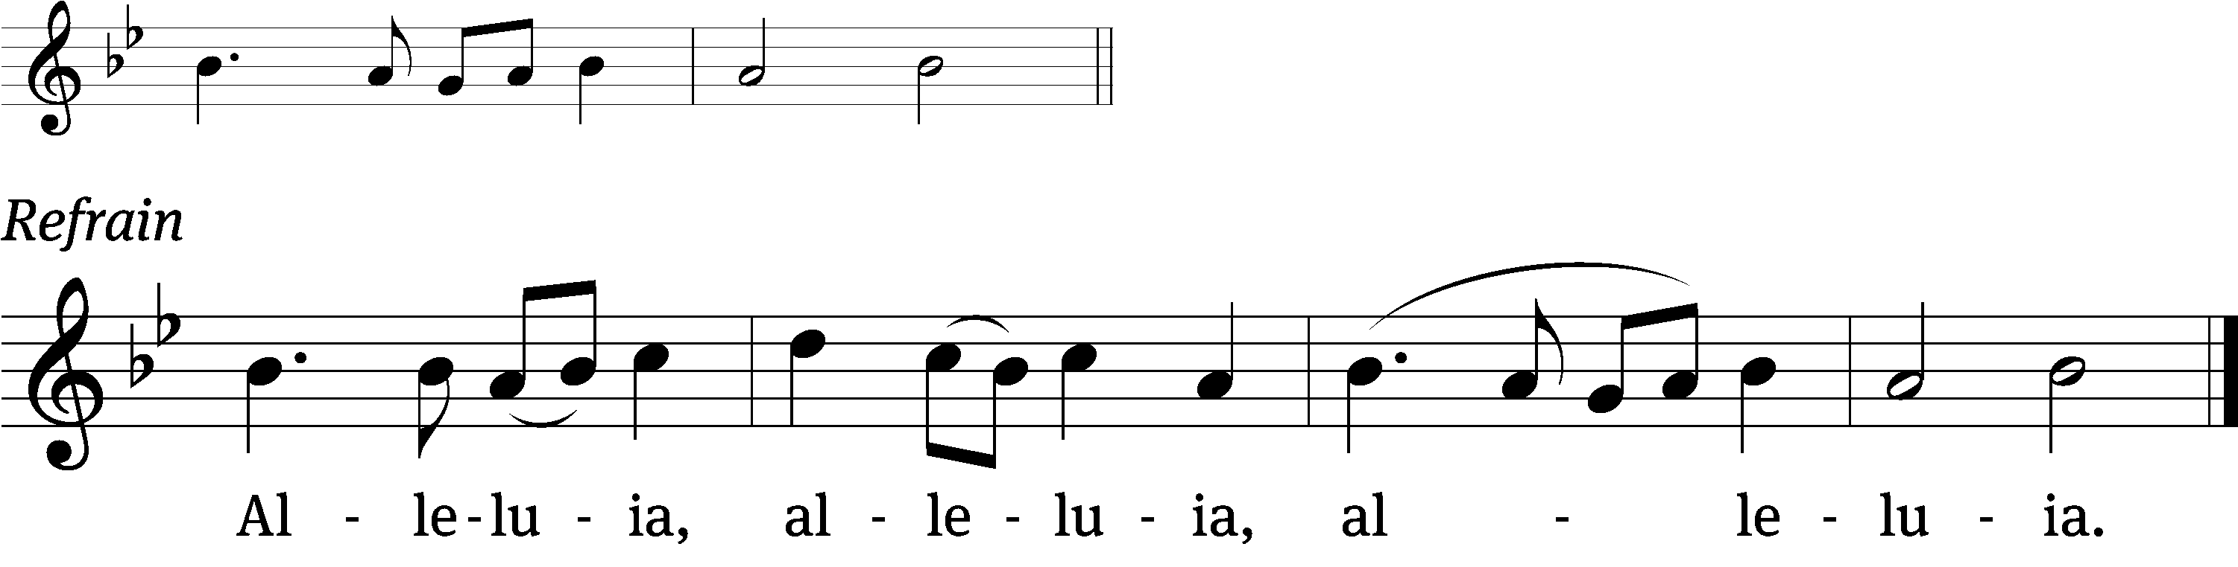
Jesus is the light /of the world:
In him we have the / light of life. (Refrain)

Gospel Reading & Sermon Text: Matthew 5:13-20 (EHV)
“You are the salt of the earth, but if salt has lost its flavor, how will it become salty again? Then it is no good for anything except to be thrown out and trampled on by people. ¹⁴You are the light of the world. A city located on a hill cannot be hidden. ¹⁵People do not light a lamp and put it under a basket. No, they put it on a stand, and it gives light to all who are in the house. ¹⁶In the same way let your light shine in people’s presence, so that they may see your good works and glorify your Father who is in heaven.
¹⁷“Do not think that I came to destroy the Law or the Prophets. I did not come to destroy them but to fulfill them. ¹⁸Amen I tell you: Until heaven and earth pass away, not even the smallest letter, or even part of a letter, will in any way pass away from the Law until everything is fulfilled. ¹⁹So whoever breaks one of the least of these commandments and teaches others to do the same will be called least in the kingdom of heaven. But whoever practices and teaches them will be called great in the kingdom of heaven. ²⁰Indeed I tell you that unless your righteousness surpasses that of the Pharisees and experts in the law, you will never enter the kingdom of heaven.”

Choir Song: We Will Feast in the House of Zion

Sermon Theme: “Be Salt and Light to Follow Jesus.”

Noisy Offering

OFFERING: The offerings are brought forward to the altar.

Keep in Your Prayers: Harley Dorsey, Karen Reiser, Ginny Verch, Gary Wichman and Dick Zellmer.

Announcements
Thank You from Pastor & Sue: Dear members of Mt. Zion- thank you for your generous gift cards to Kwik Trip and Culvers. They will certainly come in handy in our first weeks in La Crosse. May God bless and keep you all until we meet again! Our new address is: 803 Saint Paul St., La Crosse, WI 54603.
Thank You to Ken Hielke for building the beautiful tables located in the back of the sanctuary.
ATTENTION ALL MEMBERS OF MT. ZION: Our vacancy pastor will be Pastor Kurt Hagen of St. John’s in Kingston. Due to a shortage of pastors in our area our services will be held on Saturdays at 5PM beginning TODAY. If you have any questions see Mike Meeker or any member of the Council. The Lenten services will be on Wednesday like normal.

Parents of Mt. Zion Sunday School Children: With the change in time and date of church services, the teachers will be putting together packets for the children to take home and study their lessons. No formal Sunday School will be held until further notice.
Special Announcement: Due to problems in Shepherd’s Staff some of the offering envelopes you picked up are numbered incorrectly. Jo Meeker has a list of what the numbers should be. Please contact her at the church office or in church to get your correct number. Sorry for the inconvenience.

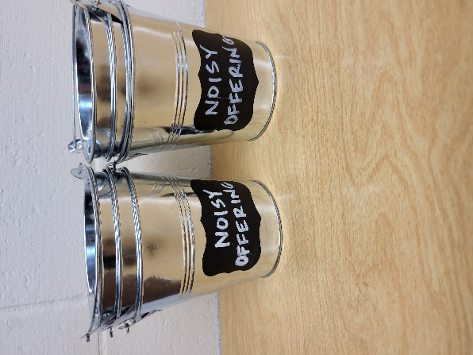
Noisy Offering: Please keep saving your spare change for our noisy offering on TODAY. Your offering will be given to our Befriend a Mission Living Stone Lutheran Church in Arvada CO. Their mission is “Connecting people to Jesus and the community.” Thank you for generous donation of $349.88 to the Vine Lutheran Church. We have appreciated your support for our various projects and activities.


During the month of February will be having a “Souper Bowl” donation. We will be collecting a variety of soups for the Community Food Pantry in Ripon. There is a box in the entryway for your donations. Thank you for your support. The Evangelism Committee
Mailbox and table: The January & February Forward In Christ is available and also the March 1, 2026-May 30, 2026 Meditations are available.

Birthday Celebration: Birthday celebration for February TBD. Join us for fellowship, cake and refreshments.

If you would like the Lord’s Supper privately, please contact Pastor Kurt Hagen at 651-764-3901, or by email pastorkhagen@gmail.com.

The Helping Hands Ministry is ready to serve the needs of our members. Please contact one of the following if you or someone you know needs assistance: Joanne Gregor at 920-896-1518 and Lisa Tremore at 920-229-1297.
For Your Information
Attendance 1/25/2026 129
Offerings for 1/25/2026 $3,150.00

Serving Our Lord

Thank you to everyone for your service to our Lord!

Ushers:

Feb. 7: Dave Smith, Josh Niemuth, Justen Niemuth

Feb. 14 & 18: Mark Roeder, Ferd Roeder, Jason Roeder

PowerPoint:

February 7: Jo Meeker

February 14: Grunert Family

February 18: The Grunerts (Ash Wednesday)

February 21: Jo Meeker

Feb. Communion Set up: Joanne Gregor

Feb. Communion Clean up: Donna Mueller

Saturday (7th) 5:00 PM Worship with Communion
Noisy Offering
Monday (9th) 10:00 AM Mt. Zion Volunteer Day
Tuesday 5:30 Council Meeting
6:30 Ladies Aid Meeting
Wednesday 6:15 PM Choir Practice
Thursday 9:00 AM Women’s Bible Study
Saturday (2/14) 5:00 PM Worship Service with Communion
Sunday 2:00 PM Call Meeting

