THIRD SUNDAY AFTER EPIPHANY

Mt. Zion Evangelical Lutheran Church

320 Mt. Zion Dr., Ripon, WI
www.mtzionripon.org
Facebook: Mt. Zion Evangelical Lutheran Church

Pastor Michael Sheppard
Pastor’s Study: 920-748-9734
E-mail: revmikesheppard@gmail.com
Epiphany 3 Jan. 25, 2026
Handicapped accessible restrooms are located upstairs next to the Pastor’s Study and downstairs next to the elevator.
Attendance: Please remember to sign the friendship pads. Registration for communion will continue as usual at the table. If you have any questions or concerns, please contact Pastor Sheppard or Mike Meeker.


Hearing Loop: Our sanctuary is equipped with a hearing loop system. Those who have compatible hearing aids (with a T-switch) will be able to hear the sound system directly into their ear(s). The two main seating areas and the choir area are looped so that you may sit in any of the three areas. We also have four receivers available for those who do not have compatible hearing aids. If you wish to use a receiver please ask the ushers. Those who wish may bring their own headphones or ear buds.

A note for our visitors on member communion –
Out of sincere love for the truth of God’s Word and for precious human souls, we practice member communion in our synod and congregation. This teaching, as practiced by the Church for centuries, is thoroughly Scriptural. It questions the faith of no individual yet asks that there be full doctrinal agreement between those who commune. For this reason, we ask that only those who are members of a WELS or ELS congregation join us for the Lord’s Supper. If you wish to commune with us please speak with the pastor before the service.
The front row on the pulpit side is reserved for people who are unable to navigate the steps. Pastor will serve you Communion first.

Prayer Before Communion: Dearest Jesus, I marvel that you read and wine of Holy Communion. Touch me with your grace that moved you to reach out to me, a poor, miserable sinner! Use this sacred supper to bring me closer to you. Amen.

Hymns: 689, 904, (670)
Women’s Choir: “Go Now in Peace”
A farewell benediction for Pastor and Sue Sheppard that they go in Peace, Faith and Love-knowing that God will be with them always!

Order of Worship Setting Three pg. 188

First Reading: Isaiah 8:19-9:4 (EHV)
When they tell you, “Consult the mediums and the spiritists, who whisper and mutter,” shouldn’t a people consult their God? Should they consult the dead on behalf of the living? ²⁰To the law and to the testimony! If people do not speak according to this word, there will be no dawn for them. ²¹They will pass through the land, distressed and starving, but when this takes place and they are starving, they will be frustrated, and they will curse their king and their God. They will turn their faces upward, ²²and then they will look down to the ground, but I tell you, they will see only distress, darkness, and the gloom that brings anguish. They will be banished into thick darkness.
^{9:1}Nevertheless, there will be no more gloom for the land that was in anguish. In former times, he humbled the land of Zebulun and the land of Naphtali, but in the latter time he will cause it to be glorious, along the way of the sea, beyond the Jordan, in Galilee of the Gentiles.
²The people walking in darkness have seen a great light.
For those living in the land of the shadow of death, the light has dawned.
³You have multiplied the nation. You have increased its joy.
They rejoice before you like the joy at harvest time,
like the celebration when people divide the plunder.
⁴For you have shattered the yoke that burdened them.
You have broken the bar on their shoulders and
the rod of their oppressor,
as you did in the day of Midian.

Psalm: 27C (Insert) The LORD is My Light and My Salvation

Second Reading: I John 2:3-11 (EHV)
This is how we know that we have known him: if we keep his commands. ⁴The one who says, “I know him,” but does not keep his commands is a liar, and the truth is not in him. ⁵If anyone keeps God’s word, the love of God is truly made complete in him. This is how we know that we are in him: ⁶The one who says he remains in him should walk as Jesus walked.
⁷Dear friends, I am not writing you a new command but an old one that you have had since the beginning. The old command is the message you heard. ⁸At the same time, the command I am writing is new—it is true in Jesus and in you, because the darkness is passing away, and the true light is already shining. ⁹The one who says he is in the light and yet hates his brother is still in the darkness. ¹⁰The one who loves his brother remains in the light, and nothing causes him to stumble. ¹¹The one who hates his brother is in the darkness and walks in the darkness and does not know where he is going, because the darkness has blinded his eyes.

Gospel Acclamation
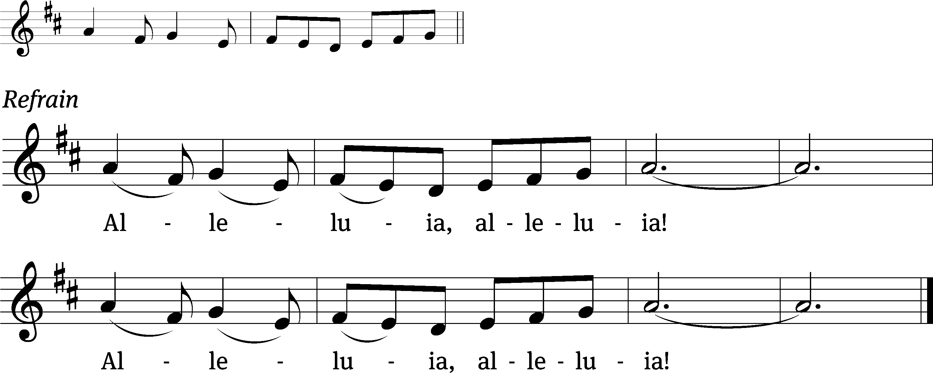
Jesus is the light /of the world:
In him we have the / light of life. (Refrain)
Gospel Reading: Matthew 4:12-23 (EHV)
When Jesus heard that John was put in prison, he withdrew into Galilee. ¹³He left Nazareth and went to live in Capernaum, which is by the sea, in the region of Zebulun and Naphtali. ¹⁴He did this to fulfill what was spoken through the prophet Isaiah:
¹⁵Land of Zebulun and land of Naphtali,
along the way of the sea, beyond the Jordan,
Galilee of the Gentiles,
¹⁶the people dwelling in darkness have seen a great light,
and on those dwelling in the region and the shadow of death a light has dawned.
¹⁷From that time, Jesus began to preach: “Repent, because the kingdom of heaven is near.”
¹⁸As Jesus was walking by the Sea of Galilee, he saw two brothers, Simon, who is called Peter, and his brother Andrew. They were casting a net into the sea, since they were fishermen. ¹⁹He said to them, “Come, follow me, and I will make you fishers of men.”
²⁰They immediately left their nets and followed him. ²¹Going on from there, he saw two other brothers, James the son of Zebedee and his brother John. They were in the boat with their father Zebedee, mending their nets. Jesus called them. ²²Immediately they left the boat and their father and followed him.
²³Jesus traveled throughout Galilee, teaching in their synagogues, preaching the gospel of the kingdom, and healing every disease and every sickness among the people.

Choir Song: I Am Not Alone
This engaging anthem sings of God’s steadfast presence in our lives.

Sermon Text: Hebrews 13:20,21 (EHV)
Now may the God of peace—who brought back from the dead our Lord Jesus, that great Shepherd of the sheep, in connection with his blood, which established the eternal testament.

Sermon Theme: “May the Lord Equip You for Doing His Will!.” (Farewell)

OFFERING: The offerings are brought forward to the altar.

Keep in Your Prayers: Harley Dorsey, Karen Reiser, Ginny Verch, Gary Wichman and Dick Zellmer.

Announcements
Potluck: A potluck dinner will be held TODAY to say goodbye to Pastor and Sue Sheppard. Dinner will be served at 11:15.

Service Announcement: No services will be held on Sunday Feb. 1st.

Offering Statements are available in your church mailboxes, please take yours today.

ATTENTION ALL MEMBERS OF MT. ZION: Our vacancy pastor will be Pastor Kurt Hagen of St. John’s in Kingston. Due to a shortage of pastors our services will be held on Saturdays at 5PM beginning February 7th. If you have any questions see Mike Meeker or any member of the Council. The Lenten services will be on Wednesday like normal.

Parents of Mt. Zion Sunday School Children: With the change in time and date of church services, the teachers will be putting together packets for the children to take home and study their lessons. No formal Sunday School will be held until further notice.

Special Announcement: Due to problems in Shepherd’s Staff some of the offering envelopes you picked up are numbered incorrectly. Jo Meeker has a list of what the numbers should be. Please contact her at the church office or in church to get your correct number. Sorry for the inconvenience.

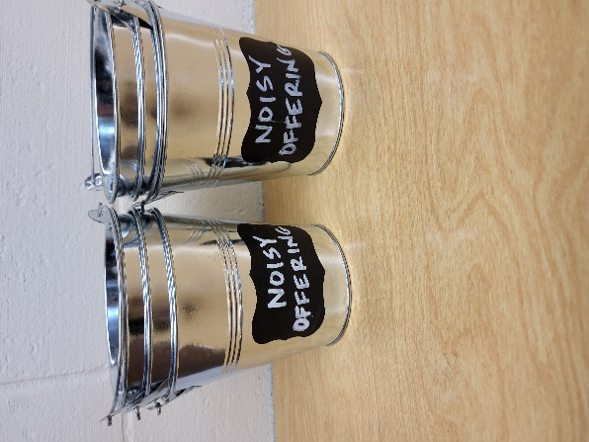
Noisy Offering: Please keep saving your spare change for our noisy offering on Feb. 7th. Your offering will be given to our Befriend a Mission Living Stone Lutheran Church in Arvada CO. Their mission is “Connecting people to Jesus and the community.” Thank you for generous donation of $349.88 to the Vine Lutheran Church. We have appreciated your support for our various projects and activities.


Cereal Request: Mount Zion has received a request from Shannon Wright from the Traded Treasures Community Food Pantry for donations. They are in desperate need for cereal. There is a box in the entryway for your cereal donations. This is a great opportunity for us to reach out to members of our community in need of our help. Thank you for your support. The Evangelism Committee

Mailbox and table: The January & February Forward In Christ is available and also the Nov. 30 2025-Feb. 28, 2026 Meditations are available.

Birthday Celebration: Birthday celebration for February TBD. Join us for fellowship, cake and refreshments.

If you would like the Lord’s Supper privately, please contact Pastor Kurt Hagen at 651-764-3901, or by email pastorkhagen@gmail.com.

The Helping Hands Ministry is ready to serve the needs of our members. Please contact one of the following if you or someone you know needs assistance: Joanne Gregor at 920-896-1518 and Lisa Tremore at 920-229-1297.
For Your Information
Attendance 1/18/2026 78
Offerings for 1/18/2026 $2,104.00
Serving Our Lord

Thank you to everyone for your service to our Lord!

Ushers:

Jan. 25 & Feb. 7: Dave Smith, Josh Niemuth, Justen Niemuth

Feb. 14 & 18: Mark Roeder, Ferd Roeder, Jason Roeder

PowerPoint:

January 25: Jo Meeker

February 7: Jo Meeker

February 14: Grunert Family

February 18: The Grunerts (Ash Wednesday)

Feb. Communion Set up: Joanne Gregor

Feb. Communion Clean up: Donna Mueller

Sunday (25th) 9:00 AM Worship with Communion
10:15 AM Sunday School
11:15 AM Farewell Potluck
Thursday 9:00 AM Women’s Bible Study (Gathering Room)
Sunday (1st) No service
Saturday (2/7) 5:00 PM Worship Service with Communion
Short informational meeting to follow

