SECOND SUNDAY AFTER EPIPHANY
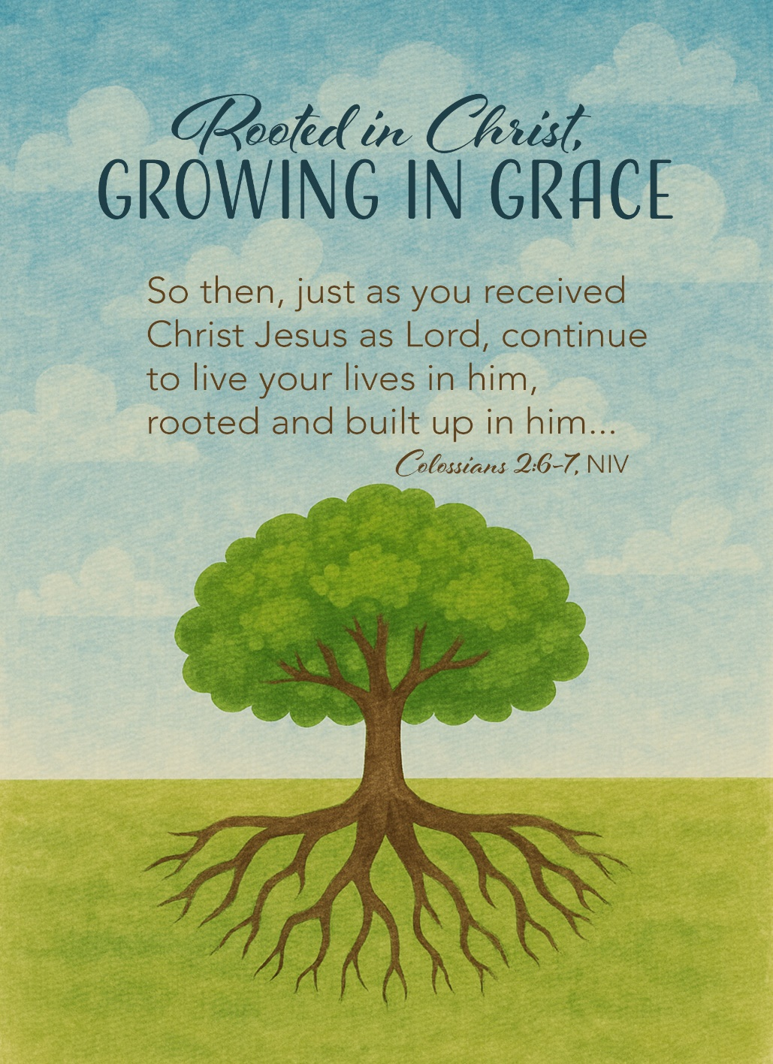
Mt. Zion Evangelical Lutheran Church

320 Mt. Zion Dr., Ripon, WI
www.mtzionripon.org
Facebook: Mt. Zion Evangelical Lutheran Church

Pastor Michael Sheppard
Pastor’s Study: 920-748-9734
E-mail: revmikesheppard@gmail.com
Epiphany 2 Jan. 18, 2026
Handicapped accessible restrooms are located upstairs next to the Pastor’s Study and downstairs next to the elevator.
Attendance: Please remember to sign the friendship pads. Registration for communion will continue as usual at the table. If you have any questions or concerns, please contact Pastor Sheppard or Mike Meeker.


Hearing Loop: Our sanctuary is equipped with a hearing loop system. Those who have compatible hearing aids (with a T-switch) will be able to hear the sound system directly into their ear(s). The two main seating areas and the choir area are looped so that you may sit in any of the three areas. We also have four receivers available for those who do not have compatible hearing aids. If you wish to use a receiver please ask the ushers. Those who wish may bring their own headphones or ear buds.

Hymn Sing: 767, 575 vs 1,2,3,5, 856 vs 1,3,5, 863
Hymns: 510, 375, 803, 798

Order of Worship Setting One pg. 154

First Reading: Isaiah 49:1-6 (EHV)
Listen to me, you coastlands.
Pay attention, you faraway peoples!
The Lord called me from the womb.
When I was inside my mother, he mentioned my name.
²He made my mouth like a sharpened sword.
He hid me in the shadow of his hand.
He made me a polished arrow.
He concealed me in his quiver.
³He said to me, “You are my servant Israel,
in whom I will display my glory.”
⁴But I said to myself, “I have labored in vain.
I spent my strength and came up empty, with nothing.
Yet a just verdict for me rests with the Lord,
and my reward is with my God.”
⁵But now the Lord,
who formed me from the womb to be his servant,
to turn Jacob back to him,
so that Israel might be gathered to him,
so that I will be honored in the eyes of the Lord,
because my God has been my strength—
⁶the Lord said:
It is too small a thing that you should just be my servant
to raise up only the tribes of Jacob
and to restore the ones I have preserved in Israel,
so I will appoint you to be a light for the nations,
so that my salvation will be known to the end of the earth.

Psalm: 40A LORD, Come to My Aid

Second Reading & Sermon Text: Colossians 2:6-15 (EHV)
Therefore, just as you received Christ Jesus as Lord, continue to walk in him, ⁷by being rooted and built up in him, and strengthened in the faith just as you were taught, while you overflow in faith with thanksgiving.
⁸See to it that no one takes you captive through philosophy and empty deceit, which are in accord with human tradition, namely, the basic principles of the world, but not in accord with Christ. ⁹For all the fullness of God’s being dwells bodily in Christ. ¹⁰And you have been brought to fullness in him. Christ is the head over every ruler and authority. ¹¹You were also circumcised in him, with a circumcision not done by human hands, in the putting off of the body of flesh, in the circumcision of Christ, ¹²when you were buried with Christ in baptism. And in baptism you were also raised with him through the faith worked by the God who raised Christ from the dead. ¹³ Even when you were dead in your trespasses and the uncircumcision of your flesh, God made you alive with Christ by forgiving us all our trespasses. ¹⁴ God erased the record of our debt brought against us by his legal demands. This record stood against us, but he took it away by nailing it to the cross. ¹⁵ After disarming the rulers and authorities, he made a public display of them by triumphing over them in Christ.

Gospel Acclamation
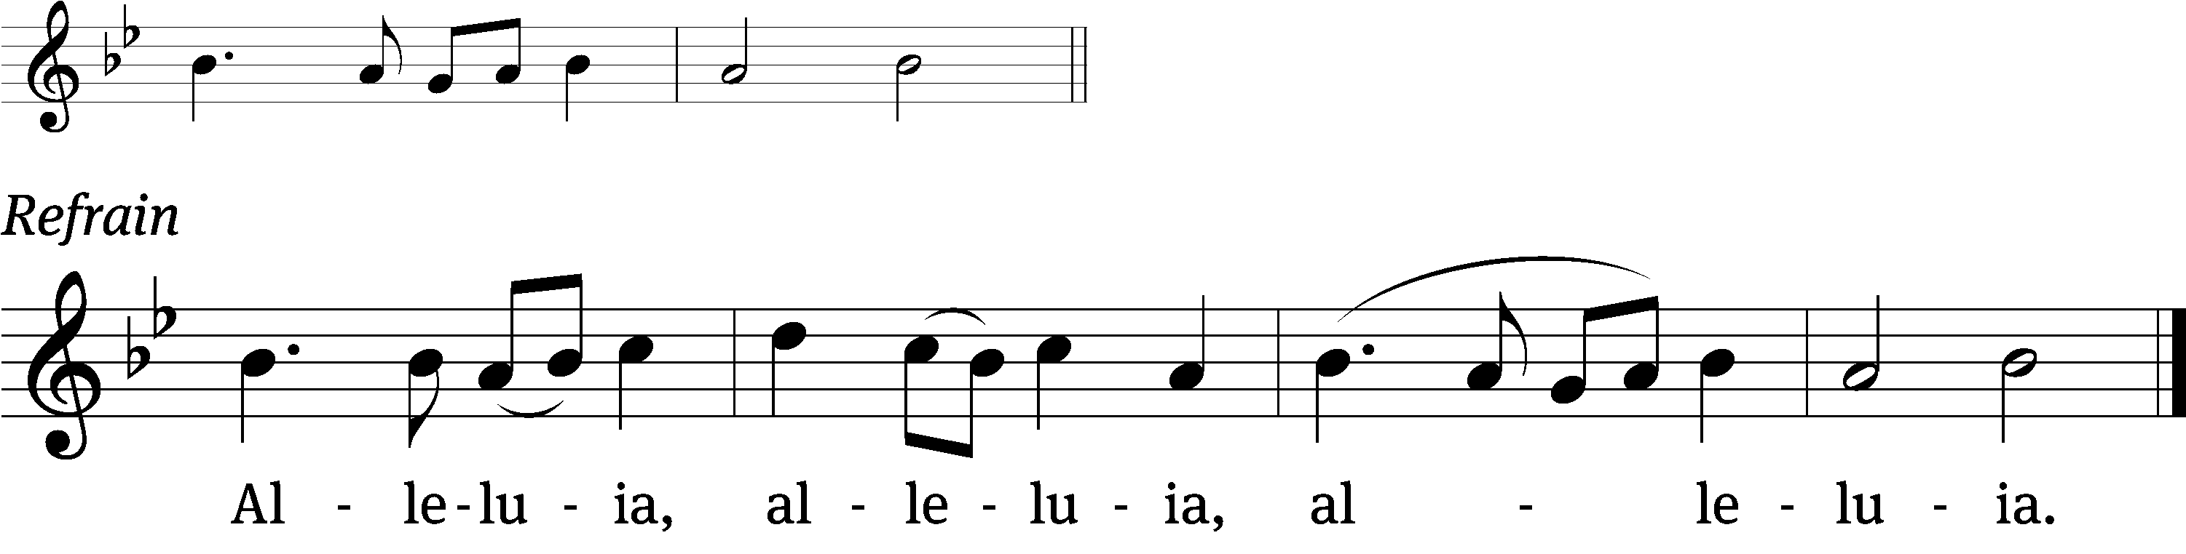
Jesus is the light /of the world:
In him we have the / light of life. (Refrain)

Gospel Reading: John 1:29-41 (EHV)
The next day, John saw Jesus coming toward him and said, “Look! The Lamb of God, who takes away the sin of the world! ³⁰This is the one I was talking about when I said, ‘The one coming after me outranks me because he existed before me.’ ³¹I myself did not know who he was, but I came baptizing with water so that he would be revealed to Israel.”
³²John also testified, “I saw the Spirit descend like a dove from heaven and remain on him. ³³I myself did not recognize him, but the one who sent me to baptize with water said to me, ‘The one on whom you see the Spirit descend and remain, he is the one who will baptize with the Holy Spirit.’ ³⁴I saw this myself and have testified that this is the Son of God.”
³⁵The next day, John was standing there again with two of his disciples. ³⁶When John saw Jesus passing by, he said, “Look! The Lamb of God!” ³⁷The two disciples heard him say this, and they followed Jesus.
³⁸When Jesus turned around and saw them following him, he asked, “What are you looking for?”
They said to him, “Rabbi” (which means “Teacher”), “where are you staying?”
³⁹He told them, “Come, and you will see.” So they came and saw where he was staying. They stayed with him that day. It was about the tenth hour.
⁴⁰Andrew, Simon Peter’s brother, was one of the two who heard John and followed Jesus. ⁴¹The first thing Andrew did was to find his own brother Simon and say to him, “We have found the Messiah!” (which is translated “the Christ”).

Sermon Theme: “Continue to Walk in Christ Jesus.”

OFFERING: The offerings are brought forward to the altar.

Keep in Your Prayers: Harley Dorsey, Karen Reiser, Ginny Verch, Gary Wichman and Dick Zellmer.

Announcements
ATTENTION ALL MEMBERS OF MT. ZION: Our vacancy pastor will be Pastor Kurt Hagen of St. John’s in Kingston. Due to a shortage of pastors our services will be held on Saturdays at 5PM beginning February 7th. No decision has been made concerning Sunday School. If you have any questions see Mike Meeker or any member of the Council. The Lenten services will be on Wednesday like normal.

Hymn Sing: Today’s hymn sing will begin at approximately 8:45am. Whether hymn sings will continue during the vacancy is yet to be determined.

Special Announcement: Due to problems in Shepherd’s Staff some of the offering envelopes you picked up are numbered incorrectly. Jo Meeker has a list of what the numbers should be. Please contact her at the church office or in church to get your correct number. Sorry for the inconvenience.

The Annual Voter’s Meeting will held TODAY immediately after the service.

Potluck: A potluck dinner is being planned for Sunday January 25th to say goodbye to Pastor and Sue Sheppard.

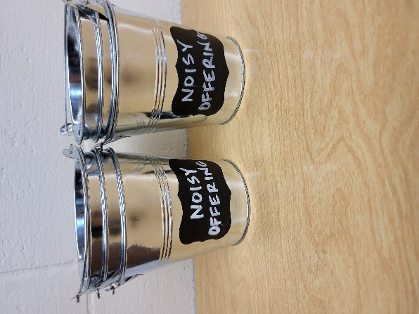
Noisy Offering: Please keep saving your spare change for our noisy offering on Feb. 1st. Your offering will be given to our Befriend a Mission Living Stone Lutheran Church in Arvada CO. Their mission is “Connecting people to Jesus and the community.” Thank you for generous donation of $349.88 to the Vine Lutheran Church. We have appreciated your support for our various projects and activities.

Shut-in Visits: We are hoping to start a program to make sure all our shut-ins are receiving consistent visits from members here at church. If you would like to coordinate a schedule to plan monthly visits or if you would like to volunteer to visit a shut-in please see the sign-up sheet on the table by the office.


Cereal Request: Mount Zion has received a request from Shannon Wright from the Traded Treasures Community Food Pantry for donations. They are in desperate need for cereal. There is a box in the entryway for your cereal donations. This is a great opportunity for us to reach out to members of our community in need of our help. Thank you for your support. The Evangelism Committee

Mailbox and table: The January Forward In Christ is available and also the Nov. 30 2025-Feb. 28, 2026 Meditations are available.

Birthday Celebration: Birthday celebration for February TBD. Join us for fellowship, cake and refreshments.

If you would like the Lord’s Supper privately, please contact Pastor Sheppard on his cell 920-745-0883, or by email revmikesheppard@gmail.com.
The Helping Hands Ministry is ready to serve the needs of our members. Please contact one of the following if you or someone you know needs assistance: Joanne Gregor at 920-896-1518 and Lisa Tremore at 920-229-1297.
For Your Information
Attendance 1/11/2026 89
Offerings for 1/11/2026 $2,577.00

Serving Our Lord

Thank you to everyone for your service to our Lord!

Ushers:

Jan. 18: Ken Hielke, Todd Zellmer, Jonathan Zellmer, Dustin Zellmer

Jan. 25 & Feb. 1: Dave Smith, Josh Niemuth, Justen Niemuth

PowerPoint:

January 18: Jan Ohlrich

January 25: Jo Meeker

February 1: Grunert Family

February 8: Jo Meeker

Jan. Communion Set up: Joanne Gregor

Jan. Communion Clean up: Donna Mueller

Sunday (18th) 8:45 Hymn Sing
9:00 AM Worship
10:15 AM Sunday School & Annual Voters’ Meeting
5:00 PM Confirmation Class
Tuesday 9:00 Bible Study
Wednesday 6:15 PM Choir Practice
Thursday 9:00 AM Women’s Bible Study (Gathering Room)
Sunday 9:00 AM Worship Service with Communion
10:15 AM Sunday School
11:00 AM Farewell Potluck Dinner for the Sheppards

