EIGHTEENTH SUNDAY OF PENTECOST
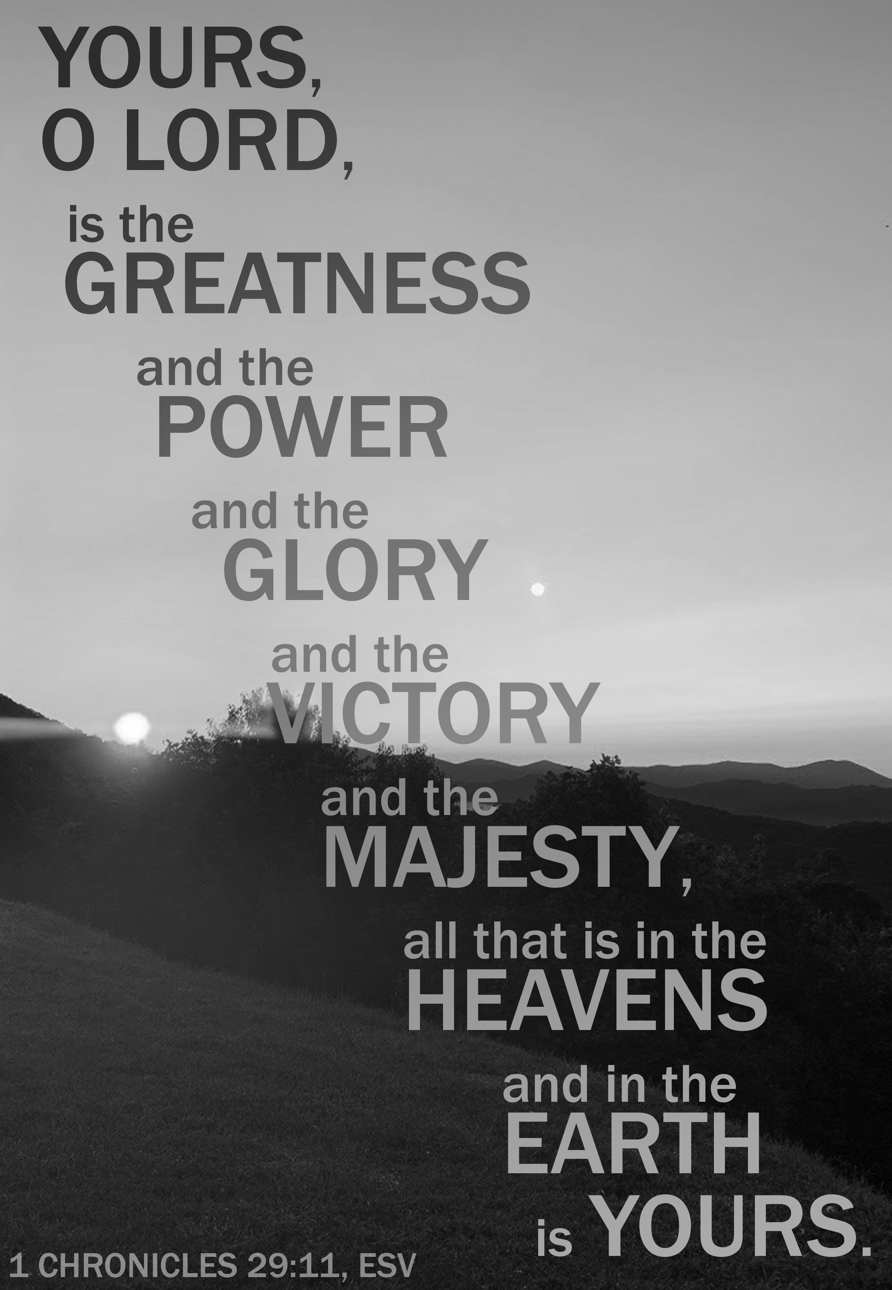
Mt. Zion Evangelical Lutheran Church

320 Mt. Zion Dr., Ripon, WI
www.mtzionripon.org
Facebook: Mt. Zion Evangelical Lutheran Church

Pastor Michael Sheppard
Pastor’s Study: 920-748-9734
E-mail: revmikesheppard@gmail.com
18th Sunday of Pentecost Oct. 5, 2025
Handicapped accessible restrooms are located upstairs next to the Pastor’s Study and downstairs next to the elevator.
Attendance: Please remember to sign the friendship pads. Registration for communion will continue as usual at the table. If you have any questions or concerns, please contact Pastor Sheppard or Mike Meeker.


Hearing Loop: Our sanctuary is equipped with a hearing loop system. Those who have compatible hearing aids (with a T-switch) will be able to hear the sound system directly into their ear(s). The two main seating areas and the choir area are looped so that you may sit in any of the three areas. We also have four receivers available for those who do not have compatible hearing aids. If you wish to use a receiver please ask the ushers. Those who wish may bring their own headphones or ear buds.

Peace Children: Thank you to the children from Peace Lutheran School for beautifying our service this morning.

Hymns: 726, 748, 750

Order of Worship Morning Prayer pg. 207

Psalm: 62D (Insert) I’ll Not Be Shaken
Peace Children: The Lord is My Salvation

Reading 2 Thessalonians 1:1-5,11,12 (EHV)
Paul, Silas, and Timothy,
To the church of the Thessalonians in God our Father and the Lord Jesus Christ:
²Grace to you and peace from God our Father and the Lord Jesus Christ.
³We are always obligated to thank God for you, brothers, as is fitting, because your faith is growing more and more, and the love that each and every one of you has for one another is increasing. ⁴So we ourselves boast about you in God’s churches in regard to your patient endurance and faith in all your persecutions and in the trials that you are enduring. ⁵This is evidence of God’s righteous verdict that resulted in your being counted worthy of God’s kingdom, for which you also suffer.
¹¹For this reason, we are always praying for you, that our God will make you worthy of your calling and use his power to fulfill every good desire and work of your faith, ¹²so that the name of our Lord Jesus Christ may be glorified in you and you in him, in keeping with the grace of our God and Lord Jesus Christ.

Gospel: Luke 17: 1-10 (EHV)
Jesus said to his disciples, “Temptations to sin are sure to come, but woe to the one through whom they come! ²It would be better for that person if a millstone would be hung around his neck and he would be thrown into the sea than for him to cause one of these little ones to sin. ³Watch yourselves.
“If your brother sins, rebuke him. If he repents, forgive him. ⁴Even if he sins against you seven times in a day, and seven times returns to you and says, ‘I repent,’ forgive him.”
⁵The apostles said to the Lord, “Increase our faith.”
⁶The Lord said, “If you had faith like a mustard seed, you could tell this mulberry tree, ‘Be uprooted and planted in the sea,’ and it would obey you. ⁷Which one of you who has a servant plowing or taking care of sheep will say to him when he comes in from the field, ‘Come at once and recline at the table’? ⁸Won’t the master tell him instead, ‘Prepare my supper, and after you are properly dressed, serve me while I eat and drink. After that you may eat and drink’? ⁹He does not thank the servant because he did what he was commanded to do, does he? ¹⁰So also you, when you have done all that you were commanded, say, ‘We are unworthy servants. We have only done what we were supposed to do.’”

Children’s Sermon

Sermon Text: I Chronicles 29:1,2,10-18 (EHV)
King David said this to the whole assembly:
My son Solomon, the one God has chosen, is young and inexperienced. The work is great because this citadel is not for a man. It is for the Lord God. ²According to all my strength, I have provided these things for the house of my God: gold for the gold items, silver for the silver, bronze for the bronze, iron for the iron, wood for the wooden, onyx stones and settings, antimony, stones of many different colors, every kind of precious stone, and alabaster in abundance.
¹⁰David blessed the Lord in the presence of the entire assembly. He said:
Blessed are you, Lord, the God of Israel, our father, from eternity to eternity. ¹¹To you, O Lord, belong greatness, power, glory, victory, and majesty, because everything in the heavens and on the earth belongs to you. You, Lord, are exalted as head above everything. The kingdom belongs to you. ¹²Riches and honor come from you. You are ruling over everything. In your hand are power and strength. It is in your power to make anyone great and strong. ¹³Now, our God, we are thanking you and praising your glorious name.
¹⁴Who am I? Who are my people that we are able to offer willingly like this? For everything comes from you. What we have given to you came from your hand. ¹⁵We are aliens and temporary residents before you, as were all our fathers. Our days on the earth are like a shadow, and there is no hope of staying.
¹⁶Lord, our God, all this abundance, which we have provided for building a house for you, for your holy name, is from your hand. This abundance belongs to you.
¹⁷I know, my God, that you test the heart, and you take pleasure in uprightness. In the uprightness of my heart I have freely offered all these things. Now with joy I see your people, who are present here to bring the offering freely to you.
¹⁸Lord, the God of our fathers, Abraham, Isaac, and Israel, preserve forever this purpose and way of thinking in the heart of your people. Direct their heart to you.

Sermon Theme: “The Upright Heart Brings Gifts Freely to the Lord.”

OFFERING: The offerings are brought forward to the altar.

Keep in Your Prayers: Harley Dorsey, Carol Henning, Karen Reiser, Gary Wichman and Dick Zellmer.

Peace Children: So Much, So Worth It

Announcements
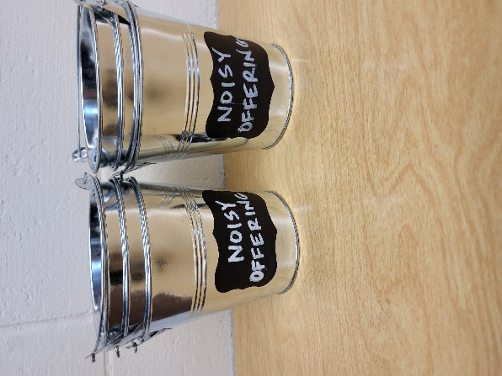
Today’s noisy offering will be given to WLA (Winnebago Lutheran Academy). We have appreciated your support for our various projects and activities. Thank you for your generosity.

New Member Welcome and Pine Car Derby: Mt. Zion will have a potluck dinner after church today for our newest members. We will welcome Jim and Deb Paulus, Judy Doll, Michelle Doll and David Thiele and Matt and Ethel Behm. Join us after Bible Study and Sunday School for the meal and pine car derby.

The Tapestry is Back: Carol Kapp’s Lord Supper Tapestry has been moved back to the fellowship hall and is ready for volunteers to work on it again. Starting Oct. 7th there will be someone to help with the tapestry on Tuesday afternoons from 1-3 and on Thursday mornings from 10:30-12. If these times don’t work for you, you can come in the mornings when Jo is working (Mon., Tues., Wed.,) using the front entrance. Please be sure to let Jo know you are there to work on the tapestry. Finally, if you have a key, you can work on the tapestry whenever it works into your schedule. We are looking for more volunteers. If you don’t know how to latch hook, Sue Sheppard or Joanne Gregor would be willing to help you learn. Looking forward to working with you to complete the Lord Supper tapestry Carol Kapp started. God’s Blessings!

Hymn Sing: The next hymn sing will be next Sunday, October 12th. If you have any requests for future hymn sings please talk to Sue Sheppard or Jo Meeker.

LWMS Rally: On October 18th St. Stephens of Beaver Dam will be hosting the Fall Rally. To those women who have been working on the plastic crosses for LWMS, please return them to the church by Oct. 16th. There is a basket on the table outside the office. They do not have to be completed with the ribbon; we will take them along to the Fall Rally.

Mission Festival: On October 19th Pastor Abram Degner will be here to preach on the WELS 175th Anniversary, Christ THROUGH Us. Following the service, he will make a presentation in the fellowship hall. We will then join in a potluck dinner. No Sunday School or Bible Study will be held that Sunday.

Birthday Celebration: The October birthday celebration will be October 26th, in the fellowship hall.

Friendly Reminder: Children’s offering envelopes and children’s bulletins are available on the back table. The prayer box is also there for any prayer requests.

Greeters: Thank you to all who have greeted so far. A new signup sheet for August through December is available. If you would like to be greeters for this year, please sign up on the sheet on the podium by the library.

Mailbox and table: The October Forward In Christ is available and also the August 31, 2025-November 29, 2025 Meditations are available.

If you would like the Lord’s Supper privately, please contact Pastor Sheppard on his cell 920-745-0883, or by email revmikesheppard@gmail.com.
The Helping Hands Ministry is ready to serve the needs of our members. Please contact one of the following if you or someone you know needs assistance: Joanne Gregor at 920-896-1518, Lisa Tremore at 920-229-1297 or Tammy Niemuth at 920-299-0240.

For Your Information
Attendance 9/28 102
Offerings for 9/28 $3,698.00

Serving Our Lord

Thank you to everyone for your service to our Lord!

Ushers:

Oct. 5 & 12: Gary Quade, Travis Schmudlach, Kyle Stollfuss

Oct. 19 & 26: Steve Ohlrich, Derek Chitwood, Alex Kranz

PowerPoint:

October 5: Grunert Family

October 12: Jean Lynch

Oct.19: Jan Ohlrich

Oct. 26: Judy Doll

Oct. Communion Set up: Jo Meeker

Oct. Communion Clean up: Marilyn Ninneman & Tammy Niemuth

Sunday (5th) 9:00 AM Worship Service with the Peace children singing, Noisy Offering and Children’s Sermon
10:15 AM Sunday School; Bible Study
11:15 AM New member potluck and Pine car Derby
5:00 PM Confirmation Class
Monday 6:00 PM Evangelism Committee Mtg.
Tuesday 9:00 AM Bible Study (book of John)
Thursday 9:00 AM Women’s Bible Study (Fellowship Hall)
Friday 1:00 PM Movie “I Can Only Imagine”
Saturday 9:30 AM -11 Junior Youth Group
Sunday 8:45 AM Hymn Sing
9:00 AM Worship Service with Communion
10:15 AM Pre-Voter’s Meeting
10:15 AM Sunday School
5:00 PM Confirmation Class

