Seventh Sunday of Easter
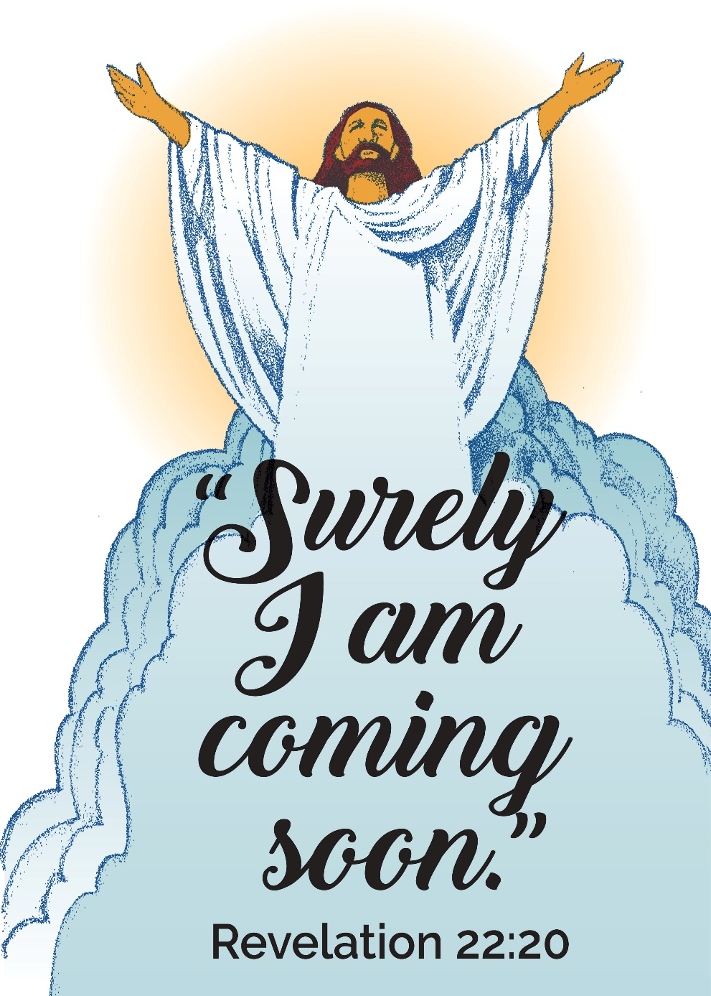

Mt. Zion Evangelical Lutheran Church
320 Mt. Zion Dr., Ripon, WI
www.mtzionripon.org
Facebook: Mt. Zion Evangelical Lutheran Church

Pastor Michael Sheppard
Pastor’s Study: 920-748-9734
E-mail: revmikesheppard@gmail.com
Easter 7 May 26 & 29, 2022

Welcome to Mt. Zion!
Handicapped accessible restrooms are located upstairs next to the Pastor’s Study and downstairs next to the elevator.
Attendance: Please remember to sign the friendship pads. Registration for communion will continue as usual at the table. If you have any questions or concerns please contact Pastor Sheppard or Mark Roeder.

Please feel free to ask Pastor Sheppard any questions you may have concerning COVID-19. May the Lord be with us as we worship together at church. (The services will continue to be posted on Facebook, Rumble, and the church website, and available on DVD.)

Hearing Loop: Our sanctuary is equipped with a hearing loop system. Those who have compatible hearing aids (with a T-switch) will be able to hear the sound system directly into their ear(s). The two main seating areas and the choir area are looped so that you may sit in any of the three areas. We also have four receivers available for those who do not have compatible hearing aids. If you wish to use a receiver please ask the ushers. Those who wish may bring their own headphones or ear buds.

A note for our visitors on member communion –
Out of sincere love for the truth of God’s Word and for precious human souls, we practice member communion in our synod and congregation. This teaching, as practiced by the Church for centuries, is thoroughly Scriptural. It questions the faith of no individual yet asks that there be full doctrinal agreement between those who commune. For this reason, we ask that only those who are members of a WELS or ELS congregation join us for the Lord’s Supper. If you wish to commune with us please speak with the pastor before the service.
The front row on the pulpit side is reserved for people who are unable to navigate the steps. Pastor will serve you Communion first.

Prayer Before Communion: Dearest Jesus, I marvel that you came to this earth as the Word made flesh. With similar awe I contemplate how you give me your body and blood in the bread and wine of Holy Communion. Touch me with your grace that moved you to reach out to me, a poor, miserable sinner! Use this sacred supper to bring me closer to you. Amen.

Hymns: 902, 446, 660, 746 vs 1, 7, 3

Order of Worship: Setting One CW21 Pg. 154

First Reading & Sermon Text: Acts 16: 6-10 (EHV)
They went through the region of Phrygia and Galatia, because they were prevented by the Holy Spirit from speaking the word in the province of Asia. ⁷When they went as far as Mysia, they tried to go into Bithynia, but the Spirit of Jesus did not allow them. ⁸So they passed by Mysia and went down to Troas. ⁹A vision appeared to Paul during the night. A Macedonian man was standing there, urging him, “Come over to Macedonia and help us!” ¹⁰As soon as he had seen the vision, we immediately made plans to proceed to Macedonia, because we concluded that God had called us to preach the good news to them.

Oh, How Good and Pleasant It Is (Responsive Reading) Insert

Second Reading: Revelation 22: 12-17, 20 (EHV)
Look, I am coming soon and my reward is with me, to repay each one according to what he has done. ¹³I am the Alpha and the Omega, the First and the Last, the Beginning and the End. ¹⁴Blessed are those who wash their robes, so that they may have the right to the Tree of Life and so that they may enter through the gates into the city. ¹⁵Outside are the dogs, that is, the sorcerers, the adulterers, the murderers, the idolaters, and everyone who loves and practices falsehood.
¹⁶I, Jesus, have sent my angel to give you this testimony for the churches. I am the Root and the Offspring of David, the bright Morning Star.
¹⁷The Spirit and the bride say, “Come.” And let the one who hears this say, “Come.” And let the one who is thirsty come. Let the one who wants the water of life take it as a gift.
²⁰The one who testifies about these things says, “Yes, I am coming soon.”
Amen. Come, Lord Jesus!

Gospel: John 17: 20-26 (EHV)
“I am praying not only for them, but also for those who believe in me through their message. ²¹May they all be one, as you, Father, are in me, and I am in you. May they also be one in us, so that the world may believe that you sent me. ²²I have given them the glory you gave me, so that they may be one, as we are one: ²³I in them, and you in me. May they become completely one, so that the world may know that you sent me and loved them even as you loved me.
²⁴“Father, I want those you have given me to be with me where I am so that they may see my glory—the glory you gave me, because you loved me before the world’s foundation. ²⁵Righteous Father, the world did not know you, but I knew you, and these men knew that you sent me. ²⁶I made your name known to them and will continue to make it known, so that the love you have for me may be in them, and that I may be in them.”

The Holy Bible, Evangelical Heritage Version® (EHV®)
copyright © 2018 The Wartburg Project. All rights reserved. www.wartburgproject.org

Sermon Theme: “The Gospel Is Preached In The World.”

OFFERING: The offerings are brought forward to the altar.

Please remember in your prayers: Ted Machmueller & Benjie Niemuth

Announcements
Mark your calendar for Sunday, June 12th
Who: All members of Mt. Zion
What: Pie and Ice Cream Social
When: After church on Sunday June 12th
Where: Church fellowship hall
You may eat in the fellowship hall or take the wonderful dessert home and enjoy at your leisure. Please stop down have a piece of pie with or without ice cream. Yum!!!!!!!
A Free will offering will be accepted for the Lutheran Women’s Missionary Society Send One Sister (SOS) Fund. Send One Sister (SOS) was designed to give a woman, who might not otherwise be able to attend a national convention because of financial reasons, a chance to attend her first convention by using SOS funds. Mt Zion ladies would like to help the Beaver Dam LWMS Circuit send a few women to the convention in La Crosse in 2023.
Kids C.A.R.E. The 2021-2022 Kids C.A.R.E. project, Outreach to Roma, has come to an end. Mt. Zion contributed $564. Thank you so much for your generosity which will help our Bulgarian missionaries share the gospel message with the Roma people. Please continue to keep Kids C.A.R.E. in your prayers.
Bus Trip: The Zion/St.John’s Fellowship Travel Group is hosting a WELS Fellowship Road trip in August to Washington DC. Only 8 seats are available. See the information and itinerary sheet on the bulletin board by the office. Or take one home.
Red Hymnals: It was decided that whoever would like to take one or more old hymnals home may do so at no cost. They are located on the table by the entrance to the sancuary. Please feel free to take.

May is Mental Health Month. When we pray for help in our emotional or spiritual distress, God’s answer may come in the form of a Christian mental health professional who offers Christ-centered counsel. Christian Family Solutions is a trusted resource for Christ-centered mental health care. CFS has 110 mental health professionals on staff who offer outpatient counseling, plus more intensive treatment programs for those with a higher level of need. To learn more or to find helpful mental health resources visit ChristianFamilySolutions.org.
Birthday Celebration: Cake will be served to celebrate the birthdays for June.
Mailbox and table: The June Forward In Christ is available and also the May 29th, 2022-August 27th, 2022 Meditations are available.
If you would like the Lord’s Supper privately, please contact Pastor Sheppard on his cell 920-745-0883, or by email revmikesheppard@gmail.com.

The Helping Hands Ministry is ready to serve the needs of our members. Please contact one of the following if you or someone you know needs assistance: Joanne Gregor at 920-896-1518, Lisa Tremore at 920-229-1297 or Tammy Niemuth at 920-299-0240.

For Your Information
Attendance 5/19 - 5/22/2022 94
Offerings for 5/19 - 5/22/2022: $2,404.00

Serving Our Lord

Thank you to everyone for your service to our Lord!

Ushers:

May 29 & June 5: Tobin Storzer, Rick Retelle, Kelly Frank

June 12 & 19: Dennis Scott, Dave Patchett, Dawson Niemuth, Rick Niemuth

PowerPoint:

May 26: Jo Meeker

May 29: Jan Olrich

June 30: Jo Meeker

July 3: Arjeta Rushani

June Communion Set up: Mary Clement

June Communion Clean up: Paul & Peggy Walkowicz

This week at Mt. Zion
Sunday (29th) 9:00 AM Worship with Communion
Wednesday Bus Trip, Church Office Closed
Thursday 9:00 AM Church Office Open
6:30 PM Worship
Sunday 9:00 AM Worship

Secretary Jo Meeker
Church Office: 920-748-5641
Office Hours: Mon. 9-12, Tues. & Wed. 9-11
E-mail: mountzionripon@gmail.com

Acknowledgments
Unless otherwise indicated, Scripture quotations are from The Holy Bible, New International Version®, NIV®. Copyright © 1973, 1978, 1984, 2011 by Biblica, Inc.TM Used by permission of Zondervan. All rights reserved worldwide.
Software distributed in partnership with Northwestern Publishing House.
Created by Christian Worship: Service Builder © 2022 Concordia Publishing House.

