SEVENTH SUNDAY OF EASTER
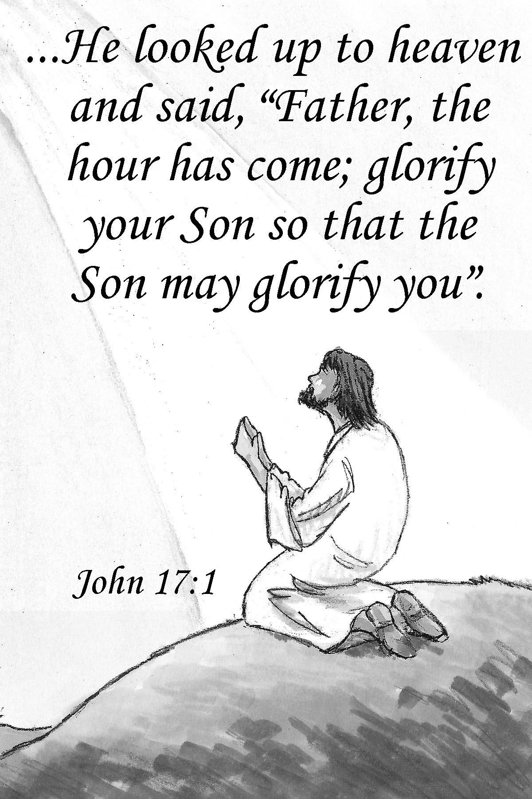
Mt. Zion Evangelical Lutheran Church

320 Mt. Zion Dr., Ripon, WI
www.mtzionripon.org
Facebook: Mt. Zion Evangelical Lutheran Church

Pastor Kurt Hagen (Vacancy Pastor)
Phone 651-764-3901
pastorhagen@gmail.com

7th Sunday of Easter May 16, 2026
Handicapped accessible restrooms are located upstairs next to the Pastor’s Study and downstairs next to the elevator.
Attendance: Please remember to sign the friendship pads. Registration for communion will continue as usual at the table. If you have any questions or concerns, please contact Mike Meeker.


Hearing Loop: Our sanctuary is equipped with a hearing loop system. Those who have compatible hearing aids (with a T-switch) will be able to hear the sound system directly into their ear(s). The two main seating areas and the choir area are looped so that you may sit in any of the three areas. We also have four receivers available for those who do not have compatible hearing aids. If you wish to use a receiver please ask the ushers. Those who wish may bring their own headphones or ear buds.

A note for our visitors on member communion –
Out of sincere love for the truth of God’s Word and for precious human souls, we practice member communion in our synod and congregation. This teaching, as practiced by the Church for centuries, is thoroughly Scriptural. It questions the faith of no individual yet asks that there be full doctrinal agreement between those who commune. For this reason, we ask that only those who are members of a WELS or ELS congregation join us for the Lord’s Supper. If you wish to commune with us please speak with the pastor before the service. The Lord’s Supper will be celebrated for those who desire it. The front row on the pulpit side is reserved for people who are unable to navigate the steps. Pastor will serve you Communion first.

Prayer Before Communion: Lord Jesus, I thank you for the gift of your Holy Supper. As I come to your table, work true repentance in my heart. Teach me to confess my sins and to believe that I am forgiven for your sake. May your body and blood, in and with the bread and wine, nourish my faith and strengthen my will to live in a way that is pleasing to you. Help me see what a blessing your sacrament is for my soul, and lead me to your altar often to receive your forgiveness. Amen.

Hymns: 700, 446, (550), 715

Pastor Hagen is conducting this evening’s service.
Guest Organist is Adah Hagen

Order of Worship Setting One pg. 154

First Reading: Acts 1:12-26 (EHV)
Then they returned to Jerusalem from the mountain called the Mount of Olives, which is near Jerusalem, a Sabbath day’s journey away.
¹³When they entered the city, they went to the upstairs room where they were staying. Peter and John were there, also James and Andrew, Philip and Thomas, Bartholomew and Matthew, James the son of Alphaeus, Simon the Zealot, and Judas the son of James. ¹⁴All of them kept praying together with one mind, along with the women, with Mary the mother of Jesus, and with his brothers.
¹⁵In those days, when the group there numbered about 120 people, Peter stood up among the brothers and said, ¹⁶“Gentlemen, brothers, the Scripture had to be fulfilled, which the Holy Spirit spoke long ago through the mouth of David about Judas, who became a guide for those who arrested Jesus. ¹⁷Judas was counted as one of us and was given a share in this ministry.
¹⁸“Now this man acquired a field with what he was paid for his wicked act. When he fell headfirst, his middle burst open, and all his intestines spilled out. ¹⁹This became known to all the residents of Jerusalem, and so in their own language that field was called Akeldema, which means Field of Blood. ²⁰Indeed, it is written in the book of Psalms:
May his residence be deserted.
Let there be no one dwelling in it.
And,
let someone else take his position.
²¹“Therefore it is necessary that one of the men who accompanied us during the entire time that the Lord Jesus went in and out among us, ²²beginning from his baptism by John until the day Jesus was taken up from us, become a witness with us of his resurrection.”
²³They proposed two: Joseph called Barsabbas (who was also called Justus) and Matthias. ²⁴Then they prayed, “Lord, you know everyone’s heart. Show us which of these two you have chosen ²⁵to take the place in this apostolic ministry from which Judas turned away to go to his own place.”
²⁶Then they assigned lots for them, and the lot fell to Matthias. So he was counted with the eleven apostles.

Psalm: 124A Our Help Is in the Name of the LORD

Second Reading: I Peter 4:12-17, 5:6-11 (EHV)
Dear friends, do not be surprised by the fiery trial that is happening among you to test you, as if something strange were happening to you. ¹³Instead rejoice whenever you are sharing in the sufferings of Christ, so that you may rejoice and be glad when his glory is revealed.
¹⁴If you are insulted in connection with the name of Christ, you are blessed, because the Spirit of glory and of God rests on you. ¹⁵Make sure that none of you suffers as a murderer, a thief, a criminal, or as a meddler. ¹⁶But if you suffer for being a Christian, do not be ashamed, but praise God in connection with this name. ¹⁷For the time has come for judgment to begin with the household of God. Now if it begins with us, what will be the end for those who disobey the gospel of God?
^{5:6}Therefore humble yourselves under God’s powerful hand so that he may lift you up at the appointed time. ⁷Cast all your anxiety on him, because he cares for you. ⁸Have sound judgment. Be alert. Your adversary, the Devil, prowls around like a roaring lion, looking for someone to devour. ⁹Resist him by being firm in the faith. You know that the same kinds of sufferings are being laid on your brotherhood all over the world.
¹⁰After you have suffered a little while, the God of all grace, who called you into his eternal glory in Christ Jesus, will himself restore, establish, strengthen, and support you. ¹¹To him be the glory and the power forever and ever. Amen.
Gospel Acclamation
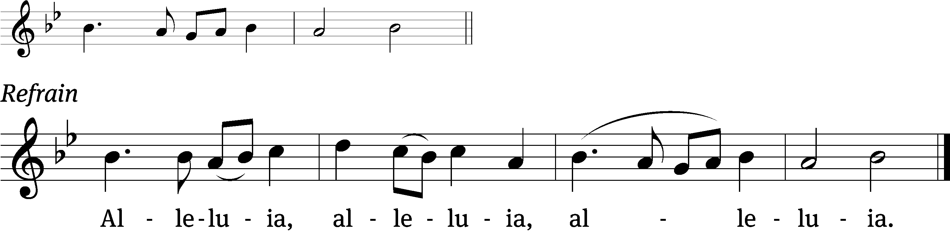
Surely I am with you /always.
To the very end /of the age. (Refrain)

Gospel Reading & Sermon Text: John 17:1-11 (EHV)
After Jesus had spoken these things, he looked up to heaven and said, “Father, the time has come. Glorify your Son so that your Son may glorify you. ²For you gave him authority over all flesh, so that he may give eternal life to all those you have given him. ³This is eternal life: that they may know you, the only true God, and Jesus Christ, whom you sent. ⁴I have glorified you on earth by finishing the work you gave me to do. ⁵Now, Father, glorify me at your own side with the glory I had at your side before the world existed.
⁶“I revealed your name to the men you gave me out of the world. They were yours; you gave them to me, and they have held on to your word. ⁷Now they know that everything you have given me comes from you. ⁸For I gave them the words you gave me, and they received them. They learned the truth that I came from you. They believed that you sent me.
⁹“I pray for them. I am not praying for the world, but for those you have given me, because they are yours. ¹⁰All that is mine is yours, and what is yours is mine. And I am glorified in them. ¹¹I am no longer going to be in the world, but they are still in the world, and I am coming to you.”

Sermon Theme: “Receive Jesus’ Gifts to Stay Faithful to Him.”

OFFERING: The offerings are brought forward to the altar.

Keep in Your Prayers: Harley Dorsey, Matt Dubey, Carol Henning, Nancy Kemnitz, Ginny Verch, Gary Wichman.

Rite of Confirmation (insert): Cooper Johnson. Please welcome him into the Mt. Zion family.

Announcements
Celebrating Our Graduates: We joyfully recognize and celebrate our graduates this month: Christian Grunert from Ripon College, Miya Grunert from Moraine Park Technical College, and Paige Wichman and Isaac Stollfuss from Ripon High School. We wish them all the best and pray for God’s richest blessings as they begin this exciting new chapter in their lives!

Lutheran Military Support Group Ammo Can Campaign – Each May and November, Lutheran Military Support Group (LMSG) seeks donations in support of our military men, women, and families. LMSG, a partnership of ELS and WELS Veterans, is working to grow awareness of and bring Christian support to our Christian Warriors and their families in our congregations. By placing your gift in the Ammo Can located (in the narthex, on the table by the office) starting May 23rd, you are supporting the spiritual and mental health of our Christian Warriors through programs like our retreats and workshops, educational support for pastors serving military families, Veterans pursuing a second career in public ministry, and more. Visit www.lutheranmilitary.org for more information. Thank you for standing Shoulder to Shoulder in Service with those who serve our Nation!

Mailbox and table: The May Forward In Christ is available and also the May 31, 2026-May 30, 2026 Meditations are available. May calendars are also available.

If you would like the Lord’s Supper privately, please contact Pastor Kurt Hagen at 651-764-3901, or by email pastorkhagen@gmail.com.

The Helping Hands Ministry is ready to serve the needs of our members. Please contact one of the following if you or someone you know needs assistance: Joanne Gregor at 920-896-1518 and Lisa Tremore at 920-229-1297.
For Your Information
Attendance 5/9/2026 80
Offerings for 5/9/2026 $1,812.00
Year to Date (thru April 25th).
Income : $53,115.85
Expenses : $68,289.50
Shortfall: $15,173.65
Our planned budget for this time frame was $77,316.56.

Serving Our Lord

Thank you to everyone for your service to our Lord!

Ushers:

May 16 & 23: Dave Smith, Josh Niemuth, Justin Niemuth

May 30 & June 6: Mark Roeder, Ferd Roeder, Jason Roeder

PowerPoint:

May 9: Jo Meeker

May 16: Kari Hielke

May 23: Jean Lynch

May Communion Set up: Robin Sitter

May Communion Clean up: Jan Ohlrich, Deb Picciotino

Saturday (16th) 5:00 PM Worship with Communion
Tuesday Church Office will be closed
Thursday 9:00 AM Women’s Bible Study
Saturday (5/23) 5:00 PM Worship Service with Communion


