Sixth Sunday of Easter
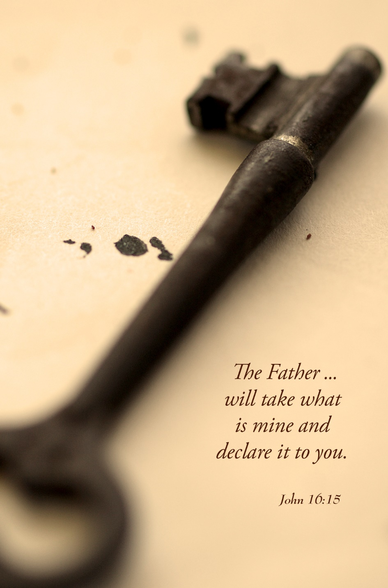

Mt. Zion Evangelical Lutheran Church
320 Mt. Zion Dr., Ripon, WI
www.mtzionripon.org
Facebook: Mt. Zion Evangelical Lutheran Church

Pastor Michael Sheppard
Pastor’s Study: 920-748-9734
E-mail: revmikesheppard@gmail.com
Easter 6 May 19 & 22, 2022

Welcome to Mt. Zion!
Handicapped accessible restrooms are located upstairs next to the Pastor’s Study and downstairs next to the elevator.
Attendance: Please remember to sign the friendship pads. Registration for communion will continue as usual at the table. If you have any questions or concerns please contact Pastor Sheppard or Mark Roeder.

Please feel free to ask Pastor Sheppard any questions you may have concerning COVID-19. May the Lord be with us as we worship together at church. (The services will continue to be posted on Facebook, Rumble, and the church website, and available on DVD.)

Hearing Loop: Our sanctuary is equipped with a hearing loop system. Those who have compatible hearing aids (with a T-switch) will be able to hear the sound system directly into their ear(s). The two main seating areas and the choir area are looped so that you may sit in any of the three areas. We also have four receivers available for those who do not have compatible hearing aids. If you wish to use a receiver please ask the ushers. Those who wish may bring their own headphones or ear buds.

Hymns: 557 vs. 1-5, 803, 869, 557 vs. 6-10

Order of Worship: Setting One CW21 Pg. 154

Clavinova Dedication
Brothers and sisters in Christ, today we seek God’s blessing as we gather with thankfulness to set apart this instrument to his glory. God has given us the gift of music, and to him we sound our praise.
Sing to the Lord, praise his name;
proclaim his salvation day after day.
Sing to the Lord a new song;
play skillfully, and shout for joy.
For the word of the Lord is right and true;
he is faithful in all he does.
Ascribe to the Lord the glory due his name;
bring an offering and come into his courts.
Dedication of the clavanova.
The Service continues with the first hymn.
First Reading & Sermon Text: Acts 14: 8-22 (EHV)
In Lystra there was a man who was sitting down because he had no strength in his feet. He had never walked because he was lame from birth. ⁹When he was listening to Paul as he was speaking, Paul looked at him closely and saw that he had faith so that he could be healed. ¹⁰Paul said in a loud voice, “Stand up on your feet!” And the man jumped up and began to walk.
¹¹When the crowds saw what Paul had done, they raised their voices, saying in the Lycaonian language, “The gods have come down to us in human form.” ¹²Barnabas they called Zeus, and Paul they called Hermes, because he was the main speaker. ¹³The priest of Zeus, whose temple was just outside the city, brought bulls and garlands to the city gates, because he wanted to offer sacrifices, along with the crowds.
¹⁴But when the apostles Paul and Barnabas heard about this, they tore their clothes and rushed into the crowd, shouting, ¹⁵“Men, why are you doing these things? We too are men with the same nature as you. We are preaching the good news to you so that you turn from these worthless things to the living God, who made the heaven, the earth, the sea, and everything in them. ¹⁶In past generations he allowed all the nations to go their own ways. ¹⁷Yet he did not leave himself without testimony of the good he does. He gives you rain from heaven and crops in their seasons. He fills you with food and fills your hearts with gladness.” ¹⁸Even though they said these things, they had a hard time stopping the crowds from sacrificing to them.
¹⁹Then some Jews came from Antioch and Iconium and persuaded the crowds to stone Paul. When they thought he was dead, they dragged him out of the city. ²⁰But after the disciples had gathered around him, he stood up and went into the city. The next day, he left with Barnabas for Derbe.
²¹After they preached the good news in that city and had gathered many disciples, they returned to Lystra, Iconium, and Antioch, ²²strengthening the souls of the disciples and encouraging them to continue in the faith. They told them, “We must go through many troubles on our way to the kingdom of God.”

Every Heart Its Tribute Pays Insert

Second Reading: Revelation 21: 21-27 (EHV)
The twelve gates are twelve pearls. Each of the gates is made out of one pearl. And the street of the city is pure gold, like transparent glass.
²²I did not see a temple in the city, because the Lord God Almighty and the Lamb are its temple. ²³The city does not need the sun or the moon to shine on it, because the glory of God has given it light, and the Lamb is its lamp. ²⁴The nations will walk by its light, and the kings of the earth will bring their glory into it. ²⁵There is no day when its gates will be shut, for there will be no night in that place. ²⁶They will bring the glory and the honor of the nations into it. ²⁷Nothing that is unclean and no one who does what is detestable or who tells lies will ever enter it, but only those who are written in the Lamb’s Book of Life.

Gospel: John 16: 16-24 (EHV)
“In a little while you are not going to see me anymore, and again in a little while you will see me, because I am going away to the Father.”
¹⁷Therefore some of his disciples asked one another, “What does he mean when he tells us, ‘In a little while you are not going to see me, and again in a little while you will see me,’ and ‘Because I am going away to the Father’?” ¹⁸So they kept asking, “What does he mean by ‘a little while’? We don’t understand what he’s saying.”
¹⁹Jesus knew that they wanted to ask him about this, so he said to them, “Are you trying to determine with one another what I meant by saying, ‘In a little while you are not going to see me, and again in a little while you will see me’? ²⁰Amen, Amen, I tell you: You will weep and wail, but the world will rejoice. You will become sorrowful, but your sorrow will turn to joy. ²¹A woman giving birth has pain, because her time has come. But when she has delivered the child, she no longer remembers the anguish, because of her joy that a person has been born into the world.
²²“So you also have sorrow now. But I will see you again. Your heart will rejoice, and no one will take your joy away from you. ²³In that day you will not ask me anything. Amen, Amen, I tell you: Whatever you ask the Father in my name, he will give you. ²⁴Until now you have not asked for anything in my name. Ask, and you will receive, so that your joy may be made complete.

The Holy Bible, Evangelical Heritage Version® (EHV®)
copyright © 2018 The Wartburg Project. All rights reserved. www.wartburgproject.org

Sermon Theme: “We Go Through Many Troubles.”

OFFERING: The offerings are brought forward to the altar.

Please remember in your prayers: Ted Machmueller & Benjie Niemuth

Announcements
Mark your calendar for Sunday, June 12th
Who: All members of Mt. Zion
What: Pie and Ice Cream Social
When: After church on Sunday June 12th
Where: Church fellowship hall
You may eat in the fellowship hall or take the wonderful dessert home and enjoy at your leisure. Please stop down have a piece of pie with or without ice cream. Yum!!!!!!!
A Free will offering will be accepted for the Lutheran Women’s Missionary Society Send One Sister (SOS) Fund. Send One Sister (SOS) was designed to give a woman, who might not otherwise be able to attend a national convention because of financial reasons, a chance to attend her first convention by using SOS funds. Mt Zion ladies would like to help the Beaver Dam LWMS Circuit send a few women to the convention in La Crosse in 2023.
Red Hymnals: It was decided that whoever would like to take one or more old hymnals home may do so at no cost. They are located on the cart outside of the office. Please feel free to take.
May is Mental Health Month. When we pray for help in our emotional or spiritual distress, God’s answer may come in the form of a Christian mental health professional who offers Christ-centered counsel. Christian Family Solutions is a trusted resource for Christ-centered mental health care. CFS has 110 mental health professionals on staff who offer outpatient counseling, plus more intensive treatment programs for those with a higher level of need. To learn more or to find helpful mental health resources visit ChristianFamilySolutions.org.
Birthday Celebration: Cake will be served today to celebrate the birthdays for May.
Mailbox and table: The May Forward In Christ is available and also the May 29th, 2022-August 27th, 2022 Meditations are available.
If you would like the Lord’s Supper privately, please contact Pastor Sheppard on his cell 920-745-0883, or by email revmikesheppard@gmail.com.

The Helping Hands Ministry is ready to serve the needs of our members. Please contact one of the following if you or someone you know needs assistance: Joanne Gregor at 920-896-1518, Lisa Tremore at 920-229-1297 or Tammy Niemuth at 920-299-0240.

For Your Information
Attendance 5/12 - 5/15/2022 105
Offerings for 5/12 - 5/15/2022: $3,175.55

Serving Our Lord

Thank you to everyone for your service to our Lord!

Ushers:

May 22: Dave Smith, Josh Niemuth, Remington Mueller, Roman Mueller

May 29: Tobin Storzer, Rick Retelle, Kelly Frank

PowerPoint:

May 19: Jo Meeker

May 22: Arjeta Rushani

May 26: Jo Meeker

May 29: Jan Olrich

May Communion Set up: Robin Sitter

May Communion Clean up: Paul & Peggy Walkowicz

This week at Mt. Zion
Sunday (22nd) 9:00 AM Worship
10:15 AM Birthday Celebration
Monday 6:30 PM Bible Study
Thursday 6:30 PM Worship with Communion
Sunday 9:00 AM Worship with Communion

Secretary Jo Meeker
Church Office: 920-748-5641
Office Hours: Mon. 9-12, Tues. & Wed. 9-11
E-mail: mountzionripon@gmail.com

Acknowledgments
Unless otherwise indicated, Scripture quotations are from The Holy Bible, New International Version®, NIV®. Copyright © 1973, 1978, 1984, 2011 by Biblica, Inc.TM Used by permission of Zondervan. All rights reserved worldwide.
Software distributed in partnership with Northwestern Publishing House.
Created by Christian Worship: Service Builder © 2022 Concordia Publishing House.

