FIFTH SUNDAY OF EASTER

Mt. Zion Evangelical Lutheran Church

320 Mt. Zion Dr., Ripon, WI
www.mtzionripon.org
Facebook: Mt. Zion Evangelical Lutheran Church

Pastor Michael Sheppard
Pastor’s Study: 920-748-9734
E-mail: revmikesheppard@gmail.com
Easter 5 April 25 & 28, 2024
Handicapped accessible restrooms are located upstairs next to the Pastor’s Study and downstairs next to the elevator.
Attendance: Please remember to sign the friendship pads. Registration for communion will continue as usual at the table. If you have any questions or concerns please contact Pastor Sheppard or Mike Meeker.

Hearing Loop: Our sanctuary is equipped with a hearing loop system. Those who have compatible hearing aids (with a T-switch) will be able to hear the sound system directly into their ear(s). The two main seating areas and the choir area are looped so that you may sit in any of the three areas. We also have four receivers available for those who do not have compatible hearing aids. If you wish to use a receiver please ask the ushers. Those who wish may bring their own headphones or ear buds.

A note for our visitors on member communion –
Out of sincere love for the truth of God’s Word and for precious human souls, we practice member communion in our synod and congregation. This teaching, as practiced by the Church for centuries, is thoroughly Scriptural. It questions the faith of no individual yet asks that there be full doctrinal agreement between those who commune. For this reason, we ask that only those who are members of a WELS or ELS congregation join us for the Lord’s Supper. If you wish to commune with us please speak with the pastor before the service.
The front row on the pulpit side is reserved for people who are unable to navigate the steps. Pastor will serve you Communion first.

Prayer Before Communion: Dearest Jesus, I marvel that you came to this earth as the Word made flesh. With similar awe I contemplate how you give me your body and blood in the bread and wine of Holy Communion. Touch me with your grace that moved you to reach out to me, a poor, miserable sinner! Use this sacred supper to bring me closer to you. Amen.

Prayer After Communion: Thank you, Lord Jesus Christ, for nourishing me in this sacrament with your body and blood. You have given me forgiveness, life, and salvation. Let me always remain in you as a branch remains in the vine. Send me out in the power of your Spirit to live and work to your praise and glory. Amen.

Hymns: 730, 469, (661), 728

Order of Worship: Setting Three pg. 188

First Reading & Sermon Text: Acts 4:32-37 (EHV)
The whole group of believers was one in heart and soul. No one claimed that any of his possessions was his own, but they held everything in common. ³³The apostles continued to testify about the resurrection of the Lord Jesus Christ with great power, and abundant grace was on all of them. ³⁴There was not a needy person among them. For from time to time those who were owners of lands or houses sold them, brought the proceeds received from what was sold, ³⁵and laid it at the apostles’ feet. It was distributed to each one according to what anyone needed.
³⁶Joseph, who was called Barnabas by the apostles (which is translated “son of encouragement”), a Levite, a native of Cyprus, ³⁷sold a field that belonged to him. He brought the money and laid it at the apostles’ feet.

Psalm: 63A In the Morning I Will Sing
The congregation is invited to sing the refrain; the verses will be sung by the soloists.

Second Reading: 1 John 3:18-24 (EHV)
Dear children, let us love not only with word or with our tongue, but also in action and truth.
¹⁹This is how we know that we are of the truth and how we will set our hearts at rest in his presence: ²⁰If our hearts condemn us, God is greater than our hearts, and he knows everything. ²¹Dear friends, if our hearts do not condemn us, we have confidence before God. ²²We also receive from him whatever we ask, because we keep his commands and do what is pleasing in his sight. ²³This then is his command: that we believe in the name of his Son, Jesus Christ, and that we love one another just as he commanded us. ²⁴The one who keeps his commands remains in God and God in him. This is how we know that he remains in us: We know it from the Spirit, whom he has given to us.

Gospel Acclamation

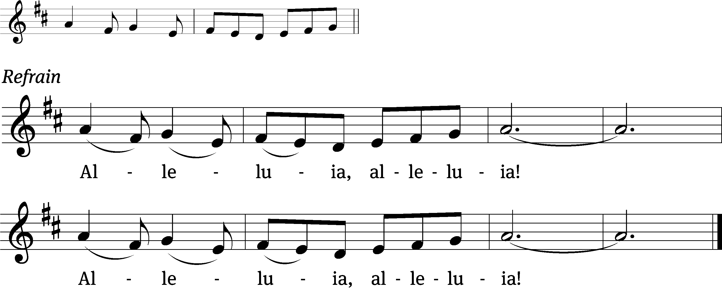
Praise God for a / living hope:
Christ is risen / from the dead! Refrain

Gospel: John 15:1-8 (EHV)
“I am the true vine, and my Father is the gardener. ²Every branch in me that does not bear fruit, he is going to cut off. And he prunes every branch that does bear fruit, so that it will bear more fruit.
³“You are already clean because of the word I have spoken to you. ⁴Remain in me, and I am going to remain in you. A branch cannot bear fruit by itself; it must remain in the vine. Likewise, you cannot bear fruit unless you remain in me.
⁵“I am the Vine; you are the branches. The one who remains in me and I in him is the one who bears much fruit, because without me you can do nothing. ⁶If anyone does not remain in me, he is thrown away like a branch and withers. Such branches are gathered, thrown into the fire, and burned. ⁷If you remain in me and my words remain in you, ask whatever you wish, and it will be done for you. ⁸My Father is glorified by this: that you continue to bear much fruit and prove to be my disciples.”

Sermon Theme: “Jesus Gives Fruits Flowing From Faith in Him.”

OFFERING: The offerings are brought forward to the altar.

Announcements

Dishes: Please check downstairs in the kitchen for any pans or dishes you may have left behind. Whatever is left after May 5th we will take to the WLA thrift store. Thank you.

Hymn Sing: The next and final hymn sing until September will be May 5th.

Birthday Celebration: The next birthday celebration will be May 5^{th.}

Spring Banquet: The Spring Banquet this year is on Tuesday, May 14th, beginning at 6:00 pm. The meal will be potluck, so bring your favorite casserole, salad, or dessert! There is a sign-up sheet on the podium by the library. ALL members (men, women and children) are invited, so bring as many people as you like! Our entertainment this year is Mr. Rich Pinski, who will sing and play the accordion.

Women’s Bible Study: A signup sheet is by the library door for any women interested in a women’s Bible study. There are two dates and times that seemed to work best for most women. Please sign up as soon as possible so we can get started.

Kids C.A.R.E. The 2024 Kids C.A.R.E project Missionary Kids Retreat will be ending in May. There will be a freewill offering today. Your offering will support our missionary kids return stateside to schools, sometimes without their families, or return with their families to new American ministries, schools, and culture. World Missions realized a program was necessary to help our teenagers and young adults transition to their new stateside lives. At these retreats, our high school and college-aged attendees will receive tools to cope with these transitions and will have opportunities to forge friendships with others who have had similar experiences. Thank you for your donations and your prayers.

Greeters: Thank you to all who have greeted so far. If you would like to be greeters for this year, please sign up on the sheet on the podium by the library, or talk to Mike or Jo Meeker.

Student Needs Closet THANK YOU: Mt. Zion has done an amazing job of donating supplies to the Ripon Area School District Student Needs Closet. When you support the needs of students, you are serving the Lord in our community. Your donations are greatly appreciated. Please continue to check the supply list outside the church office by the tiger boxes. As new needs arise, the list will be updated.

Mailbox and table: The May Forward In Christ is available and also the March 3, 2024 – June 4 Meditations are available.
If you would like the Lord’s Supper privately, please contact Pastor Sheppard on his cell 920-745-0883, or by email revmikesheppard@gmail.com.
The Helping Hands Ministry is ready to serve the needs of our members. Please contact one of the following if you or someone you know needs assistance: Joanne Gregor at 920-896-1518, Lisa Tremore at 920-229-1297 or Tammy Niemuth at 920-299-0240.

For Your Information
Attendance 4/18-4/21/2024 87
Offerings for 4/18-4/21/24 $3,101.00

Serving Our Lord

Thank you to everyone for your service to our Lord!

Ushers:

April 28: Tim Lynch, Logan Lynch, TJ Sitter

May 5 & 12: Ken Hielke, Todd Zellmer, Jonathan Zellmer, Dustin Zellmer

PowerPoint:

April 25: Kim Mueller

April 28: Jo Meeker

May 2: Sara Retelle

May 5: Grunert Family

April Communion Set up: Rhonda Schwandt

April Communion Clean up: Marilyn Ninneman & Debra Picchiottino

Secretary Jo Meeker
Church Office: 920-748-5641
Office Hours: Mon. 9-12, Tues. & Wed. 9-11
E-mail: mountzionripon@gmail.com

Sunday (28th) 9:00 AM Worship Service with Communion
10:15 AM Sunday School & Bible Study
Monday 6:30 PM Bible Study
Tuesday 9:00 AM Bible Study
Wednesday 5:00-6:30 PM Catechism Class
6:15 PM Choir Practice
Thursday 6:30 PM Worship Service
Sunday 9:00 AM Worship Service
10:15 AM Sunday School & Bible Class

