FOURTH SUNDAY OF EASTER

Mt. Zion Evangelical Lutheran Church

320 Mt. Zion Dr., Ripon, WI
www.mtzionripon.org
Facebook: Mt. Zion Evangelical Lutheran Church

Pastor Kurt Hagen (Vacancy Pastor)
Phone 651-764-3901
pastorhagen@gmail.com

4th Sunday of Easter April 25, 2026
Handicapped accessible restrooms are located upstairs next to the Pastor’s Study and downstairs next to the elevator.
Attendance: Please remember to sign the friendship pads. Registration for communion will continue as usual at the table. If you have any questions or concerns, please contact Mike Meeker.


Hearing Loop: Our sanctuary is equipped with a hearing loop system. Those who have compatible hearing aids (with a T-switch) will be able to hear the sound system directly into their ear(s). The two main seating areas and the choir area are looped so that you may sit in any of the three areas. We also have four receivers available for those who do not have compatible hearing aids. If you wish to use a receiver please ask the ushers. Those who wish may bring their own headphones or ear buds.

A note for our visitors on member communion –
Out of sincere love for the truth of God’s Word and for precious human souls, we practice member communion in our synod and congregation. This teaching, as practiced by the Church for centuries, is thoroughly Scriptural. It questions the faith of no individual yet asks that there be full doctrinal agreement between those who commune. For this reason, we ask that only those who are members of a WELS or ELS congregation join us for the Lord’s Supper. If you wish to commune with us please speak with the pastor before the service. The Lord’s Supper will be celebrated for those who desire it. The front row on the pulpit side is reserved for people who are unable to navigate the steps. Pastor will serve you Communion first.

Prayer Before Communion: Dearest Jesus, I thank you for the gift of your Holy Supper. As I come to your table, work true repentance in my heart. Teach me to confess my sins and to believe that I am forgiven for your sake. May your body and blood, which are in and with the bread and wine, nourish my faith and strengthen my will to live to the glory of your name. Amen.

Hymns: 776, 552, (670), 555

Pastor Dietsche is conducting this evening’s service.
Guest Organist is Barry Hay

Order of Worship Setting One pg. 154

First Reading: Acts 2:42-47 (EHV)
They continued to hold firmly to the apostles’ teaching and to the fellowship, to the breaking of the bread, and to the prayers. ⁴³Awe came over every soul, and many wonders and signs were being done through the apostles. ⁴⁴All the believers were together and had everything in common. ⁴⁵They were selling their possessions and property and were distributing the proceeds according to what anyone needed.
⁴⁶Day after day, with one mind, they were devoted to meeting in the temple area, as they continued to break bread in their homes. They shared their food with glad and sincere hearts, ⁴⁷as they continued praising God and being viewed favorably by all the people. Day after day the Lord added to their number those who were being saved.

Psalm: 23A I Will Live in the House of the LORD

Second Reading: I Peter 2:19-25 (EHV)
For this is favorable: if a person endures sorrows while suffering unjustly because he is conscious of God. ²⁰For what credit is it to you if you receive a beating for sinning and patiently endure it? But if you suffer for doing good and endure it, this is favorable with God.
²¹Indeed, you were called to do this, because Christ also suffered for you, leaving you an example so that you would follow in his steps. ²²He did not commit a sin, and no deceit was found in his mouth. ²³When he was insulted, he did not insult in return. When he suffered, he made no threats. Instead, he entrusted himself to him who judges justly. ²⁴He himself carried our sins in his body on the tree so that we would be dead to sins and alive to righteousness. By his wounds you were healed. ²⁵For you were like sheep going astray, but you are now returned to the Shepherd and Overseer of your souls.

Gospel Acclamation
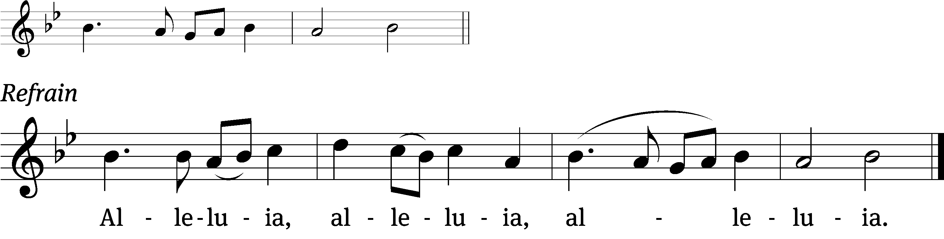
I am the good /Shepherd
I know my sheep and my /sheep know me. (Refrain)

Gospel Reading: John 10:1-10 (EHV)
“Amen, Amen, I tell you: Anyone who does not enter the sheep pen by the door, but climbs in by some other way, is a thief and a robber. ²The one who enters by the door is the shepherd of the sheep. ³The doorkeeper opens the door for him, and the sheep listen to his voice. He calls his own sheep by name and leads them out. ⁴When he has brought out all his own sheep, he walks ahead of them. The sheep follow him because they know his voice. ⁵They will never follow a stranger, but will run away from him, because they do not know the voice of strangers.” ⁶Jesus used this illustration in speaking to the people, but they did not understand what he was telling them.
⁷So Jesus said again, “Amen, Amen, I tell you: I am the door for the sheep. ⁸All who came before me were thieves and robbers, but the sheep did not listen to them. ⁹I am the door. Whoever enters through me will be saved. He will come in and go out, and find pasture.
¹⁰“A thief comes only to steal and kill and destroy. I came that they may have life, and have it abundantly.”

Choir Song: Let There Be Praise
“Forevermore let his love fill the air, and let there be praise.” Drum: Kari Hielke, Maracas: Brenda Dolderer

Sermon Text: Psalm 23
Sermon Theme: “We Confess the Lord is our Shepherd”
- The Lord purchased us to be His own
- The Lord guides and protects us

OFFERING: The offerings are brought forward to the altar.

Keep in Your Prayers: Harley Dorsey, Matt Dubey, Carol Henning, Ginny Verch, Gary Wichman and Dick Zellmer.

Announcements
Baptism: A private baptism was held here at Mt. Zion on Saturday 4/18. Our new members are Macklin Podoll son of Hailey Wichman and Jason Podoll and Finnick Kasuboski son of Faith and Bradley Kasuboski. Congratulations.
Communion setup and cleanup: Since communion is every week we are in need of more help. None of it is hard to do and does not take long. If you are interested please sign up on the sheet by the library. If you have questions please talk to Jo Meeker.

Spring Banquet: The Ladies Aid is holding a spring banquet again this year on May 12th. All women of the congregation and their guests are invited. It will be a potluck again. Please sign up on the sheet by the library if you plan to attend, we only need this for a table count.

May 1st Movie Matinee
A Christian college freshman and his atheist philosophy professor debate the existence of God. To pass the course, Josh Wheaton must prove to the class that God is alive. Putting his relationships and his future on the line, will Josh be able to support his beliefs? Court is now in session!

Orphan dishes: Please pick up any dishes you may have left in the kitchen during soup suppers. Any dishes left after May 2 will be donated to Second Impressions.
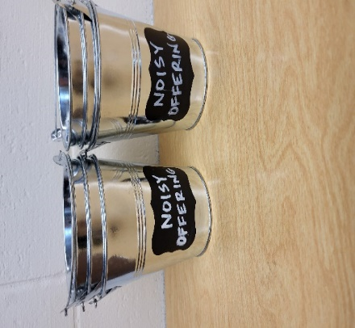
“Noisy Offering”: Please keep saving your spare change for our “noisy offering” on May 9th. The “noisy offering” for Gracie Niemuth, a student at Luther Prep, was an amazing $762.49. Thanks so much! Please take a moment to check out the Evangelism bulletin board. We have received a thank you from Living Stone Lutheran Church Arvada, CO. We have appreciated your support for our various projects and activities.
Mailbox and table: The April Forward In Christ is available and also the March 1, 2026-May 30, 2026 Meditations are available. March calendars are also available.

If you would like the Lord’s Supper privately, please contact Pastor Kurt Hagen at 651-764-3901, or by email pastorkhagen@gmail.com.

The Helping Hands Ministry is ready to serve the needs of our members. Please contact one of the following if you or someone you know needs assistance: Joanne Gregor at 920-896-1518 and Lisa Tremore at 920-229-1297.
For Your Information
Attendance 4/25/2026 60
Offerings for 4/25/2026 $3,301.59

Serving Our Lord

Thank you to everyone for your service to our Lord!

Ushers:

April 25: Mike Schaub, Kevin Schenning, Eric Eckert, Adam Covach

May 3&10: Ken Hielke, Todd Zellmer, Jonathan Zellmer, Dusting Zellmer

PowerPoint:

April 25: Jo Meeker

May 2: Jan Ohlrich

May 9: Jo Meeker

May Communion Set up: Robin Sitter

May Communion Clean up: Jan Ohlrich, Deb Picciotino

Saturday (25th) 5:00 PM Worship with Communion
Wednesday 6: 15 PM Choir Practice
Thursday 9:00 AM Women’s Bible Study
Saturday (5/2) 5:00 PM Worship Service with Communion



