FOURTH SUNDAY OF EASTER
GOOD SHEPHERD SUNDAY
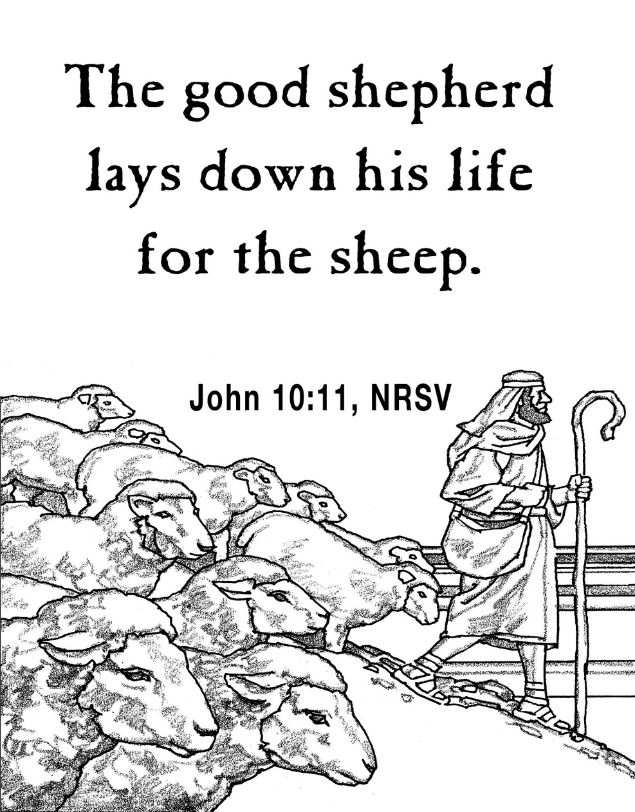
Mt. Zion Evangelical Lutheran Church

320 Mt. Zion Dr., Ripon, WI
www.mtzionripon.org
Facebook: Mt. Zion Evangelical Lutheran Church

Pastor Michael Sheppard
Pastor’s Study: 920-748-9734
E-mail: revmikesheppard@gmail.com
Easter 4 April 18 & 21, 2024
Handicapped accessible restrooms are located upstairs next to the Pastor’s Study and downstairs next to the elevator.
Attendance: Please remember to sign the friendship pads. Registration for communion will continue as usual at the table. If you have any questions or concerns please contact Pastor Sheppard or Mike Meeker.

Hearing Loop: Our sanctuary is equipped with a hearing loop system. Those who have compatible hearing aids (with a T-switch) will be able to hear the sound system directly into their ear(s). The two main seating areas and the choir area are looped so that you may sit in any of the three areas. We also have four receivers available for those who do not have compatible hearing aids. If you wish to use a receiver please ask the ushers. Those who wish may bring their own headphones or ear buds.

Prayer Before Worship: Lord Jesus, my Good Shepherd, you speak to your sheep through the voice of your holy Word. As I gather around that Word in your house, lead me to listen to your voice. Grant me a heart that rejects all voices contradicting yours and renew within me a spirit that trusts in every word you say. For your words grant life, and life to the full. Amen.

Guest organist Thursday: Dawn Panoch

Hymns: 531, 552, 817, 555

Order of Worship: Setting One pg. 154

First Reading & Sermon Text: Acts 20:28-32 (EHV)
“Always keep watch over yourselves and over the whole flock in which the Holy Spirit has placed you as overseers, to shepherd the church of God, which he purchased with his own blood. ²⁹I know that after my departure savage wolves, who will not spare the flock, will come in among you. ³⁰Even from your own group men will rise up, twisting the truth in order to draw away disciples after them. ³¹Therefore be always on the alert! Remember that for three years, night and day, I never stopped warning each one of you with tears.
³²“And now I entrust you to God and to the word of his grace, which has power to build you up and to give you an inheritance among all those who are sanctified.

Psalm: 23A I Will Live in the House of the LORD

Second Reading: 1 John 4:1-6 (EHV)
Dear friends, do not believe every spirit, but test the spirits to see if they are from God, for many false prophets have gone out into the world. ²This is how you can recognize the Spirit of God: Every spirit who confesses that Jesus Christ has come in the flesh is from God, ³and every spirit who does not confess Jesus is not from God. This is the spirit of the Antichrist, which you have heard is coming and is already in the world. ⁴You are from God, dear children, and you have overcome the false prophets, because the one in you is greater than the one in the world. ⁵They are from the world. That is why they speak from a worldly perspective and the world listens to them. ⁶We are from God. The one who knows God listens to us, but whoever is not from God does not listen to us. That is how we can distinguish between the spirit of truth and the spirit of error.

Gospel Acclamation
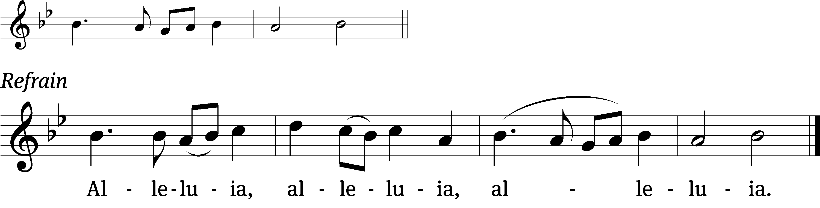
Praise God for a / living hope:
Christ is risen / from the dead! Refrain

Gospel: John 10:11-18 (EHV)
I am the Good Shepherd. The Good Shepherd lays down his life for the sheep. ¹²The hired man, who is not a shepherd, does not own the sheep. He sees the wolf coming, leaves the sheep, and runs away. Then the wolf attacks the sheep and scatters them. ¹³Because he works for money, he does not care about the sheep.
¹⁴“I am the Good Shepherd. I know my sheep and my sheep know me ¹⁵(just as the Father knows me and I know the Father). And I lay down my life for the sheep. ¹⁶I also have other sheep that are not of this sheep pen. I must bring them also, and they will listen to my voice. Then there will be one flock and one shepherd. ¹⁷This is why the Father loves me, because I lay down my life so that I may take it up again. ¹⁸No one takes it from me, but I lay it down on my own. I have the authority to lay it down, and I have the authority to take it up again. This is the commission I received from my Father.”

Choir: "This Is My Story, This Is My Song"
This piece is a powerful statement of faith and devotion.

Sermon Theme: “Jesus Warns Against Wolves.”

OFFERING: The offerings are brought forward to the altar.

Announcements
LWMS Rally: If you wish to attend the rally on April 27th in Kingston and would like to carpool, please sign up on the podium by the church library. We will be leaving the lower parking lot at 8:45am.

Spring Banquet: The Spring Banquet this year is on Tuesday, May 14th, beginning at 6:00 pm. The meal will be potluck, so bring your favorite casserole, salad, or dessert! There is a sign-up sheet on the podium by the library. ALL members (men, women and children) are invited, so bring as many people as you like! Our entertainment this year is Mr. Rich Pinski, who will sing and play the accordion.

Women’s Bible Study: A signup sheet is by the library door for any women interested in a women’s Bible study. There are two dates and times that seemed to work best for most women. Please sign up as soon as possible so we can get started.

Kids C.A.R.E. The 2024 Kids C.A.R.E project Missionary Kids Retreat will be ending in May. There will be a freewill offering today and Sunday the 28th. Your offering will support our missionary kids return stateside to schools, sometimes without their families, or return with their families to new American ministries, schools, and culture. World Missions realized a program was necessary to help our teenagers and young adults transition to their new stateside lives. At these retreats, our high school and college-aged attendees will receive tools to cope with these transitions and will have opportunities to forge friendships with others who have had similar experiences. Thank you for your donations and your prayers.

Dishes: Please check downstairs in the kitchen for any pans or dishes you may have left behind. Whatever is left in two weeks we will take to the WLA thrift store. Thank you.

Hymn Sing: The next and final hymn sing until September will be May 5th.

Birthday Celebration: The next birthday celebration will be May 5^{th.}

Greeters: Thank you to all who have greeted so far. If you would like to be greeters for this year, please sign up on the sheet on the podium by the library, or talk to Mike or Jo Meeker.

Student Needs Closet THANK YOU: Mt. Zion has done an amazing job of donating supplies to the Ripon Area School District Student Needs Closet. When you support the needs of students, you are serving the Lord in our community. Your donations are greatly appreciated. Please continue to check the supply list outside the church office by the tiger boxes. As new needs arise, the list will be updated.

Mailbox and table: The April Forward In Christ is available and also the March 3, 2024 – June 4 Meditations are available.
If you would like the Lord’s Supper privately, please contact Pastor Sheppard on his cell 920-745-0883, or by email revmikesheppard@gmail.com.
The Helping Hands Ministry is ready to serve the needs of our members. Please contact one of the following if you or someone you know needs assistance: Joanne Gregor at 920-896-1518, Lisa Tremore at 920-229-1297 or Tammy Niemuth at 920-299-0240.

For Your Information
Attendance 4/11-4/14/2024 106
Offerings for 4/11-4/14/24 $3,085.10

Serving Our Lord

Thank you to everyone for your service to our Lord!

Ushers:

April 21 & 28: Tim Lynch, Logan Lynch, TJ Sitter

May 5 & 12: Ken Hielke, Todd Zellmer, Jonathan Zellmer, Dustin Zellmer

PowerPoint:

April 18: Sara Retelle

April 21: Grunert Family

April 25: Kim Mueller

April 28: Jo Meeker

April Communion Set up: Rhonda Schwandt

April Communion Clean up: Marilyn Ninneman & Debra Picchiottino

Secretary Jo Meeker
Church Office: 920-748-5641
Office Hours: Mon. 9-12, Tues. & Wed. 9-11
E-mail: mountzionripon@gmail.com

Sunday (21st) 9:00 AM Worship Service
10:15 AM Sunday School & Bible Study
Monday 6:30 PM Bible Study
Tuesday 9:00 AM Bible Study
Wednesday 5:00 PM Catechism Class
6:15 PM Choir Practice
Thursday 6:30 PM Worship Service with Communion
Sunday 9:00 AM Worship Service with Communion
10:15 AM Sunday School & Bible Class
