THIRD SUNDAY OF EASTER
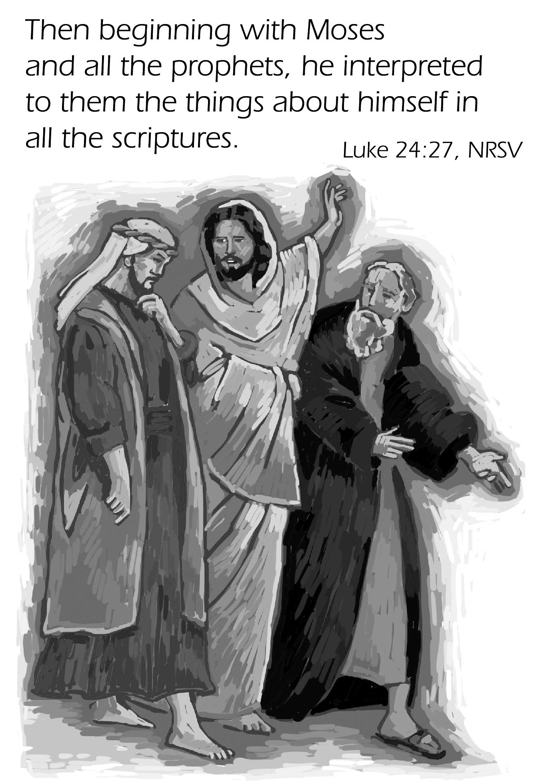
Mt. Zion Evangelical Lutheran Church

320 Mt. Zion Dr., Ripon, WI
www.mtzionripon.org
Facebook: Mt. Zion Evangelical Lutheran Church

Pastor Kurt Hagen (Vacancy Pastor)
Phone 651-764-3901
pastorhagen@gmail.com

3rd Sunday of Easter April 18, 2026
Handicapped accessible restrooms are located upstairs next to the Pastor’s Study and downstairs next to the elevator.
Attendance: Please remember to sign the friendship pads. Registration for communion will continue as usual at the table. If you have any questions or concerns, please contact Mike Meeker.


Hearing Loop: Our sanctuary is equipped with a hearing loop system. Those who have compatible hearing aids (with a T-switch) will be able to hear the sound system directly into their ear(s). The two main seating areas and the choir area are looped so that you may sit in any of the three areas. We also have four receivers available for those who do not have compatible hearing aids. If you wish to use a receiver please ask the ushers. Those who wish may bring their own headphones or ear buds.

A note for our visitors on member communion –
Out of sincere love for the truth of God’s Word and for precious human souls, we practice member communion in our synod and congregation. This teaching, as practiced by the Church for centuries, is thoroughly Scriptural. It questions the faith of no individual yet asks that there be full doctrinal agreement between those who commune. For this reason, we ask that only those who are members of a WELS or ELS congregation join us for the Lord’s Supper. If you wish to commune with us please speak with the pastor before the service. The Lord’s Supper will be celebrated for those who desire it. The front row on the pulpit side is reserved for people who are unable to navigate the steps. Pastor will serve you Communion first.

Prayer Before Communion: Dearest Jesus, I thank you for the gift of your Holy Supper. As I come to your table, work true repentance in my heart. Teach me to confess my sins and to believe that I am forgiven for your sake. May your body and blood, which are in and with the bread and wine, nourish my faith and strengthen my will to live to the glory of your name. Amen.

Hymns: 631, 449 (In place of the Gloria), 459, (441), 803

Pastor Hagen is conducting this evening’s service.
Guest Organist is Doug Jahnke

Order of Worship Setting One pg. 154

First Reading: Acts 2:14a,32-41 (EHV)
¹⁴Then Peter stood up with the Eleven, raised his voice, and spoke loudly and clearly to them:
³²“This Jesus is the one God has raised up. We are all witnesses of that. ³³So, after he was exalted to the right hand of God and after he received the promised Holy Spirit from the Father, he poured out what you are now seeing and hearing.
³⁴“For David did not ascend into heaven, and yet he says:
The Lord said to my Lord,
‘Sit at my right hand,
³⁵until I make your enemies
a footstool under your feet.’
³⁶“Therefore let all the house of Israel know for certain that God has made this Jesus, whom you crucified, both Lord and Christ.”
³⁷Now when the people heard this, they were cut to the heart and said to Peter and the other apostles, “Gentlemen, brothers, what should we do?”
³⁸Peter answered them, “Repent and be baptized, every one of you, in the name of Jesus Christ for the forgiveness of your sins, and you will receive the gift of the Holy Spirit. ³⁹For the promise is for you and for your children and for all who are far away, as many as the Lord our God will call.”
⁴⁰He testified solemnly with many other words and was appealing to them, saying, “Escape from this crooked generation.”
⁴¹Those who accepted his message were baptized, and that day about three thousand people were added.

Psalm: 116A We Lift Up the Cup of Salvation

Second Reading: I Peter 1:17-21 (EHV)
If you call on the Father who judges impartially, according to the work of each person, conduct yourselves during the time of your pilgrimage in reverence, ¹⁸because you know that you were redeemed from your empty way of life handed down to you from your forefathers, not with things that pass away, such as silver or gold, ¹⁹but with the precious blood of Christ, like a lamb without blemish or spot. ²⁰He was chosen before the foundation of the world but revealed in these last times for your sake. ²¹Through him you are believers in God, who raised him from the dead and gave him glory, so that your faith and hope are in God.

Gospel Acclamation
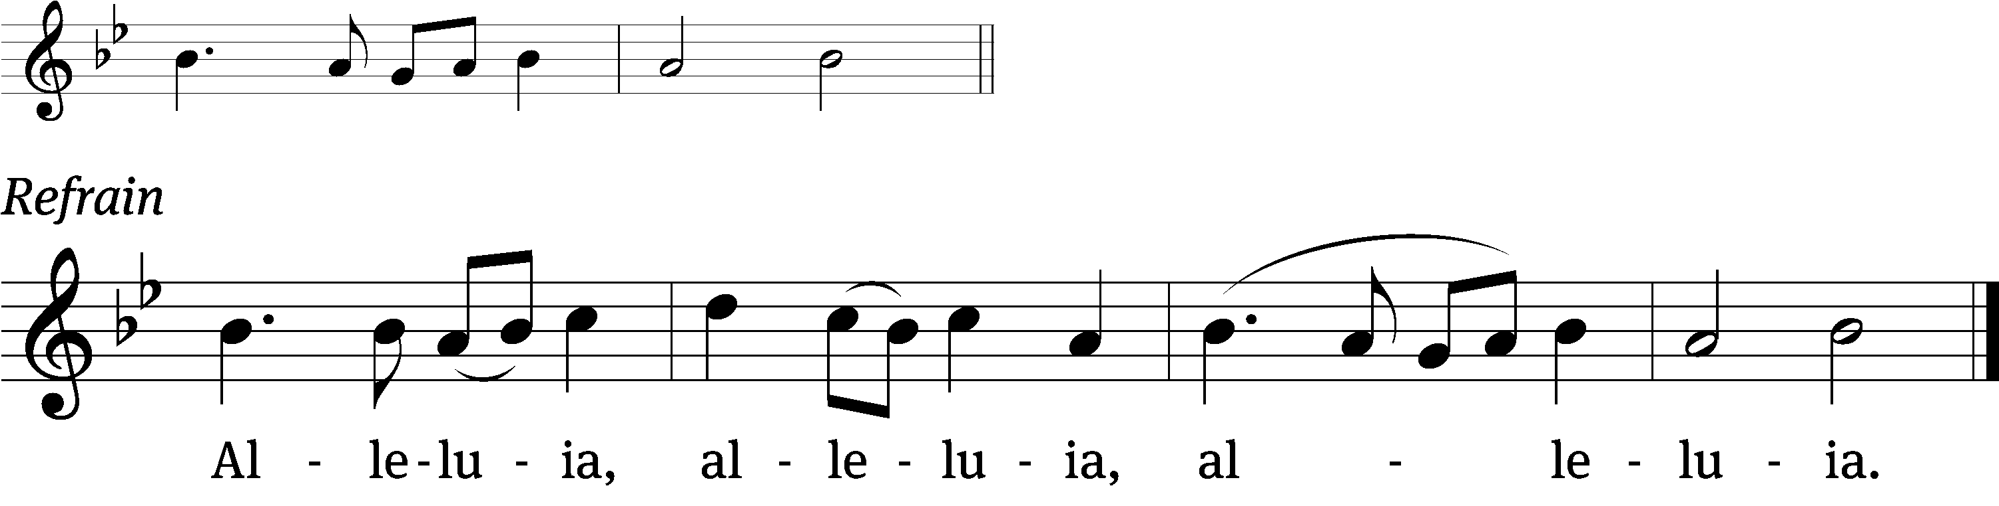
Were not out hearts burning with- /in us
While he talked with us on the road and opened the Scrip- /tures to us? (Refrain)

Gospel Reading & Sermon Text: Luke 24: 13-35 (EHV)
Now, on that same day, two of them were going to a village named Emmaus, about seven miles from Jerusalem. ¹⁴They were talking with each other about all of these things that had happened. ¹⁵While they were talking and discussing this, Jesus himself approached and began to walk along with them. ¹⁶But their eyes were kept from recognizing him. ¹⁷He said to them, “What are you talking about as you walk along?” Saddened, they stopped.
¹⁸One of them, named Cleopas, answered him, “Are you the only visitor in Jerusalem who does not know the things that have happened there in these days?”
¹⁹“What things?” he asked them.
They replied, “The things concerning Jesus of Nazareth, a man who was a prophet, mighty in deed and word before God and all the people. ²⁰The chief priests and our rulers handed him over to be condemned to death. And they crucified him. ²¹But we were hoping that he was going to redeem Israel. Not only that, but besides all this, it is now the third day since these things happened. ²²Also some women of our group amazed us. They were at the tomb early in the morning. ²³When they did not find his body, they came back saying that they had even seen a vision of angels, who said that he was alive. ²⁴Some of those who were with us went to the tomb. They found it just as the women had said, but they did not see him.”
²⁵He said to them, “How foolish you are and slow of heart to believe all that the prophets have spoken! ²⁶Did not the Christ have to suffer these things and to enter his glory?” ²⁷Then beginning with Moses and all the prophets, he explained to them what was said in all the Scriptures concerning himself.
²⁸As they approached the village where they were going, he acted as if he were going to travel farther. ²⁹But they urged him strongly, saying, “Stay with us, since it is almost evening, and the day is almost over.”
So he went in to stay with them. ³⁰When he reclined at the table with them, he took the bread, blessed it, broke it, and began giving it to them. ³¹Suddenly their eyes were opened, and they recognized him. Then he vanished from their sight. ³²They said to each other, “Were not our hearts burning within us while he was speaking to us along the road and while he was explaining the Scriptures to us?” ³³They got up that very hour and returned to Jerusalem. They found the Eleven and those who were with them assembled together. ³⁴They were saying, “The Lord really has been raised! He has appeared to Simon.” ³⁵They themselves described what had happened along the road, and how they recognized him when he broke the bread.

Sermon Theme: “Walking with Jesus”

OFFERING: The offerings are brought forward to the altar.

Keep in Your Prayers: Harley Dorsey, Matt Dubey, Carol Henning, Ginny Verch, Gary Wichman and Dick Zellmer.

Announcements
Catechism Class: Catechism instruction will be Saturdays from 3:30-4:30 PM here at Mt. Zion. The Cong. is invited to attend. No Catechism class on April 25th.

Voters’ Meeting: The Quarterly Voters’ Meeting will be held TODAY after the church service.

May 1st Movie Matinee
A Christian college freshman and his atheist philosophy professor debate the existence of God. To pass the course, Josh Wheaton must prove to the class that God is alive. Putting his relationships and his future on the line, will Josh be able to support his beliefs? Court is now in session!

Communion setup and cleanup: Since communion is every week we are in need of more help. None of it is hard to do and does not take long. If you are interested please sign up on the sheet by the library. If you have questions please talk to Jo Meeker.

Spring Banquet: The Ladies Aid is holding a spring banquet again this year on May 12th. All women of the congregation and their guests are invited. It will be a potluck again. Please sign up on the sheet by the library if you plan to attend, we only need this for a table count.

Orphan dishes: Please pick up any dishes you may have left in the kitchen during soup suppers. Any dishes left after May 2 will be donated to Second Impressions.
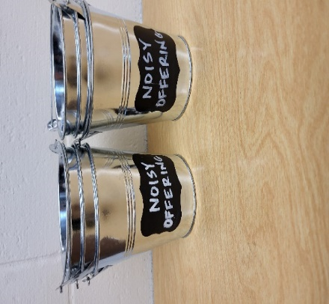
“Noisy Offering”: Please keep saving your spare change for our “noisy offering” on May 9th. The “noisy offering” for Gracie Niemuth, a student at Luther Prep, was an amazing $762.49. Thanks so much! Please take a moment to check out the Evangelism bulletin board. We have received a thank you from Living Stone Lutheran Church Arvada, CO. We have appreciated your support for our various projects and activities.
Mailbox and table: The April Forward In Christ is available and also the March 1, 2026-May 30, 2026 Meditations are available. March calendars are also available.

If you would like the Lord’s Supper privately, please contact Pastor Kurt Hagen at 651-764-3901, or by email pastorkhagen@gmail.com.

The Helping Hands Ministry is ready to serve the needs of our members. Please contact one of the following if you or someone you know needs assistance: Joanne Gregor at 920-896-1518 and Lisa Tremore at 920-229-1297.

For Your Information
Attendance 4/18/2026 75
Offerings for 4/18/2026 $2,317.00

Serving Our Lord

Thank you to everyone for your service to our Lord!

Ushers:

April 18 & 25: Mike Schaub, Kevin Schenning, Eric Eckert Adam Covach

PowerPoint:

April 18: Jo Meeker

April 25: Jo Meeker

May 2: Jan Ohlrich

April Communion Set up: Rhonda Schwandt

April Communion Clean up: Marilyn Ninneman

Saturday (18th) 5:00 PM Worship with Communion
Wednesday 6: 15 PM Choir Practice
Thursday 9:00 AM Women’s Bible Study
Saturday (4/25) 5:00 PM Worship Service with Communion

