THIRD SUNDAY OF EASTER
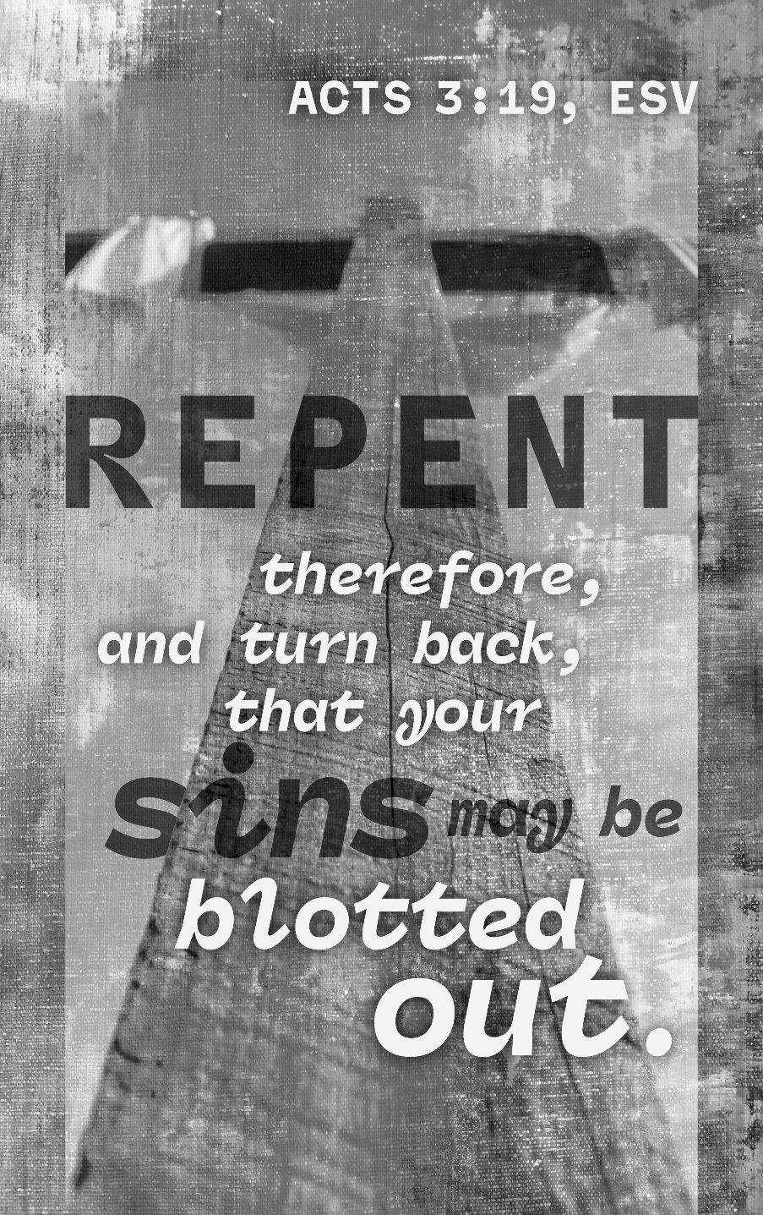
Mt. Zion Evangelical Lutheran Church

320 Mt. Zion Dr., Ripon, WI
www.mtzionripon.org
Facebook: Mt. Zion Evangelical Lutheran Church

Pastor Michael Sheppard
Pastor’s Study: 920-748-9734
E-mail: revmikesheppard@gmail.com
Easter 3 April 11 & 14, 2024
Handicapped accessible restrooms are located upstairs next to the Pastor’s Study and downstairs next to the elevator.
Attendance: Please remember to sign the friendship pads. Registration for communion will continue as usual at the table. If you have any questions or concerns please contact Pastor Sheppard or Mike Meeker.

Hearing Loop: Our sanctuary is equipped with a hearing loop system. Those who have compatible hearing aids (with a T-switch) will be able to hear the sound system directly into their ear(s). The two main seating areas and the choir area are looped so that you may sit in any of the three areas. We also have four receivers available for those who do not have compatible hearing aids. If you wish to use a receiver please ask the ushers. Those who wish may bring their own headphones or ear buds.

A note for our visitors on member communion –
Out of sincere love for the truth of God’s Word and for precious human souls, we practice member communion in our synod and congregation. This teaching, as practiced by the Church for centuries, is thoroughly Scriptural. It questions the faith of no individual yet asks that there be full doctrinal agreement between those who commune. For this reason, we ask that only those who are members of a WELS or ELS congregation join us for the Lord’s Supper. If you wish to commune with us please speak with the pastor before the service.
The front row on the pulpit side is reserved for people who are unable to navigate the steps. Pastor will serve you Communion first.

Prayer Before Communion: Dearest Jesus, I marvel that you came to this earth as the Word made flesh. With similar awe I contemplate how you give me your body and blood in the bread and wine of Holy Communion. Touch me with your grace that moved you to reach out to me, a poor, miserable sinner! Use this sacred supper to bring me closer to you. Amen.

Prayer After Communion: Thank you, Lord Jesus Christ, for nourishing me in this sacrament with your body and blood. You have given me forgiveness, life, and salvation. Let me always remain in you as a branch remains in the vine. Send me out in the power of your Spirit to live and work to your praise and glory. Amen.

Hymns: 573, 459, (660), 816

Order of Worship: Setting One pg. 154

First Reading & Sermon Text: Acts 3:11-20 (EHV)
While the man held on to Peter and John, all the people came running toward them in utter amazement in the area called Solomon’s Colonnade.
¹²When Peter saw this, he addressed the people: “Men of Israel, why are you amazed at this? Why are you staring at us, as if by our own power or godliness we have made this man walk? ¹³The God of Abraham, Isaac, and Jacob, the God of our fathers, glorified his servant Jesus, whom you handed over and disowned in the presence of Pilate, though he had decided to release him. ¹⁴You disowned the Holy and Righteous One and asked to have a murderer given to you. ¹⁵You killed the Author of Life, whom God raised from the dead. We are witnesses of this. ¹⁶And on the basis of faith in his name, it is the name of Jesus that has strengthened this man, whom you see and know. This faith that comes through Jesus has given him this perfect health in the presence of all of you.
¹⁷“Now brothers, I know that you acted in ignorance, just like your leaders. ¹⁸But in this way God fulfilled what he had foretold through the mouth of all the prophets: that his Christ would suffer. ¹⁹Therefore repent and return to have your sins wiped out, ²⁰so that refreshing times may come from the presence of the Lord and that he may send Jesus, the Christ appointed for you.

Psalm: 150B (Insert) Alleluia! Alleluia! Alleluia!

Second Reading: 1 John 1:5-2:2 (EHV)
This is the message we heard from him and proclaim to you: God is light. In him there is no darkness at all. ⁶If we say we have fellowship with him but still walk in darkness, we are lying and do not put the truth into practice. ⁷But if we walk in the light, just as he is in the light, we have fellowship with one another, and the blood of Jesus Christ, his Son, cleanses us from all sin. ⁸If we say we have no sin, we deceive ourselves, and the truth is not in us. ⁹If we confess our sins, he is faithful and just to forgive us our sins and to cleanse us from all unrighteousness. ¹⁰If we say we have not sinned, we make him out to be a liar, and his Word is not in us.
^{2:1}My children, I write these things to you so that you will not sin. If anyone does sin, we have an Advocate before the Father: Jesus Christ, the Righteous One. ²He is the atoning sacrifice for our sins, and not only for ours but also for the whole world.
Gospel Acclamation
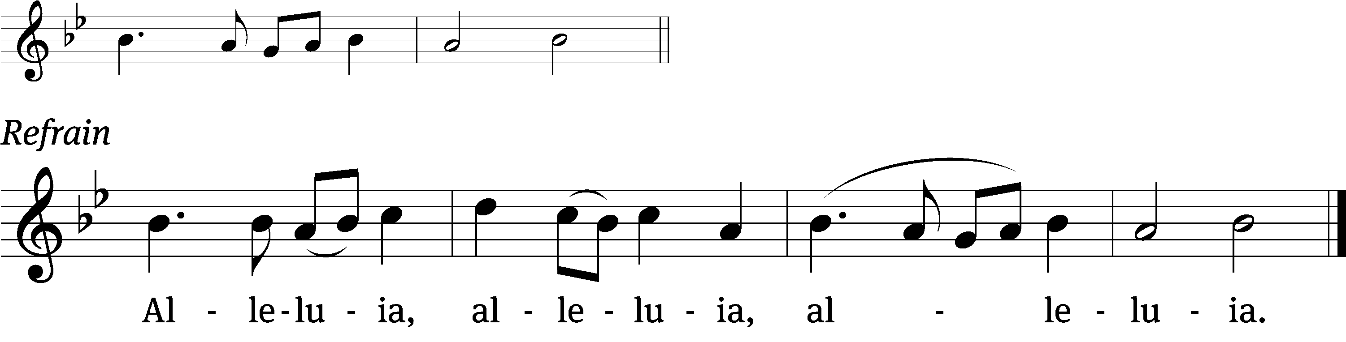
Praise God for a / living hope:
Christ is risen / from the dead!

Gospel: Luke 24:36-49 (EHV)
As they were talking about these things, Jesus himself stood among them and said to them, “Peace be with you.”
³⁷But they were terrified and frightened and thought they were looking at a ghost.
³⁸He said to them, “Why are you troubled? Why do doubts arise in your hearts? ³⁹Look at my hands and my feet. It is I myself. Touch me and see, because a ghost does not have flesh and bones as you see that I have.” ⁴⁰When he had said this, he showed them his hands and his feet. ⁴¹While they still did not believe it (because of their joy), and while they were still wondering, he said to them, “Do you have anything here to eat?”
⁴²They gave him a piece of broiled fish and some honeycomb. ⁴³He took it and ate in front of them. ⁴⁴He said to them, “These are my words, which I spoke to you while I was still with you: Everything must be fulfilled that is written about me in the Law of Moses, the Prophets, and the Psalms.”
⁴⁵Then he opened their minds to understand the Scriptures. ⁴⁶He said to them, “This is what is written and so it must be: The Christ will suffer and rise from the dead on the third day, ⁴⁷and repentance and forgiveness of sins will be preached in his name to all nations, beginning from Jerusalem. ⁴⁸You are witnesses of these things. ⁴⁹Look, I am sending you what my Father promised. But stay in the city until you are clothed with power from on high.”

Sermon Theme: “Jesus Gives Us a Message of Hope.”

OFFERING: The offerings are brought forward to the altar.

Announcements
Quarterly Voters Meeting: The regular quarterly voters’ meeting will be held TODAY after the service.

Newcomers Dinner: The congregation is invited to join us for the New Member potluck on April 14th at 11:00 AM, after the quarterly Voters’ Meeting. TODAY! Please bring a dish to pass.

Women’s Bible Study: A signup sheet is by the library door for any women interested in a women’s Bible study. There are two dates and times that seemed to work best for most women. Please sign up as soon as possible so we can get started.

LWMS rally on April 27th in Kingston
If you wish to attend the rally and carpool, please sign up near the church library. We will be leaving the lower parking lot at 8:45

Hymn Sing: The next and final hymn sing until September will be May 5th.

Birthday Celebration: The next birthday celebration will be May 5^{th.}

Greeters: We have started the greeter program again. Thank you to all who have greeted so far. If you would like to be greeters for this year, please sign up on the sheet on the podium by the library.

Kids C.A.R.E. The 2024 Kids C.A.R.E project Missionary Kids Retreat will be ending in May. There will be a freewill offering on April 21st and 28th. Your offering will support our missionary kids return stateside to schools, sometimes without their families, or return with their families to new American ministries, schools, and culture. World Missions realized a program was necessary to help our teenagers and young adults transition to their new stateside lives. At these retreats, our high school and college-aged attendees will receive tools to cope with these transitions and will have opportunities to forge friendships with others who have had similar experiences. Thank you for your donations and your prayers.

Student Needs Closet THANK YOU: Mt. Zion has done an amazing job of donating supplies to the Ripon Area School District Student Needs Closet. When you support the needs of students, you are serving the Lord in our community. Your donations are greatly appreciated. Please continue to check the supply list outside the church office by the tiger boxes. As new needs arise, the list will be updated.

Mailbox and table: The April Forward In Christ is available and also the March 3, 2024 – June 4 Meditations are available.
If you would like the Lord’s Supper privately, please contact Pastor Sheppard on his cell 920-745-0883, or by email revmikesheppard@gmail.com.

The Helping Hands Ministry is ready to serve the needs of our members. Please contact one of the following if you or someone you know needs assistance: Joanne Gregor at 920-896-1518, Lisa Tremore at 920-229-1297 or Tammy Niemuth at 920-299-0240.

For Your Information
Attendance 4/4-4/7/2024 87
Offerings for 3/28-3/31/24 $5,202.87

Serving Our Lord

Thank you to everyone for your service to our Lord!

Ushers:

April 14: Dennis Scott, Dawson Niemuth, Rick Niemuth

April 21 & 28: Tim Lynch, Logan Lynch, TJ Sitter

PowerPoint:

April 11: Kim Mueller

April 14: Rushani Family

April 18: Sara Retelle

April 21: Grunert Family

April Communion Set up: Rhonda Schwandt

April Communion Clean up: Marilyn Ninneman & Debra Picchiottino

Secretary Jo Meeker
Church Office: 920-748-5641
Office Hours: Mon. 9-12, Tues. & Wed. 9-11
E-mail: mountzionripon@gmail.com

Sunday (14th) 9:00 AM Worship Service with Communion
10:15 AM Sunday School, Quarterly Voter’s Meeting
11:00 AM Newcomer’s Potluck Dinner
Monday 6:30 PM Bible Study
Tuesday 9:00 AM Bible Study
Wednesday 5:00 PM Catechism Class
6:15 PM Choir Practice
Thursday 6:30 PM Worship Service
Sunday 9:00 AM Worship Service
10:15 AM Sunday School & Bible Class

