SECOND SUNDAY OF EASTER
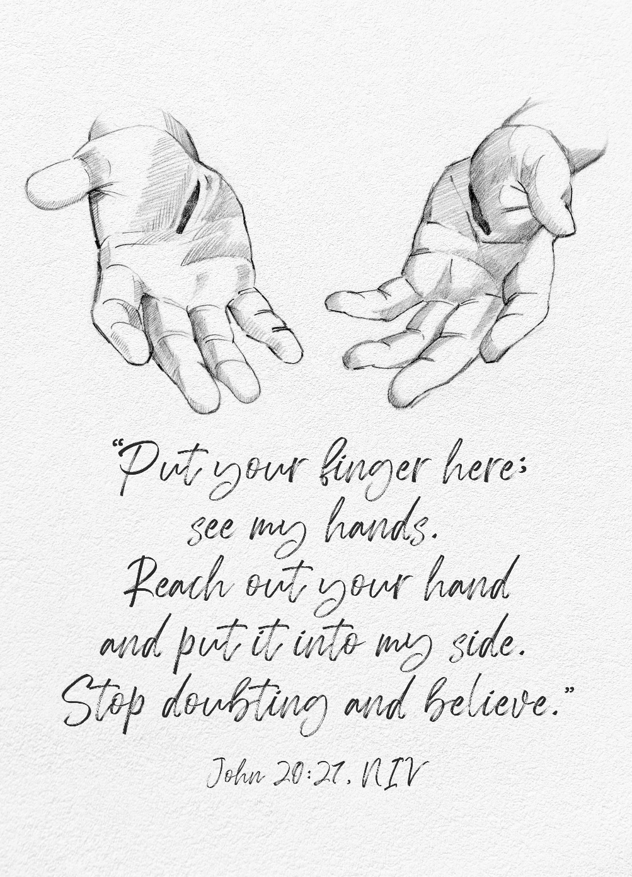
Mt. Zion Evangelical Lutheran Church

320 Mt. Zion Dr., Ripon, WI
www.mtzionripon.org
Facebook: Mt. Zion Evangelical Lutheran Church

Pastor Michael Sheppard
Pastor’s Study: 920-748-9734
E-mail: revmikesheppard@gmail.com
Easter 2 April 4 & 7, 2024
Handicapped accessible restrooms are located upstairs next to the Pastor’s Study and downstairs next to the elevator.
Attendance: Please remember to sign the friendship pads. Registration for communion will continue as usual at the table. If you have any questions or concerns please contact Pastor Sheppard or Mike Meeker.

Hearing Loop: Our sanctuary is equipped with a hearing loop system. Those who have compatible hearing aids (with a T-switch) will be able to hear the sound system directly into their ear(s). The two main seating areas and the choir area are looped so that you may sit in any of the three areas. We also have four receivers available for those who do not have compatible hearing aids. If you wish to use a receiver please ask the ushers. Those who wish may bring their own headphones or ear buds.

Easter Prayer: “He is not here. He has risen, just as he said. Come, see the place where the Lord lay” (Matthew 28:6 EHV). Jesus, the angel’s announcement puts a spring in my step and fills my heart with joy! Your resurrection stands as my eternal guarantee that all your other promises will come true as well – including this life-changing one: “Because I live, you also will live” (John 14:19). I have nothing to fear, not even the grave! Alleluia! Amen.

Hymn Sing: 450, 462, 451, 465 vs. 1,2,4,5
Hymns: 537, 456, 824

Order of Worship: Thursday Evening Prayer CW21 pg. 215
Sunday Morning Prayer CW 21 pg. 207

Psalm: 16A My Heart, Therefore, Is Glad

Reading: I John 1:1-4 (EHV)
That which was from the beginning, which we have heard, which we have seen with our eyes, which we have observed and our hands have touched regarding the Word of Life—²the life appeared, and we have seen it. We testify and proclaim to you the eternal life, which was with the Father and has appeared to us. ³We are proclaiming what we have seen and heard also to you, so that you may have fellowship with us. Our fellowship is with the Father and his Son Jesus Christ. ⁴We write these things to you so that our joy may be complete.

Gospel: John 20:19-31 (EHV)
On the evening of that first day of the week, the disciples were together behind locked doors because of their fear of the Jews. Jesus came, stood among them, and said to them, “Peace be with you!” ²⁰After he said this, he showed them his hands and side. So the disciples rejoiced when they saw the Lord.
²¹Jesus said to them again, “Peace be with you! Just as the Father has sent me, I am also sending you.” ²²After saying this, he breathed on them and said, “Receive the Holy Spirit. ²³Whenever you forgive people’s sins, they are forgiven. Whenever you do not forgive them, they are not forgiven.”
²⁴But Thomas, one of the Twelve, the one called the Twin, was not with them when Jesus came. ²⁵So the other disciples kept telling him, “We have seen the Lord!”
But he said to them, “Unless I see the nail marks in his hands, and put my finger into the mark of the nails, and put my hand into his side, I will never believe.”
²⁶After eight days, his disciples were inside again, and Thomas was with them. Though the doors were locked, Jesus came and stood among them. “Peace be with you,” he said. ²⁷Then he said to Thomas, “Put your finger here and look at my hands. Take your hand and put it into my side. Do not continue to doubt, but believe.”
²⁸Thomas answered him, “My Lord and my God!”
²⁹Jesus said to him, “Because you have seen me, you have believed. Blessed are those who have not seen and yet have believed.”
³⁰Jesus, in the presence of his disciples, did many other miraculous signs that are not written in this book. ³¹But these are written that you may believe that Jesus is the Christ, the Son of God, and that by believing you may have life in his name.

Sermon Text: Acts 18:1-11 (EHV)
After this, Paul left Athens and went to Corinth. ²There he found a Jew named Aquila, a native of Pontus, who had recently come from Italy with his wife Priscilla, because Claudius had ordered all the Jews to leave Rome. Paul went to see them. ³Because he had the same occupation, he stayed and worked with them, for they were tentmakers by trade. ⁴Every Sabbath he led a discussion in the synagogue, trying to persuade both Jews and Greeks.
⁵When Silas and Timothy came down from Macedonia, Paul was entirely devoted to preaching the word, testifying to the Jews that Jesus was the Christ. ⁶But when they opposed Paul and slandered him, he shook out his clothes and said to them, “Your blood be on your own heads! I am innocent. From now on, I will go to the Gentiles!”
⁷He left that place and went to the house of a man named Titius Justus, a worshipper of God, whose house was next door to the synagogue. ⁸Crispus, the synagogue leader, believed in the Lord, together with his entire household. And many of the Corinthians, when they heard, believed and were baptized.
⁹One night the Lord spoke to Paul in a vision: “Do not be afraid, but keep on speaking, and do not be silent. ¹⁰For I am with you, and no one will lay a hand on you to harm you, because I have many people in this city.” ¹¹He stayed there a year and six months, teaching the word of God among them.

Sermon Theme: “Jesus Gives Peace to the Discouraged.”

OFFERING: The offerings are brought forward to the altar.
Announcements
Hymn Sing: The hymn sing today will begin at approximately 8:45. The next and final hymn sing until September will be May 5th.

Birthday Celebration: Please join us for birthday cake downstairs today, before the start of the voter’s meeting. The next birthday celebration is TBD.

Voter’s Meeting: Today after the service we will have a discussion on the sale of the property across the street and a vote on the asking price. The Council is asking for a good attendance at this meeting.

Easter Breakfast: A big thank you to the Easter breakfast crew. Great Job!

Lilies: Thank you to those who purchased Easter lilies to beautify our church this Easter season. Easter lilies were given in memory of: Richard Worm, Taylor Baccus, Gerald Thiele, Gail Tremore, Warren & Barb Lueck, Art & Verna Brey, and Bob Rosenberg. Thank you to everyone!

Quarterly Voters Meeting: The regular quarterly voters’ meeting will be held April 14th after the service.

Newcomers Dinner: The congregation is invited to join us for the New Member potluck on April 14th at 11:00 AM, after the quarterly Voters’ Meeting.

Women’s Bible Study: A signup sheet is by the library door for any women interested in a women’s Bible study. There are two dates and times that seemed to work best for most women. Please sign up as soon as possible so we can get started.

Greeters: We have started the greeter program again. Thank you to all who have greeted so far. If you would like to be greeters for this year, please sign up on the sheet on the podium by the library.
Student Needs Closet THANK YOU: Mt. Zion has done an amazing job of donating supplies to the Ripon Area School District Student Needs Closet. When you support the needs of students, you are serving the Lord in our community. Your donations are greatly appreciated. Please continue to check the supply list outside the church office by the tiger boxes. As new needs arise, the list will be updated.

Mailbox and table: The April Forward In Christ is available and also the March 3, 2024 – June 4 Meditations are available.
If you would like the Lord’s Supper privately, please contact Pastor Sheppard on his cell 920-745-0883, or by email revmikesheppard@gmail.com.
The Helping Hands Ministry is ready to serve the needs of our members. Please contact one of the following if you or someone you know needs assistance: Joanne Gregor at 920-896-1518, Lisa Tremore at 920-229-1297 or Tammy Niemuth at 920-299-0240.

For Your Information
Attendance 3/28-3/31/2024 297
Offerings for 3/28-3/31/24 $6,449.00

Serving Our Lord

Thank you to everyone for your service to our Lord!

Ushers:

April 7: Mike Schaub, Kevin Schenning, Eric Eckert, Adam Covach

April 14: Dennis Scott, Dawson Niemuth, Rick Niemuth

PowerPoint:

April 4: Jo Meeker

April 7: Grunert Family

April 11: Kim Mueller

April 14: Rushani Family

April Communion Set up: Rhonda Schwandt

April Communion Clean up: Marilyn Ninneman & Debra Picchiottino

Secretary Jo Meeker
Church Office: 920-748-5641
Office Hours: Mon. 9-12, Tues. & Wed. 9-11
E-mail: mountzionripon@gmail.com

Sunday (7th) 8:45 AM Hymn Sing
9:00 AM Worship Service
10:15 AM Sunday School, Birthday Cake
Special Voter’s Meeting
Monday 6:30 PM Bible Study
Tuesday 9:00 AM Bible Study
5:30 PM Council Meeting
6:30 PM Ladies Aid
Wednesday 5:00 PM Catechism Class
6:15 PM Choir Practice
Thursday 6:30 PM Worship Service with Communion
Sunday 9:00 AM Worship Service with Communion
10:15 AM Sunday School, Voter’s Meeting, Newcomer’s Potluck Dinner

