SECOND SUNDAY OF EASTER
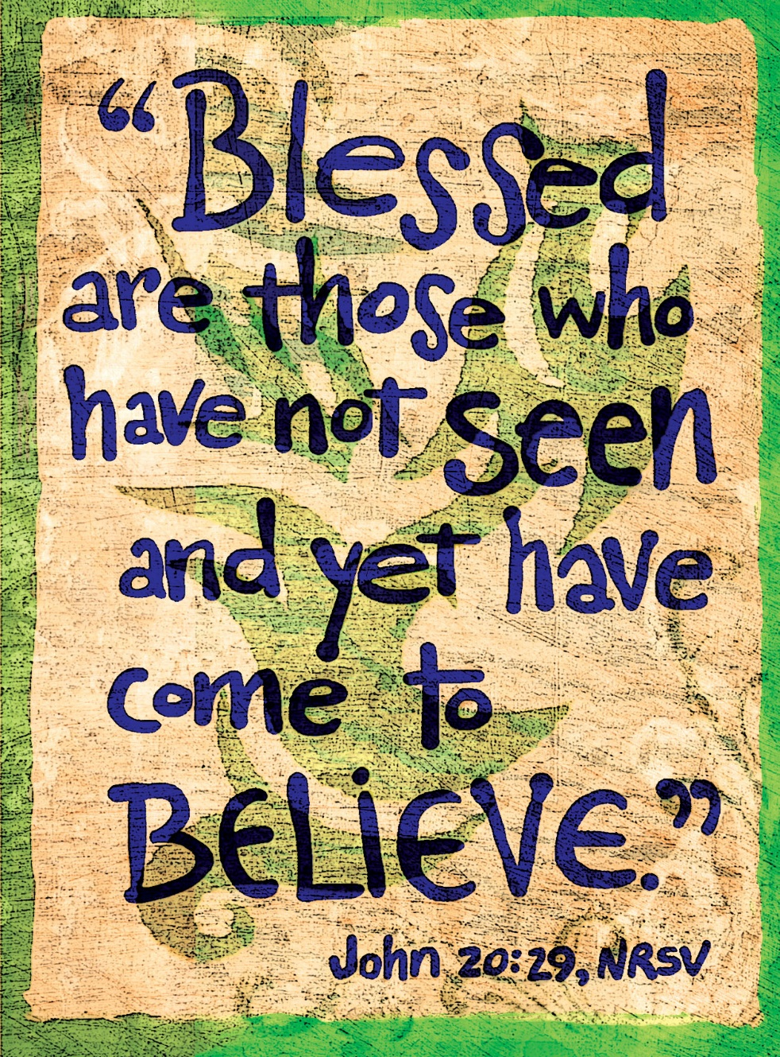
Mt. Zion Evangelical Lutheran Church

320 Mt. Zion Dr., Ripon, WI
www.mtzionripon.org
Facebook: Mt. Zion Evangelical Lutheran Church

Pastor Kurt Hagen (Vacancy Pastor)
Phone 651-764-3901
pastorhagen@gmail.com

2nd Sunday of Easter March 21, 2026
Handicapped accessible restrooms are located upstairs next to the Pastor’s Study and downstairs next to the elevator.
Attendance: Please remember to sign the friendship pads. Registration for communion will continue as usual at the table. If you have any questions or concerns, please contact Mike Meeker.


Hearing Loop: Our sanctuary is equipped with a hearing loop system. Those who have compatible hearing aids (with a T-switch) will be able to hear the sound system directly into their ear(s). The two main seating areas and the choir area are looped so that you may sit in any of the three areas. We also have four receivers available for those who do not have compatible hearing aids. If you wish to use a receiver please ask the ushers. Those who wish may bring their own headphones or ear buds.

A note for our visitors on member communion –
Out of sincere love for the truth of God’s Word and for precious human souls, we practice member communion in our synod and congregation. This teaching, as practiced by the Church for centuries, is thoroughly Scriptural. It questions the faith of no individual yet asks that there be full doctrinal agreement between those who commune. For this reason, we ask that only those who are members of a WELS or ELS congregation join us for the Lord’s Supper. If you wish to commune with us please speak with the pastor before the service. The Lord’s Supper will be celebrated for those who desire it. The front row on the pulpit side is reserved for people who are unable to navigate the steps. Pastor will serve you Communion first.

Prayer Before Communion: Dearest Jesus, I thank you for the gift of your Holy Supper. As I come to your table, work true repentance in my heart. Teach me to confess my sins and to believe that I am forgiven for your sake. May your body and blood, which are in and with the bread and wine, nourish my faith and strengthen my will to live to the glory of your name. Amen.

Hymns: 456 vs.1-4, 456 vs.5-9, (450-455), 470

Pastor Hagen is conducting this evening’s service.
Guest Organist is Adah Hagen

Order of Worship Setting One pg. 154

First Reading: Isaiah 44:21-28 (EHV)
²¹ Remember these things, O Jacob, because you are my servant, Israel. I am forming you to be my servant. You, Israel, you will never be forgotten by me. ²² I am blowing away your rebellious deeds like a cloud, and your sins like a mist. Return to me, because I am redeeming you.
²³ Shout for joy, you heavens, because of what the Lord is doing.
Make a joyful shout, you depths of the earth.
Burst forth with shouts of joy, you mountains,
you forest and every tree in it,
because the Lord has redeemed Jacob,
and in Israel he will display his beauty.
²⁴ This is what the Lord, your Redeemer,
the Lord who formed you from the womb, says.
I am the Lord, the one who does all things,
who stretched out the heavens by myself,
who hammered out the earth.
(Who was with me then?)
²⁵ I frustrate the signs of the deceivers
and make fools of the fortune tellers.
I overturn the wisdom of the wise
and turn their knowledge into foolishness.
²⁶ He is the one who fulfills the word of his servants,
who completes the plan announced by his messengers,
who says about Jerusalem, “It will be inhabited,”
and about the cities of Judah, “They will be rebuilt,
and I will raise up their ruins.”
²⁷ He is the one who says to the deep ocean, “Dry up,”
the one who says, “I will dry up your rivers.”
²⁸ He is the one who says about Cyrus, “He is my shepherd,
and he will complete everything I desire.”
He is the one who says about Jerusalem, “It will be rebuilt,”
and who says to the temple, “Your foundations will be laid.”

Psalm: 16A My Heart, Therefore Is Glad

Second Reading: I Peter 2:1-10 (EHV)
Therefore rid yourselves of all evil, all deceit, hypocrisy, jealousy, and all slander. ² Like newborn babies, crave the pure milk of the word so that by it you may grow up with the result being salvation. ³ Certainly you have tasted that the Lord is good!
⁴ As you come to him, the Living Stone, rejected by men but chosen by God and precious, ⁵ you also, like living stones, are being built as a spiritual house to be a holy priesthood, in order to bring spiritual sacrifices that are acceptable to God through Jesus Christ. ⁶ For it says in Scripture: See, I lay a stone in Zion, a chosen and precious cornerstone, and the one who believes in him will certainly not be put to shame.
⁷ Therefore, for you who believe, this is an honor. But for those who do not believe: The stone which the builders rejected has become the cornerstone, ⁸ and, a stone over which they stumble
and a rock over which they fall. Because they continue to disobey the word, they stumble over it. And that is the consequence appointed for them.
⁹ But you are a chosen people, a royal priesthood, a holy nation, the people who are God’s own possession, so that you may proclaim the praises of him who called you out of darkness into his marvelous light. ¹⁰ At one time you were not a people, but now you are the people of God. At one time you were not shown mercy, but now you have been shown mercy.

Gospel Acclamation
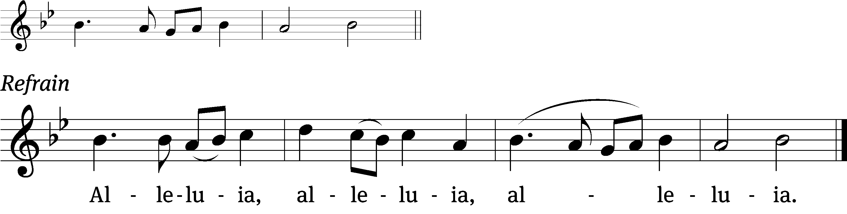
Blessed are those who /have not seen
And yet / have believed (Refrain)

Gospel Reading: John 20:1-9 (EHV)
Early on the first day of the week, while it was still dark, Mary Magdalene went to the tomb. She saw that the stone had been taken away from the tomb. ² So she left and ran to Simon Peter and the other disciple, the one Jesus loved. “They have taken the Lord out of the tomb,” she told them, “and we don’t know where they put him!”
³ So Peter and the other disciple went out, heading for the tomb. ⁴ The two were running together, but the other disciple outran Peter and got to the tomb first. ⁵ Bending over, he saw the linen cloths lying there, yet he did not go in.
⁶ Then Simon Peter, who was following him, arrived and went into the tomb. He saw the linen cloths lying there. ⁷ The cloth that had been on Jesus’ head was not lying with the linen cloths, but was folded up in a separate place by itself. ⁸ Then the other disciple, who arrived at the tomb first, also entered. He saw and believed. ⁹ (They still did not yet understand the Scripture that he must rise from the dead.)

Sermon Text: John 20:19-31 (EHV)

Sermon Theme: “The Risen Jesus Personally Brings Forgiveness, Peace, and Joy to His People.”

OFFERING: The offerings are brought forward to the altar.

Keep in Your Prayers: Harley Dorsey, Matt Dubey, Carol Henning, Ginny Verch, Gary Wichman and Dick Zellmer.

Announcements
Catechism Class: Catechism instruction will be Saturdays from 3:30-4:30 PM here at Mt. Zion. The Cong. is invited to attend.

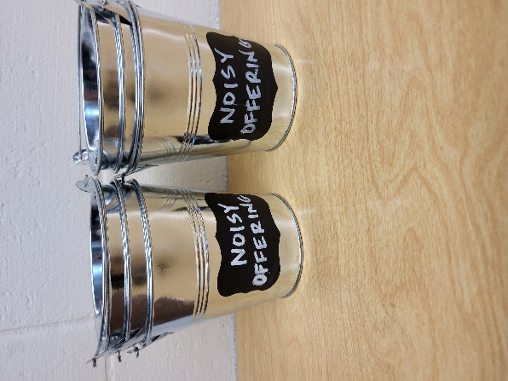
Noisy Offering: Please keep saving your spare change for our noisy offering TODAY. The February WELS Connections shared information about a Martin Luther College program called Congregational Grant Program. We are going to do a similar program to support Gracie Niemuth a member of our congregation and a junior at Lutheran Prep School in Watertown WI. Your donation will help Gracie with school expenses. We have appreciated your support for our various projects and activities.

LWMS: The Beaver Dam Circuit LWMS Spring Rally will be held Saturday April 18th at Randolph. Registration begins at 9:15 am. Please talk to Dianne Olsen if you need a ride.

Voters’ Meeting: The Quarterly Voters’ Meeting will be held after the church service on Saturday April 18th.

Communion setup and cleanup: Since communion is every week we are in need of more help. None of it is hard to do and does not take long. If you are interested please sign up on the sheet by the library. If you have questions please talk to Jo Meeker.

Mailbox and table: The April Forward In Christ is available and also the March 1, 2026-May 30, 2026 Meditations are available. March calendars are also available.

If you would like the Lord’s Supper privately, please contact Pastor Kurt Hagen at 651-764-3901, or by email pastorkhagen@gmail.com.

The Helping Hands Ministry is ready to serve the needs of our members. Please contact one of the following if you or someone you know needs assistance: Joanne Gregor at 920-896-1518 and Lisa Tremore at 920-229-1297.

For Your Information
Attendance 4/2, 3, 5/2026 272
Offerings for 4/2, 3, 5/2026 $6,339.00

Serving Our Lord

Thank you to everyone for your service to our Lord!

Ushers: April 12: Tim Lynch, TJ Sitter

April 18 & 25: Mike Schaub, Kevin Schenning, Eric Eckert Adam Covach

PowerPoint:

April 18: Jo Meeker

April 25: Jo Meeker

May 2:

April Communion Set up: Rhonda Schwandt

April Communion Clean up: Marilyn Ninneman

Saturday (11th) 5:00 PM Worship with Communion
Noisy Offering
Tuesday 5:30 PM Council Meeting
6:30 PM Ladies Aid
Wednesday 6: 15 PM Choir Practice
Thursday 9:00 AM Women’s Bible Study
Saturday (4/18) 9:15 AM LWMS Spring Rally at Randolph
5:00 PM Worship Service with Communion
6:15 PM Quarterly Voters’ Meeting

