CHRISTMAS DAY
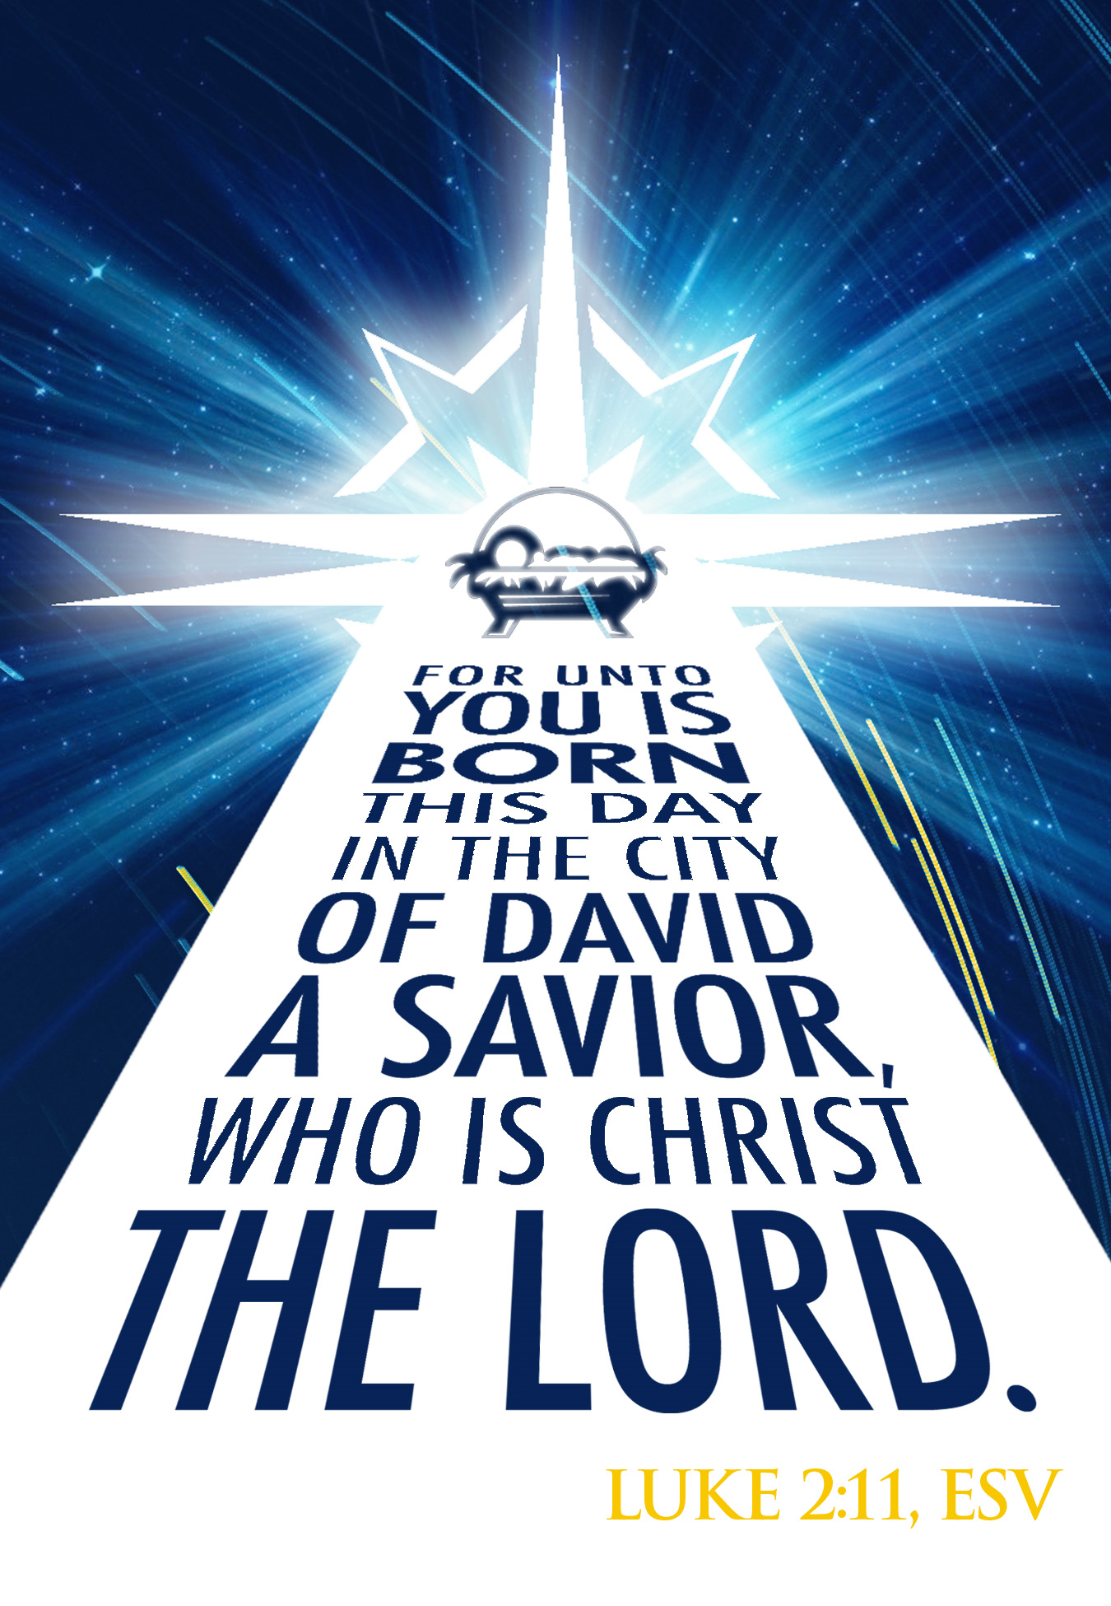
Mt. Zion Evangelical Lutheran Church

320 Mt. Zion Dr., Ripon, WI
www.mtzionripon.org
Facebook: Mt. Zion Evangelical Lutheran Church

Pastor Michael Sheppard
Pastor’s Study: 920-748-9734
E-mail: revmikesheppard@gmail.com
Christmas Day Dec. 25, 2025
Handicapped accessible restrooms are located upstairs next to the Pastor’s Study and downstairs next to the elevator.
Attendance: Please remember to sign the friendship pads. Registration for communion will continue as usual at the table. If you have any questions or concerns, please contact Pastor Sheppard or Mike Meeker.


Hearing Loop: Our sanctuary is equipped with a hearing loop system. Those who have compatible hearing aids (with a T-switch) will be able to hear the sound system directly into their ear(s). The two main seating areas and the choir area are looped so that you may sit in any of the three areas. We also have four receivers available for those who do not have compatible hearing aids. If you wish to use a receiver please ask the ushers. Those who wish may bring their own headphones or ear buds.

Hymns: 350, 358, 537, 344

Order of Worship Setting Three pg. 188

First Reading: Isaiah 52: 7-10 (EHV)
How beautiful on the mountains are the feet of a herald,
who proclaims peace and preaches good news,
who proclaims salvation,
who says to Zion, “Your God is king!”
⁸The voice of your watchmen—they lift up their voices.
Together they shout for joy,
because with both eyes they will see it
when the Lord returns to Zion.
⁹Break out, shout for joy together, you ruins of Jerusalem,
because the Lord is comforting his people.
He is redeeming Jerusalem.
¹⁰The Lord lays bare his holy arm before the eyes of all the nations,
and all the ends of the earth will see the salvation from our God.

Psalm: 98A All the Ends of the Earth

Second Reading: Hebrews 1:1-9 (EHV)
In the past, God spoke to our forefathers by the prophets at many times and in many ways. ²In these last days, he has spoken to us by his Son, whom he appointed heir of all things, and through whom he made the universe. ³The Son is the radiance of God’s glory and the exact imprint of the divine nature. He sustains all things by his powerful word. After he had provided purification for sins, he took his seat at the right hand of the Majesty on high.
⁴The Son became as much superior to the angels as the name he has inherited is more excellent than theirs. ⁵For to which of the angels did God ever say:
You are my Son. Today I have begotten you?
And again:
I will be his Father, and he will be my Son.
⁶And again, when he brought his firstborn into the world, he said:
Let all God’s angels worship him.
⁷About the angels he says:
He makes his messengers winds and his ministers flaming fire.
⁸But about the Son he says:
God, your throne is forever and ever,
and the scepter of righteousness is the scepter of your kingdom.
⁹You have loved righteousness and hated wickedness.
Therefore God, your God, has anointed you with the oil of joy beyond your companions.
Gospel Acclamation
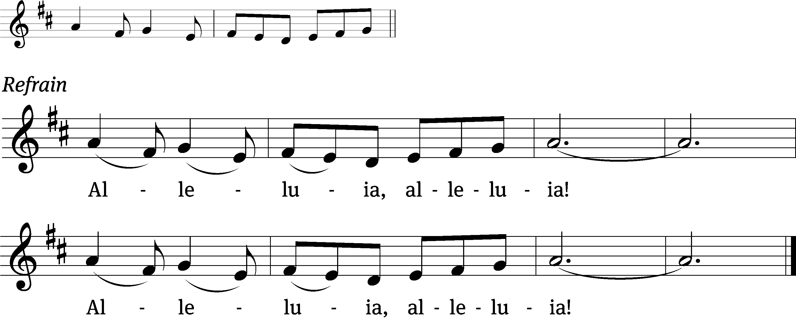
But when the set time had fully come, God / sent his Son,
born of a woman, born under the law, to redeem those und / er the law.

Gospel Reading & Sermon Text: John 1:1-10 (EHV)
In the beginning was the Word, and the Word was with God, and the Word was God. ²He was with God in the beginning. ³Through him everything was made, and without him not one thing was made that has been made. ⁴In him was life, and the life was the light of mankind. ⁵The light is shining in the darkness, and the darkness has not overcome it.
⁶There was a man, sent from God, whose name was John. ⁷He came as an eyewitness to testify about the light so that everyone would believe through him. ⁸He was not the light, but he came to testify about the light.
⁹The real light that shines on everyone was coming into the world. ¹⁰He was in the world, and the world was made through him, yet the world did not recognize him.

Sermon Theme: “Marvel at the Incarnation of Our Lord.”

OFFERING: The offerings are brought forward to the altar.

Keep in Your Prayers: Harley Dorsey, Carol Hielke, Karen Reiser, Kathy Schaub, Gary Wichman and Dick Zellmer.

