1ST SUNDAY AFTER CHRISTMAS

Mt. Zion Evangelical Lutheran Church

320 Mt. Zion Dr., Ripon, WI
www.mtzionripon.org
Facebook: Mt. Zion Evangelical Lutheran Church

Pastor Michael Sheppard
Pastor’s Study: 920-748-9734
E-mail: revmikesheppard@gmail.com
First Sunday After Christmas Dec. 28, 2025
Handicapped accessible restrooms are located upstairs next to the Pastor’s Study and downstairs next to the elevator.
Attendance: Please remember to sign the friendship pads. Registration for communion will continue as usual at the table. If you have any questions or concerns, please contact Pastor Sheppard or Mike Meeker.


Hearing Loop: Our sanctuary is equipped with a hearing loop system. Those who have compatible hearing aids (with a T-switch) will be able to hear the sound system directly into their ear(s). The two main seating areas and the choir area are looped so that you may sit in any of the three areas. We also have four receivers available for those who do not have compatible hearing aids. If you wish to use a receiver please ask the ushers. Those who wish may bring their own headphones or ear buds.

A note for our visitors on member communion –
Out of sincere love for the truth of God’s Word and for precious human souls, we practice member communion in our synod and congregation. This teaching, as practiced by the Church for centuries, is thoroughly Scriptural. It questions the faith of no individual yet asks that there be full doctrinal agreement between those who commune. For this reason, we ask that only those who are members of a WELS or ELS congregation join us for the Lord’s Supper. If you wish to commune with us please speak with the pastor before the service.
The front row on the pulpit side is reserved for people who are unable to navigate the steps. Pastor will serve you Communion first.

Prayer Before Communion: Dearest Jesus, I marvel that you read and wine of Holy Communion. Touch me with your grace that moved you to reach out to me, a poor, miserable sinner! Use this sacred supper to bring me closer to you. Amen.

Hymns: 362, 355, 331, The Blessing

Order of Worship Setting Three pg. 188

First Reading & Sermon Text: Isaiah 63:7-9 (EHV)
I will tell about the Lord’s mercies,
about the praises of the Lord,
about all that the Lord has done for us,
about his great goodness to the house of Israel,
which he performed for them according to his abundant compassion,
and according to his great mercy.
⁸He said, “Surely they are my people,
children who will not deal falsely,”
so he became their Savior.
⁹In all their anguish he felt anguish,
and the Angel of his Presence saved them.
In his love and in his pity he himself redeemed them,
and he took them up and carried them all the days of old.

Psalm: 2A You Are My Son

Second Reading: Galatians 4:4-7 (EHV)
But when the set time had fully come, God sent his Son to be born of a woman, so that he would be born under the law, ⁵in order to redeem those under the law, so that we would be adopted as sons. ⁶And because you are sons, God sent the Spirit of his Son into our hearts to shout, “Abba, Father!” ⁷So you are no longer a slave, but a son. And if you are a son, then you are also an heir of God through Christ.

Gospel Acclamation
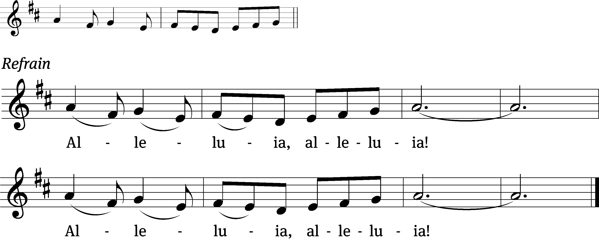
Sing to the Lord a / new song;
his right hand and his holy arm have worked salvation / for him.

Gospel Reading: Matthew 2:13-23 (EHV)
After the Wise Men were gone, an angel of the Lord suddenly appeared to Joseph in a dream. He said, “Get up, take the child and his mother, and flee to Egypt. Stay there until I tell you, because Herod will search for the child in order to kill him.”
¹⁴Joseph got up, took the child and his mother during the night, and left for Egypt. ¹⁵He stayed there until the death of Herod. This happened to fulfill what was spoken by the Lord through the prophet: “Out of Egypt I called my son.”
¹⁶When Herod realized that he had been outwitted by the Wise Men, he was furious. He issued orders to kill all the boys in Bethlehem and in all the surrounding countryside, from two years old and under. This was in keeping with the exact time he had learned from the Wise Men. ¹⁷Then what was spoken through Jeremiah the prophet was fulfilled:
¹⁸A voice was heard in Ramah,
weeping and great mourning,
Rachel weeping for her children,
and she refused to be comforted,
because they are no more.
¹⁹After Herod died, an angel of the Lord suddenly appeared in a dream to Joseph in Egypt. The angel said, ²⁰“Get up, take the child and his mother, and go to the land of Israel, for those who were trying to kill the child are dead.”
²¹Joseph got up, took the child and his mother, and went to the land of Israel. ²²But when he heard that Archelaus, Herod’s son, had succeeded his father as ruler in Judea, he was afraid to go there. Since he had been warned in a dream, he went to the region of Galilee. ²³When he arrived there, he settled in a city called Nazareth. So what was spoken through the prophets was fulfilled: “He will be called a Nazarene.”

Sermon Theme: “The Lord’s Compassion Has Brought Redemption.”

OFFERING: The offerings are brought forward to the altar.

Keep in Your Prayers: Harley Dorsey, Karen Reiser, Kathy Schaub, Ginny Verch, Gary Wichman and Dick Zellmer.

Announcements
Pre-Call Survey: A pre-call survey form is available on the table at the back of the church. Please take one home to fill out and return by Jan. 4th. This will help our District President understand our situation and pastoral needs.

Offering Envelopes: Offering envelopes for 2026 are now available. PLEASE DO NOT USE UNTIL JANUARY AS YOUR NUMBER MAY HAVE CHANGED.

New Year’s Eve: New Year's Eve worship with communion will be at 6:30 PM.
Birthday Cake: The date for the next birthday celebration will be January 4th. Join us for fellowship, cake and refreshments.

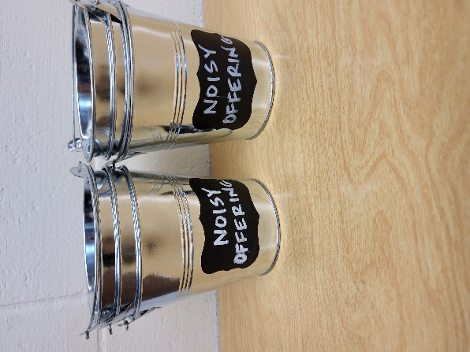
Noisy Offering: Please keep saving your spare change for our noisy offering on Jan. 4th. Your offering will be given to our Befriend a Mission the Vine Lutheran Church in Coeur d’Alene ID. Their mission is “Connecting people to Jesus and growing together in his Word.” Thank you for generous donation of $520.46 to the Lighthouse Youth Center. We have appreciated your support for our various projects and activities.

Shut-in Visits: We are hoping to start a program to make sure all our shut-ins are receiving consistent visits from members here at church. If you would like to coordinate a schedule to plan monthly visits or if you would like to volunteer to visit a shut-in please see the sign-up sheet on the table by the office.

Hymn Sing: If you have any requests for January hymn sing please talk to Sue Sheppard or Jo Meeker.

Mailbox and table: The December Forward In Christ is available and also the Nov. 30 2025-Feb. 28, 2026 Meditations are available.
If you would like the Lord’s Supper privately, please contact Pastor Sheppard on his cell 920-745-0883, or by email revmikesheppard@gmail.com.
The Helping Hands Ministry is ready to serve the needs of our members. Please contact one of the following if you or someone you know needs assistance: Joanne Gregor at 920-896-1518 and Lisa Tremore at 920-229-1297.
For Your Information
Attendance 12/21-25 386
Offerings for 12/21 $6,373.00

Serving Our Lord

Thank you to everyone for your service to our Lord!

Ushers:

Dec. 28: Tim Lynch, Logan Lynch, TJ Sitter

Dec. 31: Mike Schaub, Kevin Schenning, Eric Eckert, Adam Covach

PowerPoint:

Dec. 28 : Jo Meeker

Dec. 31: Jo Meeker

Jan. 4: Grunert Family

January 11: Jo Meeker

January 18: Jan Ohlrich

Jan. Communion Set up: Joanne Gregor

Jan. Communion Clean up: Donna Mueller

Sunday (28th) 9:00 AM Worship Service with Communion
No Bible Study or Sunday School
Sunday 9:00 AM Worship Service
10:15 AM Sunday School



