Advent 2
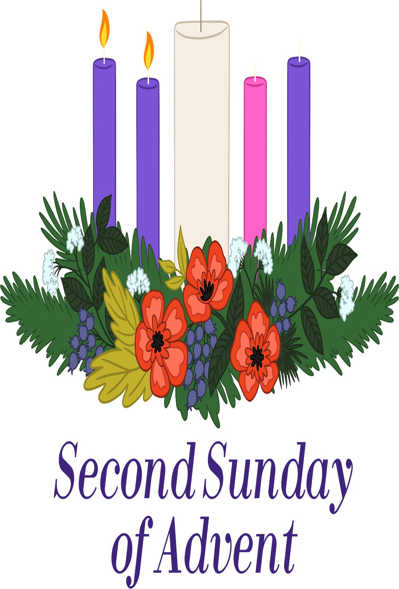
Mt. Zion Evangelical Lutheran Church
320 Mt. Zion Dr., Ripon, WI
www.mtzionripon.org
Facebook: Mt. Zion Evangelical Lutheran Church

Pastor Michael Sheppard
Pastor’s Study: 920-748-9734
E-mail: revmikesheppard@gmail.com
Advent 2 December 5, 2021

Welcome to Mt. Zion!
Handicapped accessible restrooms are located upstairs next to the Pastor’s Study and downstairs next to the elevator.
Attendance: Please remember to sign the friendship pads. Registration for communion will continue as usual at the table. If you have any questions or concerns please contact Pastor Sheppard or Mark Roeder.

Please feel free to ask Pastor Sheppard any questions you may have concerning COVID-19. May the Lord be with us as we worship together at church. (The services will continue to be posted on Facebook, Rumble, and the church website, and available on DVD.)

Hearing Loop: Our sanctuary is equipped with a hearing loop system. Those who have compatible hearing aids (with a T-switch) will be able to hear the sound system directly into their ear(s). The two main seating areas and the choir area are looped so that you may sit in any of the three areas. We also have four receivers available for those who do not have compatible hearing aids. Those who wish may bring their own headphones or ear buds. If you wish to use a receiver please ask the ushers.

Advent Prayer: Precious Savior, the pre-Christmas season with its busyness threatens to hit me like a tidal wave that washes away the spiritual focus you want me to have. Keep me grounded in the season of Advent and its rich meaning. Slow me down so that I take the time to contemplate the wonder of your first coming to be my Savior. Amen.

Hymns: 13, 16, 9

Order of Worship: Morning Praise pg. 45

Psalm 24 Pg. 73 of Christian Worship

First Lesson: Malachi 3: 1-4 (EHV)
Look! I am sending my messenger! He will prepare the way before me. Then suddenly the Lord, whom you are seeking, will come to his temple! The Messenger of the Covenant, in whom you delight, will surely come, says the Lord of Armies.
² But who can endure the day when he comes? Who will remain standing when he appears? For he will be like a refiner’s fire, like launderers bleach! ³ He will be seated like a refiner and a purifier of silver. He will purify the sons of Levi and refine them like gold and like silver. They will belong to the Lord and bring him an offering in righteousness.
⁴ Judah and Jerusalem’s offerings will be pleasing to the Lord as they were in the days of old, in years long ago.

Second Lesson: I Corinthians 4: 1-5 (EHV)
This is the way a person should think of us: as servants of Christ and stewards of God’s mysteries. ² In this connection, moreover, it is required of stewards that they be found faithful. ³ But it is a trivial matter to me if I am evaluated by you or by a day in a human court. Why, I do not even evaluate myself. ⁴ I do not in fact know of anything against myself, but I am not justified by this; rather, the one who evaluates me is the Lord. ⁵ Therefore judge nothing ahead of time, until the Lord comes. He will bring to light whatever is hidden in darkness and also reveal the intentions of hearts. Then there will be praise for each person from God.

Choir Song: “Prepare the Way O Zion”
This bright, cheerful Swedish folk song for the Advent season is accompanied by Clarinet - Sue Sheppard, Hand Drum - Mary Clement, and Piano - Kathy Schaub

Gospel Lesson & Sermon Text: Luke 3: 1-6 (EHV)
In the fifteenth year of the reign of Tiberius Caesar—while Pontius Pilate was governor of Judea, Herod was tetrarch of Galilee, his brother Philip was tetrarch of the region of Ituraea and Trachonitis, and Lysanias was tetrarch of Abilene— ² during the high priesthood of Annas and Caiaphas, the word of God came to John, the son of Zechariah, in the wilderness. ³ He went into the whole region around the Jordan, preaching a baptism of repentance for the forgiveness of sins. ⁴ Just as it is written in the book of the words of Isaiah the prophet:
A voice of one calling in the wilderness,
“Prepare the way of the Lord! Make his paths straight.
⁵ Every valley will be filled, and every mountain and hill will be
made low.
The crooked will become straight, and the rough ways smooth.
⁶ And everyone will see the salvation of God.”

The Holy Bible, Evangelical Heritage Version® (EHV®)
copyright © 2018 The Wartburg Project. All rights reserved. www.wartburgproject.org

Sermon Theme: “Prepare The Way For The Savior!”

Please remember in your prayers: Benjie Niemuth & Dick Zellmer

Door Offering: We will have a door offering today for Pastor Ziebell to thank him for his help during the year. Baskets are located at each door as you leave the church.

Announcements

Advent Devotions: Free booklets entitled “We Have Seen His Glory” are available on the tables to use each day through the Advent Season. These are made available to us as a gift from the Martin Luther College campus family. They will make nice Advent calendars. Please help yourself.
New for Online Offerings: A message from Vanco, the provider of the GivePlus Mobile app: Vanco is replacing the GivePlus Mobile app with an improved app – Vanco Mobile – that comes with more features and tools. Mt. Zion is already set up with this new app so that you can make a donation through Mt. Zion’s website, or with the mobile app. Vanco will stop supporting GivePlus Mobile on January 31, 2022, which means you will not be able to make any new donations using GivePlus Mobile after that date. (Any recurring gift that you have already scheduled will continue to be made without interruption.) Vanco Mobile is free and available in the Google Play store and the Apple App store now. Your log-in credentials stay the same in Vanco Mobile; no need for a new user ID or password.
New Tool Available: Members and guests can fill out a text field with their donation, creating a personal connection with each gift. For example, members can dedicate altar flowers or give a donation in memory of a loved one when they use Vanco Online or Vanco Mobile.

Cookies for Shut-ins: Please bring 1 dozen cookies on December 12th for our shut-ins. They will be delivered that week.
New Hymnals: The new hymnals have arrived. They are $25.00 each. You can pick them up and pay for them today.
Budget Voter’s Meeting Today: There will be a budget meeting after church in the fellowship hall. Proposed budget sheets are available on the table by the bulletins.
Clavinova Piano: We are starting to raise funds for a new Clavinova piano. Our present one is quickly wearing out. The total cost for it is $9,934.00. If you would like to donate towards the instrument, please mark that on your envelope so it goes in the right account. There has been a dedicated account set up for any donations.

WLA Capital Campaign: Please contact Kevin Ehlke with any questions you may have at 920-539-4041 or kehlke@wlavikings.org. If you would like to give in support of our current capital campaign, please use the brochures provided at your church or go to our website forward.wlavikings.org/donate. Gifts can be mailed to WLA or given online at our website. Thank you for your continued support of WLA!

Hymn Sing: Our next hymn sing will be on December 12th. If you have favorite Advent or Christmas hymns you wish to sing, please contact Jo at the church office.

Birthday Celebration: Cake will be served on December 12th to celebrate the birthdays for December.

Poinsettias are now available for purchase to help beautify our church again this year. The price is $10.99 and the plants were grown in Wisconsin. A sign-up sheet is on the wall by the flower chart. Also, you may designate a plant as a memorial if you wish. Checks should be made out to Webster’s and given to Marilyn Ninneman. Cash is also acceptable. Any questions, please call her at 748-6474.
Ladies Aid: The Ladies Aid Christmas party will be held on December 14th at 6:00 PM in the church fellowship hall. We will be collecting stocking money that evening. A signup sheet is posted on the bulletin board by the office. If you have any questions please contact Tammy Niemuth.
Hook Rug: A hook rug of the Last Supper has been donated to the church by Kathy Sprague. Carol Kapp had started work on it; there is a lot of work yet to be done on it. If you are interested, let Jo Meeker know when you would like to come in and work on it, and she can arrange for an open door. This could be a nice group project. The rug is in the old 3rd grade Sunday School room by the elevator.
Kitchen & Church Cleaning: A fall/winter cleaning list is on the bulletin board upstairs and in the kitchen. This is open to anyone in the congregation who is willing to help.

Mailbox and table: The December Forward In Christ is available and also the November 28th, 2021- February 26th, 2022 Meditations are available.

If you would like the Lord’s Supper privately, please contact Pastor Sheppard on his cell 920-745-0883, or by email revmikesheppard@gmail.com.

The Helping Hands Ministry is ready to serve the needs of our members. Please contact one of the following if you or someone you know needs assistance: Joanne Gregor at 920-896-1518, Lisa Tremore at 920-229-1297 or Tammy Niemuth at 920-299-0240.

For Your Information
Attendance 11/24-11/28/2021 166
Offerings for 11/24-11/28/2021: $10,734.00*
Includes $930 total so far towards the new Clavinova (piano)

Serving Our Lord

Thank you to everyone for your service to our Lord!

Ushers:

Dec. 5 & 12: Justen Niemuth, Ed Manske, Warren Schwandt, Derek Chitwood

Dec. 19 & 26: Dave Smith, Josh Niemuth, Remi Mueller, Roman Mueller

PowerPoint:

Dec. 5: Grunert Family

Dec. 12: Jo Meeker

Dec. 19: Sara Grunert

Dec Communion Set up: Jo Meeker

Dec Communion Clean up: Janet & Al Brooks/Sue Sheppard

This week at Mt. Zion
Sunday (5th) 9:00 AM Worship Service
10:15 AM Sunday School, Christmas Practice & Voter’s Budget Meeting
Monday 6:30 PM Bible Study
Wednesday 5:00 PM Catechism Class
6:15 PM Choir Practice
7:15 PM Council Meeting
Sunday 8:45 AM Hymn Sing
9:00 AM Worship Service with Communion
10:15 AM Sunday School, Christmas Practice & Birthday Celebration

Secretary Jo Meeker
Church Office: 920-748-5641
Office Hours: Mon. 9-12, Tues. & Wed. 9-11
E-mail: mountzionripon@gmail.com

