Advent 1
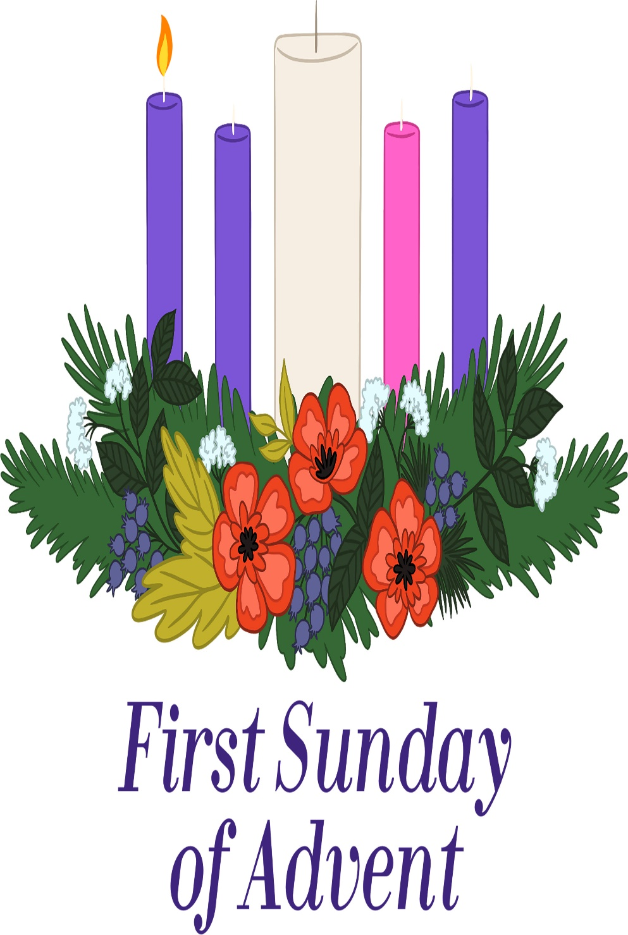
Mt. Zion Evangelical Lutheran Church
320 Mt. Zion Dr., Ripon, WI
www.mtzionripon.org
Facebook: Mt. Zion Evangelical Lutheran Church

Pastor Michael Sheppard
Pastor’s Study: 920-748-9734
E-mail: revmikesheppard@gmail.com
Advent 1 November 28, 2021

Welcome to Mt. Zion!
Handicapped accessible restrooms are located upstairs next to the Pastor’s Study and downstairs next to the elevator.
Attendance: Please remember to sign the friendship pads. Registration for communion will continue as usual at the table. If you have any questions or concerns please contact Pastor Sheppard or Mark Roeder.

Please feel free to ask Pastor Sheppard any questions you may have concerning COVID-19. May the Lord be with us as we worship together at church. (The services will continue to be posted on Facebook, Rumble, and the church website, and available on DVD.)

Hearing Loop: Our sanctuary is equipped with a hearing loop system. Those who have compatible hearing aids (with a T-switch) will be able to hear the sound system directly into their ear(s). The two main seating areas and the choir area are looped so that you may sit in any of the three areas. We also have four receivers available for those who do not have compatible hearing aids. Those who wish may bring their own headphones or ear buds. If you wish to use a receiver please ask the ushers.

A note for our visitors on member communion –
Out of sincere love for the truth of God’s Word and for precious human souls, we practice member communion in our synod and congregation. This teaching, as practiced by the Church for centuries, is thoroughly Scriptural. It questions the faith of no individual yet asks that there be full doctrinal agreement between those who commune. For this reason, we ask that only those who are members of a WELS or ELS congregation join us for the Lord’s Supper. If you wish to commune with us please speak with the pastor before the service.
The front row on the pulpit side is reserved for people who are unable to navigate the steps. Pastor will serve you Communion first.
Please Note: We will now be standing or kneeling at the communion rail. Hand sanitizer will be available on stands at the front of the church.

Advent Prayer: Precious Savior, the pre-Christmas season with its busyness threatens to hit me like a tidal wave that washes away the spiritual focus you want me to have. Keep me grounded in the season of Advent and its rich meaning. Slow me down so that I take the time to contemplate the wonder of your first coming to be my Savior. Amen.

Hymns: 469, 2, 310, 477

Order of Worship: Service of Word and Sacrament pg. 26

First Lesson & Sermon Text: Genesis 19:15-17, 23-29 (EHV)
When the dawn came, the angels urged Lot, “Get going! Take your wife and your two daughters who are here, so that you will not be swept away by the guilt of the city.” ¹⁶ But Lot was taking too much time, so the men grabbed his hand, his wife’s hand, and the hands of his two daughters, because of the Lord’s compassion for him. They led him out and placed him outside of the city. ¹⁷ Then when they had taken them out, one of them said, “Run for your life! Don’t look behind you, and don’t stay anywhere in the plain. Escape to the mountains, so that you are not swept away!” ²³ The sun had risen over the land when Lot came to Zoar. ²⁴ Then the Lord rained on Sodom and Gomorrah sulfur and fire out of the sky from the Lord. ²⁵ He overthrew those cities, as well as all the plain, all the inhabitants of the cities, and whatever grew in the soil. ²⁶ But Lot’s wife, who was behind him, looked back, and she became a pillar of salt.
²⁷ Abraham got up early in the morning and went to the place where he had stood before the Lord. ²⁸ He looked down toward Sodom and Gomorrah and all the land of the plain. As he looked, he saw that the smoke from the land was going up like the smoke from a kiln. ²⁹ And so when God destroyed the cities of the plain, God remembered Abraham and brought Lot out through the middle of the devastation, when he overthrew the cities where Lot had lived.

Psalm 25 Pg. 74 of Christian Worship

Second Lesson: I Thessalonians 3: 9-13 (EHV)
Indeed, how can we thank God enough for you in return for all the joy we have before God on account of you? ¹⁰ Night and day we are praying earnestly to see you in person and to supply what is lacking in your faith.
¹¹ May God our Father himself and our Lord Jesus direct our way to you. ¹² And may the Lord increase your love and make it overflow for each other and for all people, just as ours does for you, ¹³ so that he may establish your hearts as blameless in holiness before our God and Father, when our Lord Jesus comes with all his saints.

Gospel Lesson: Luke 21: 25-36 (EHV)
“There will be signs in the sun, moon, and stars. And on the earth nations will be in anguish, in perplexity at the roaring of the sea and the surging waves, ²⁶ people fainting from fear and expectation of the things coming on the world, for the powers of the heavens will be shaken. ²⁷ And then they will see the Son of Man coming in a cloud with power and great glory.] ²⁸ But when these things begin to happen, stand up and lift up your heads, because your redemption is near.” ²⁹ He told them a parable. “Look at the fig tree and all the trees. ³⁰ As soon as they are sprouting leaves, you can see for yourselves and know that summer is actually near. ³¹ So also, when you see these things happening, know that the kingdom of God is ion will not pass away until all these things happen. ³³ Heaven and earth will pass away, but my words will never pass away. ³⁴ “Watch yourselves or else your hearts will be weighed down with carousing, drunkenness, and the worries of this life, and that day may come on you suddenly. ³⁵ For it will come like a trap on all those who dwell on the face of the whole earth. ³⁶ Stay alert all the time, praying that you may be able to escape all these things that are going to happen and that you may be able to stand before the Son of Man.”

The Holy Bible, Evangelical Heritage Version® (EHV®)
copyright © 2018 The Wartburg Project. All rights reserved. www.wartburgproject.org

Sermon Theme: “The Lord Rains Down Justice.”

Please remember in your prayers: Benjie Niemuth & Dick Zellmer, Pastor Nathaniel Bourman, Luke Wolfgramm and Pastor Jonathan Bauer.

Door Offering: We will have a door offering today and next Sunday, Dec 5th, for Pastor Ziebell to thank him for his help during the year. Baskets are located at each door as you leave the church.

Announcements

New for Online Offerings: A message from Vanco, the provider of the GivePlus Mobile app: Vanco is replacing the GivePlus Mobile app with an improved app – Vanco Mobile – that comes with more features and tools. Mt. Zion is already set up with this new app so that you can make a donation through Mt. Zion’s website, or with the mobile app. Vanco will stop supporting GivePlus Mobile on January 31, 2022, which means you will not be able to make any new donations using GivePlus Mobile after that date. (Any recurring gift that you have already scheduled will continue to be made without interruption.) Vanco Mobile is free and available in the Google Play store and the Apple App store now. Your log-in credentials stay the same in Vanco Mobile; no need for a new user ID or password.
New Tool Available: Members and guests can fill out a text field with their donation, creating a personal connection with each gift. For example, members can dedicate altar flowers or give a donation in memory of a loved one when they use Vanco Online or Vanco Mobile.

Advent Devotions: Free booklets entitled “We Have Seen His Glory” are available on the tables to use each day through the Advent Season. These are made available to us as a gift from the Martin Luther College campus family. They will make nice Advent calendars. Please help yourself.
Cookies for Shut-ins: Please bring 1 dozen cookies on December 12th for our shut-ins. They will be delivered that week.
New Hymnals: The new hymnals have arrived. They are $25.00 each. You can pick them up and pay for them today.
Budget Voter’s Meeting: Please note there will be a budget meeting on December 5th after church in the fellowship hall. Proposed budget sheets are available on the table by the bulletins.
Befriend A Mission Program: The Befriend A Mission (BAM) program encourages congregations to remember the missions of WELS congregations as well as the missionaries who serve them. Congregations are assigned specific world and home missions. The congregations are encouraged to pray for those missions, write letters of encouragement, and send cards. Our missionaries are Pastor Bourman, Pastor Bauer, and Luke Wolfgramm. (Please look back at your newsletters in Jan-April to refresh your memory on info about the missions.) Cards are due today.
Clavinova Piano: We are starting to raise funds for a new Clavinova piano. Our present one is quickly wearing out. The total cost for it is $9,934.00. If you would like to donate towards the instrument, please mark that on your envelope so it goes in the right account. There has been a dedicated account set up for any donations.

WLA Capital Campaign: Please contact Kevin Ehlke with any questions you may have at 920-539-4041 or kehlke@wlavikings.org. If you would like to give in support of our current capital campaign, please use the brochures provided at your church or go to our website forward.wlavikings.org/donate. Gifts can be mailed to WLA or given online at our website. Thank you for your continued support of WLA!

Hymn Sing: Our next hymn sing will be on December 12th. If you have favorite Advent or Christmas hymns you wish to sing, please contact Jo at the church office.

Birthday Celebration: Cake will be served on December 12th to celebrate the birthdays for December.

Poinsettias are now available for purchase to help beautify our church again this year. The price is $10.99 and the plants were grown in Wisconsin. A sign-up sheet is on the wall by the flower chart. Also, you may designate a plant as a memorial if you wish. Checks should be made out to Webster’s and given to Marilyn Ninneman. Cash is also acceptable. Any questions, please call her at 748-6474.
Ladies Aid: The Ladies Aid Christmas party will be held on December 14th at 6:00 PM in the church fellowship hall. We will be collecting stocking money that evening. A signup sheet is posted on the bulletin board by the office. If you have any questions please contact Tammy Niemuth.
Hook Rug: A hook rug of the Last Supper has been donated to the church by Kathy Sprague. Carol Kapp had started work on it; there is a lot of work yet to be done on it. If you are interested, let Jo Meeker know when you would like to come in and work on it, and she can arrange for an open door. This could be a nice group project. The rug is in the old 3rd grade Sunday School room by the elevator.
Mailbox and table: The November Forward In Christ is available and also the November 28th, 2021- February 26th, 2022 Meditations are available.

If you would like the Lord’s Supper privately, please contact Pastor Sheppard on his cell 920-745-0883, or by email revmikesheppard@gmail.com.

The Helping Hands Ministry is ready to serve the needs of our members. Please contact one of the following if you or someone you know needs assistance: Joanne Gregor at 920-896-1518, Lisa Tremore at 920-229-1297 or Tammy Niemuth at 920-299-0240.

For Your Information
Attendance 11/18-11/21/2021 113
Offerings for 11/18-11/21/2021: $11,256.00*
Includes $710 total so far towards the new Clavinova (piano)
$955 in memory of Bob Zanto

Serving Our Lord

Thank you to everyone for your service to our Lord!

Ushers:

Nov. 28: Mike Schaub, Kevin Schenning, Robert Duzinske, Adam Covach

Dec. 5 & 12: Justen Niemuth, Ed Manske, Warren Schwandt, Derek Chitwood

PowerPoint:

Nov. 28: Jo Meeker

Dec. 5: Grunert Family

Dec. 12: Jo Meeker

Dec. 19: Sara Grunert

Nov Communion Set up: Jo Meeker

Nov Communion Clean up: Janet & Al Brooks/Sue Sheppard

This week at Mt. Zion
Sunday (28th) 9:00 AM Worship Service with Communion
10:15 AM Sunday School, Christmas Practice & Bible Study
Monday 6:30 PM Bible Study
Wednesday 5:00 PM Catechism Class
6:15 PM Choir Practice
Sunday 9:00 AM Worship Service
10:15 AM Sunday School, Christmas Practice & Voter’s Budget meeting

Secretary Jo Meeker
Church Office: 920-748-5641
Office Hours: Mon. 9-12, Tues. & Wed. 9-11
E-mail: mountzionripon@gmail.com

