FIRST SUNDAY OF ADVENT

Mt. Zion Evangelical Lutheran Church

320 Mt. Zion Dr., Ripon, WI
www.mtzionripon.org
Facebook: Mt. Zion Evangelical Lutheran Church

Pastor Michael Sheppard
Pastor’s Study: 920-748-9734
E-mail: revmikesheppard@gmail.com
First Sunday of Advent Nov. 30, 2025
Handicapped accessible restrooms are located upstairs next to the Pastor’s Study and downstairs next to the elevator.
Attendance: Please remember to sign the friendship pads. Registration for communion will continue as usual at the table. If you have any questions or concerns, please contact Pastor Sheppard or Mike Meeker.


Hearing Loop: Our sanctuary is equipped with a hearing loop system. Those who have compatible hearing aids (with a T-switch) will be able to hear the sound system directly into their ear(s). The two main seating areas and the choir area are looped so that you may sit in any of the three areas. We also have four receivers available for those who do not have compatible hearing aids. If you wish to use a receiver please ask the ushers. Those who wish may bring their own headphones or ear buds.

A note for our visitors on member communion –
Out of sincere love for the truth of God’s Word and for precious human souls, we practice member communion in our synod and congregation. This teaching, as practiced by the Church for centuries, is thoroughly Scriptural. It questions the faith of no individual yet asks that there be full doctrinal agreement between those who commune. For this reason, we ask that only those who are members of a WELS or ELS congregation join us for the Lord’s Supper. If you wish to commune with us please speak with the pastor before the service.
The front row on the pulpit side is reserved for people who are unable to navigate the steps. Pastor will serve you Communion first.

Prayer Before Communion: Dearest Jesus, I marvel that you came to this earth as the Word made flesh. With similar awe I contemplate how you give me your body and blood in the bread and wine of Holy Communion. Touch me with your grace that moved you to reach out to me, a poor, miserable sinner! Use this sacred supper to bring me closer to you. Amen.

Hymns: 360, 487, (663), 507

Order of Worship Setting Three pg. 188

First Reading & Sermon Text: Isaiah 2: 1-5 (EHV)
This is the message that Isaiah son of Amoz saw concerning Judah and Jerusalem.
²This will take place in the latter days:
The mountain of the Lord’s house will be established
as the chief of the mountains.
It will be raised above the hills,
and all nations will stream to it like a river.
³Many peoples will come and say,
“Come, let us go up to the mountain of the Lord,
to the house of the God of Jacob.
Then he will instruct us about his ways,
and we will walk in his paths.”
For from Zion the law will go out,
and the Lord’s word will go out from Jerusalem.
⁴He will judge between the nations,
and he will mediate for many peoples.
Then they will beat their swords into plowshares,
and their spears into pruning hooks.
Nation will not lift up sword against nation,
nor will they learn war anymore.
⁵O house of Jacob, come,
and let us walk in the light of the Lord.

Psalm: 24A Welcome the King of Glory
Second Reading: Philippians 4:4-7 (EHV)
Rejoice in the Lord always! I will say it again: Rejoice! ⁵Let your gentleness be known to everyone. The Lord is near. ⁶Do not worry about anything, but in everything, by prayer and petition, with thanksgiving, let your requests be made known to God. ⁷And the peace of God, which surpasses all understanding, will guard your hearts and your minds in Christ Jesus.

Gospel Acclamation
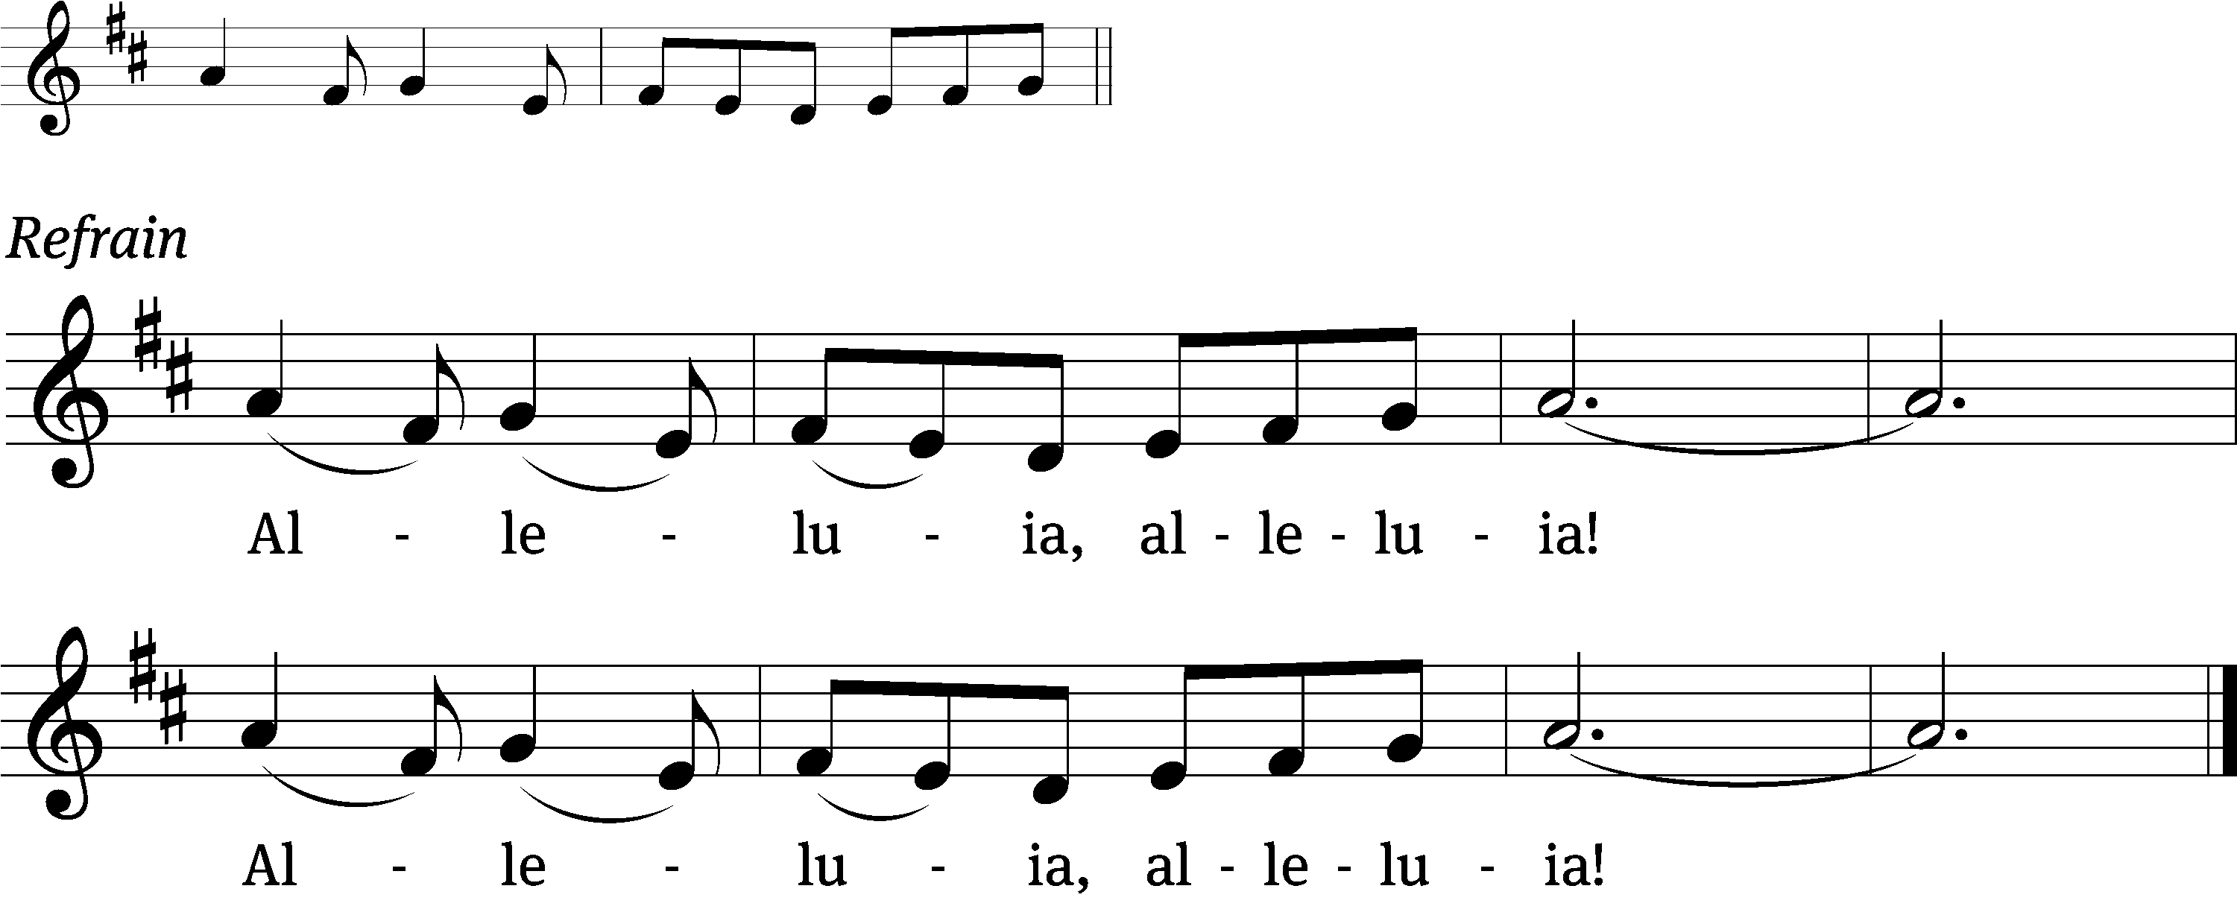
Come to us, Em-/ manuel
Come and set your / people free. Refrain

Gospel: Matthew 21: 1-11 (EHV)
As they approached Jerusalem and came to Bethphage on the Mount of Olives, Jesus sent two disciples, ²telling them, “Go to the village ahead of you. Immediately you will find a donkey tied there along with her colt. Untie them and bring them to me. ³If anyone says anything to you, you are to say, ‘The Lord needs them,’ and he will send them at once.”
⁴This took place to fulfill what was spoken through the prophet:
⁵Tell the daughter of Zion: Look, your King comes to you, humble, and riding on a donkey, on a colt, the foal of a donkey.
⁶The disciples went and did just as Jesus commanded them. ⁷They brought the donkey and the colt, laid their outer clothing on them, and he sat on it. ⁸A very large crowd spread their outer clothing on the road. Others were cutting branches from the trees and spreading them out on the road. ⁹The crowds who went in front of him and those who followed kept shouting,
Hosanna to the Son of David!
Blessed is he who comes in the name of the Lord!
Hosanna in the highest!
¹⁰When he entered Jerusalem, the whole city was stirred up, asking, “Who is this?” ¹¹And the crowds were saying, “This is Jesus, the prophet from Nazareth in Galilee.”

Sermon Theme: “Let Us Come to the Mountain of the Lord.”

OFFERING: The offerings are brought forward to the altar.

Keep in Your Prayers: Harley Dorsey, Carol Henning, Carol Hielke, Karen Reiser, Gary Wichman and Dick Zellmer.

Announcements
MLC Advent Devotions are available now on the tables by the church entry. They begin today.

Advent By Candlelight – Unwrapping the Names of Jesus TODAY! BEGINNING AT 6:00 pm. THERE IS STILL ROOM TO JOIN US. PLEASE CONTACT JO MEEKER OR KARI HIELKE.

Jesus, King of kings, Immanuel, Prince of Peace—we hear these names referring to God’s Son often during this time of year. They’re in the hymns we sing, the passages preached, the words on our lips. Do we ever stop to consider what they mean? In fact, each name reveals to us truth. They remind us of what God has accomplished. Each name confesses something uniquely special that he has done for you and for me.

This Advent by Candlelight program seeks to focus our attention right on Jesus by taking a deeper look—through Scripture, narrative, and song—at the names we hear him often called during Advent. Each name reveals a priceless gift just waiting to be opened and treasured for a lifetime. Each name is a perfect gift to unwrap.

Congregation Christmas Party will be held in the Fellowship Hall on December 9th beginning at 5:30. A signup sheet is available on the table by the office door. Cost for the catered dinner is $16.00.
Attention Parents of Sunday School Children
The Sunday School Teachers have prepared the 2025 Children’s Christmas Service. In the next few weeks we will be sending parts and songs home with the children. Please start working with them. The actual practices will start TODAY. We will hold the service on Dec. 21st.
Befriend A Mission (BAM): During November LWMS encourages congregations to remember our missionaries with cards that show our support and gives them needed encouragement. Mt. Zion has participated in this project for several years and will do so again this year from November 9th to December 7th. We are asking our members to write cards to Pastor Jeremy Belter, Pastor Kevin Schultz, and Pastor Matt Behmer. As you enter church, you will see a display table with information about each of our missionaries. There will be paper bags with Christmas cards you can take with you to write to each of our missionaries, or if you prefer to use your own cards that is another option. Please return cards to Mt. Zion by December 7th, so they can be mailed to the missionaries for Christmas. Thank you for taking a moment to send our missionaries cards and keeping them in your prayers.

Birthday Cake: The next birthday celebration will be December 7th.
Please join us for fellowship, cake and refreshments.

Shut-in Visits: We are hoping to start a program to make sure all our shut-ins are receiving consistent visits from members here at church. If you would like to coordinate a schedule to plan monthly visits or if you would like to volunteer to visit a shut-in please see the sign up sheet on the table by the office.


The December Movie Matinee will be “Ordinary Angels” on December 5th from 1-3 P.M. Popcorn and Movie Candy will be furnished but bring your own beverage. Hope to see you there!

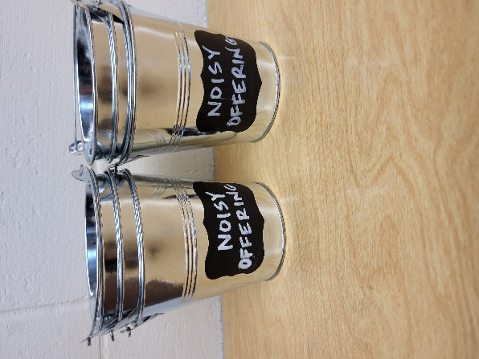
Noisy Offering: Please keep saving your spare change for our noisy offering on Dec. 7th. Your offering will be given to the Lighthouse Youth Center. The Mission of Lighthouse is to be a beacon for Christ to the youth of the community. See the bulletin insert. We have appreciated your support for our various projects and activities. Thank you for your generosity.

Hymn Sing: The next hymn sing will Dec. 28th. If you have any requests for future hymn sings please talk to Sue Sheppard or Jo Meeker.

Mailbox and table: The December Forward In Christ is available and also the Nov. 30 2025-Feb. 28, 2026 Meditations are available.
If you would like the Lord’s Supper privately, please contact Pastor Sheppard on his cell 920-745-0883, or by email revmikesheppard@gmail.com.
The Helping Hands Ministry is ready to serve the needs of our members. Please contact one of the following if you or someone you know needs assistance: Joanne Gregor at 920-896-1518 and Lisa Tremore at 920-229-1297.
For Your Information
Attendance 11/23 94
Offerings for 11/23 $2,565.00
Serving Our Lord

Thank you to everyone for your service to our Lord!

Ushers:

Nov. 30: Mike Schaub, Kevin Schenning, Eric Eckert, Adam Covach

Dec. 7 & 14 Tobin Storzer, Rick Retelle, Kelly Frank

PowerPoint:

Nov. 30: Kari Hielke

Dec. 7: Grunert Family

Dec. 14: Jo Meeker

December 21: Jan Ohlrich

Dec. Communion Set up: Jo Meeker

Dec. Communion Clean up: Janet/Al Brooks & Sue Sheppard

Sunday (30th) 9:00 AM Worship Service with Communion
10:15 AM Sunday School with Christmas Service Practice, Bible Study
5:00 PM Confirmation Class
6:00 PM Advent by Candlelight in the Fellowship Hall
Tuesday 9:00 AM Bible Study
5:30 PM Council Meeting
Wednesday NO Choir Practice
Thursday 9:00 AM Women’s Bible Study
Sunday 9:00 AM Worship Service
Birthday Celebration
10:15 AM Sunday School with Christmas Service Practice & Bible Study
5:00 PM Confirmation Class

