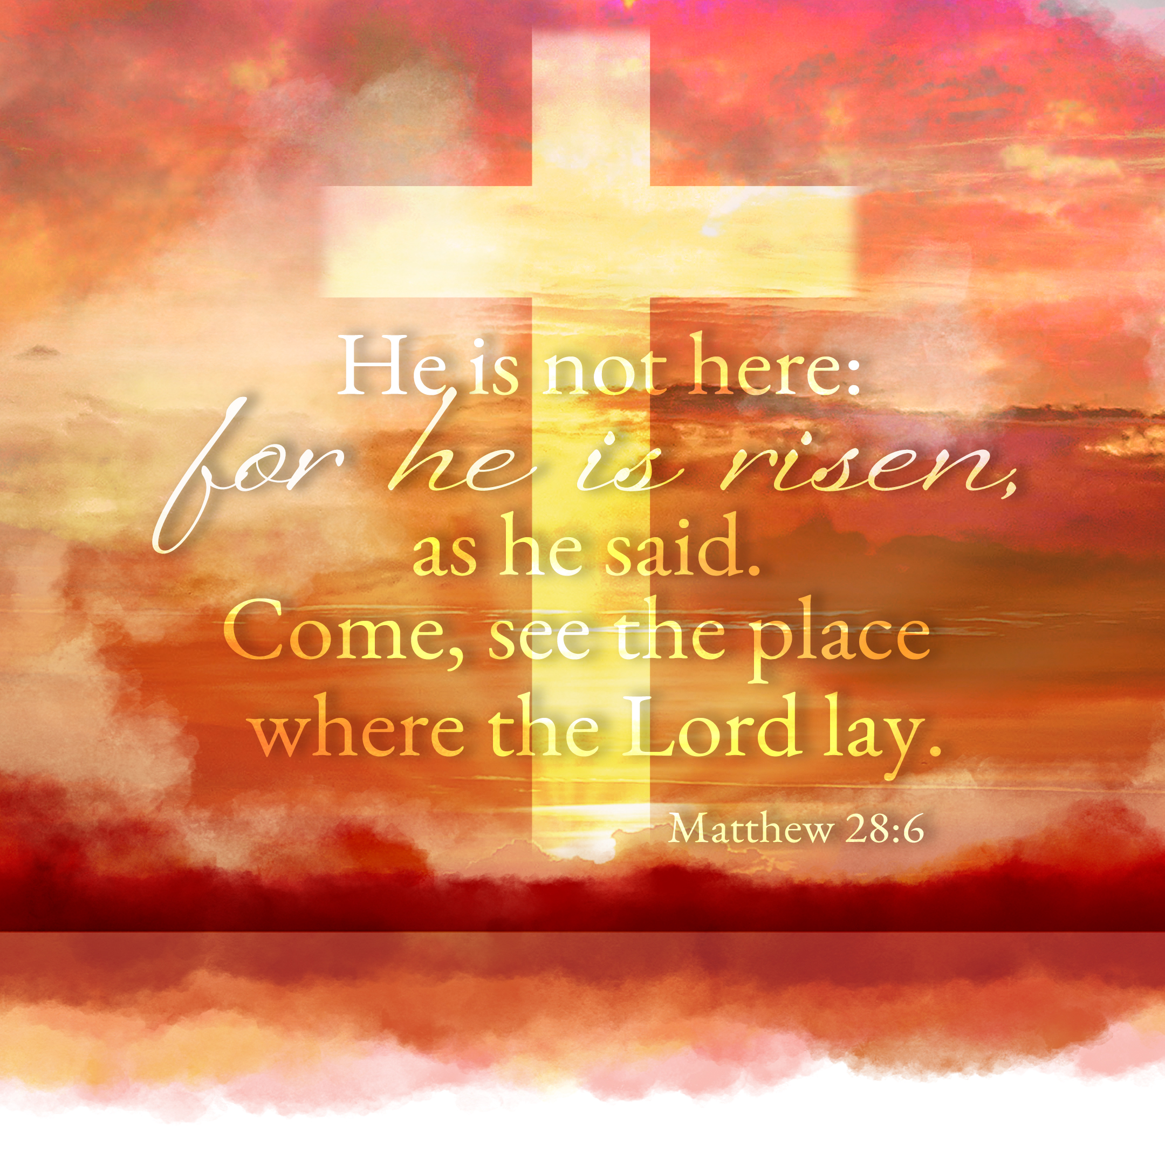
The Resurrection of the Lord
April 17, 2022 9:00AM Easter Day

Welcome to Mt. Zion!
Handicapped accessible restrooms are located upstairs next to the Pastor’s Study and downstairs next to the elevator.
Attendance: Please remember to sign the friendship pads. Registration for communion will continue as usual at the table. If you have any questions or concerns please contact Pastor Sheppard or Mark Roeder.

Please feel free to ask Pastor Sheppard any questions you may have concerning COVID-19. May the Lord be with us as we worship together at church. (The services will continue to be posted on Facebook, Rumble, and the church website, and available on DVD.)

Hearing Loop: Our sanctuary is equipped with a hearing loop system. Those who have compatible hearing aids (with a T-switch) will be able to hear the sound system directly into their ear(s). The two main seating areas and the choir area are looped so that you may sit in any of the three areas. We also have four receivers available for those who do not have compatible hearing aids. If you wish to use a receiver please ask the ushers. Those who wish may bring their own headphones or ear buds.
Hymns: 441 vs. 1–2, 7–8; 465, 445, 438
Order of Worship: Setting One CW21 Pg. 154
Trumpet Fanfare: Adam Covach, Willow Nitzke, and Pastor Ziebell
M: Christ is risen!
C: He is risen indeed! Alleluia!
M: Why do you look for the living among the dead?
C: He is not here. He has risen, just as He said.
M: Praise the Lord! Death has been swallowed up in victory.
C: Where, O death, is your victory? Where, O death, is your sting?
M: The sting of death is sin and the power of sin is the Law.
C: But thanks be to God! He gives us the victory through our Lord Jesus Christ. Alleluia!
Trumpet Fanfare
Opening Hymn
First Reading Isaiah 25:6–9
On this mountain
the Lord of Armies will prepare for all peoples
a banquet of rich food,
a banquet of aged wines,
with the best cuts of meat,
and with the finest wines.
⁷On this mountain
he will destroy the shroud that covers all peoples,
the burial cloth stretched over all nations.
⁸He has swallowed up death forever!
The Lord God will wipe away the tears from every face.
He will take away the shame of his people throughout the earth.
For the Lord has spoken.
⁹On that day it will be said,
“Look, here is our God!
We waited for him, and he saved us!
This is the Lord!
We waited for him.
Let us be glad and rejoice in his salvation!”
Psalm: My Heart, Therefore, Is Glad Psalm 16A
Second Reading 1 Corinthians 15:51–57
Look, I tell you a mystery. We will not all sleep, but we will all be changed, ⁵²in a moment, in the blink of an eye, at the last trumpet. For the trumpet will sound, and the dead will be raised imperishable, and we will be changed. ⁵³For this perishable body must put on imperishability, and this mortal body must put on immortality. ⁵⁴But once this perishable body has put on imperishability, and this mortal body has put on immortality, then what is written will be fulfilled:
Death is swallowed up in victory.
⁵⁵Death, where is your sting?
Grave, where is your victory?
⁵⁶The sting of death is sin, and the power of sin is the law. ⁵⁷But thanks be to God, who gives us the victory through our Lord Jesus Christ!
Gospel Acclamation Psalm 118:24
Soloist: Christian Grunert
Gospel & Sermon Text: Mark 16: 1-7
When the Sabbath was past, Mary Magdalene, Mary the mother of James, and Salome bought spices so they could go and anoint Jesus. ² Very early on the first day of the week, at sunrise, they went to the tomb. ³ They were saying to each other, “Who will roll the stone away from the entrance to the tomb for us?” ⁴ When they looked up, they saw that the stone, which was very large, had been rolled away.
⁵ As they entered the tomb, they saw a young man dressed in a white robe sitting on the right side, and they were alarmed. ⁶ He said to them, “Do not be alarmed. You are looking for Jesus the Nazarene, who was crucified. He has risen! He is not here. See the place where they laid him. ⁷ But go, tell his disciples and Peter, ‘He is going ahead of you into Galilee. There you will see him, just as he told you.’”

Choir: “Glorious Risen Christ”
"He who was dead is now alive!" Feel the energy and spirit of Easter morning!
Sermon Theme: “Jesus Lives, for He is Risen!”
Offering: The offerings are brought forward to the altar.

Thank you to those who purchased Easter lilies to beautify our church this morning. One lily was given in memory of Bob Rosenberg. Thank you to everyone!

Announcements
Attention Ladies: There is a sign-up sheet on the bulletin board by the office for the LWMS Spring Rally in Juneau. We will be leaving the lower level church parking lot at 8:30 AM on April 23rd.

Extra Mt. Zion T-shirts: We ordered some extra t-shirts with our recent order. If someone did not order one but is interested in buying one, these are the size and colors available: 1 large and 1 extra-large Navy; 1 large and 1 extra-large Medium Gray; 1 medium and 1 large Jade Green. Shirts are $8 a piece. Talk to Sue Sheppard if you would like to buy one.

Phone Directories: A new address/phone number directory has been produced. It is on blue paper, and there is one in each mailbox. If you need an extra directory, please speak with Jo Meeker.
Birthday Celebration: Cake will be served on Sunday May 22 to celebrate the birthdays for May.

Christian Family Solutions is a WELS affiliated organization providing counselling services to the hurting. Both in person and video appointments are available for those in need. They can be contacted directly to arrange appointments or other services. The costs are associated with the counseling services. Mt. Zion is a partner with them through the Member Assistance Program (MAP). Mt. Zion has funds dedicated to assisting our members with the cost of these services. If financial assistance is needed, Pastor Sheppard notifies Christian Family Solutions and assistance will be given towards the cost of appointments. Video counseling by computer may be conducted at the church when necessary. For more information: https://christianfamilysolutions.org

Mailbox and table: The April Forward In Christ is available and also the February 27th, 2022- May 28th, 2022 Meditations are available.

If you would like the Lord’s Supper privately, please contact Pastor Sheppard on his cell 920-745-0883, or by email revmikesheppard@gmail.com.

The Helping Hands Ministry is ready to serve the needs of our members. Please contact one of the following if you or someone you know needs assistance: Joanne Gregor at 920-896-1518, Lisa Tremore at 920-229-1297 or Tammy Niemuth at 920-299-0240.

Clavinova Update: We have reached our goal for the new Clavinova piano. Thanks to everyone who contributed to this project. It was ordered in February and will be here as soon as possible.

For Your Information
Attendance 4/6 & 4/10/2022 160
Offerings for 4/6 & 4/10/2022: $6,596.00

Serving Our Lord

Thank you to everyone for your service to our Lord!

Ushers:

Easter Sunday Early: Mike Schaub, Kevin Schenning, Eric Eckert, Adam Covach

Easter Sunday Late: Steve Ohlrich, Legrand Stibb, Austin Fischer, Alex Kranz

April 24: Mike Schaub, Kevin Schenning, Eric Eckert, Adam Covach

PowerPoint:

April 17: (SONrise Service) Kim Mueller

April 17: (Festival Worship) Miya Grunert

April 21: Kari Hielke

April 24: Grunert Family

This week at Mt. Zion
Sunday (17th) 9:00 AM Worship
10:15 AM Sunday School, Bible Study
Monday NO Bible Study
Wednesday 5:00 PM Catechism Class
6:15 PM Choir Practice
Thursday 6:30 PM Worship with Communion
Sunday 9:00 AM Worship with Communion
10:15 AM Sunday School and Bible Study

Acknowledgments
Setting One from Christian Worship
Unless otherwise indicated, Scripture quotations are from The Holy Bible, New International Version®, NIV®. Copyright © 1973, 1978, 1984, 2011 by Biblica, Inc.TM Used by permission of Zondervan. All rights reserved worldwide.
Software distributed in partnership with Northwestern Publishing House.
Created by Christian Worship: Service Builder © 2022 Concordia Publishing House.

